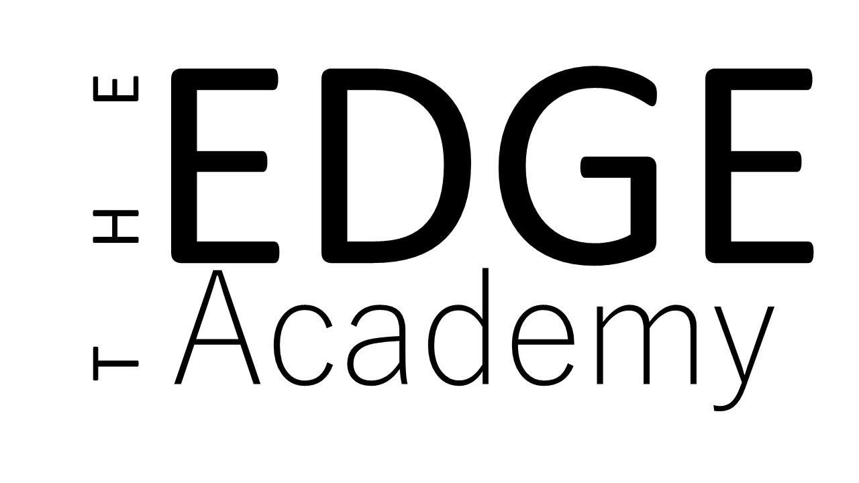

Provider Access Policy
Policy Details
Policy prepared by: | Charlotte Poynton, Vice Principal
Date reviewed: | April 2024
Approved by Governors | April 2024
Date of next review: | April 2025

The Edge Academy Provider Access Policy
Introduction
This policy statement sets out the school’s arrangements for managing the access of providers to the school for the purpose of giving them information about the provider’s education or training offer. This complies with the school’s legal obligations under Section 42B of the Education Act 1997 and The Department of Education, July 2021: “Baker Clause” and the Provider Access Legislation, January 2023
High quality careers education and guidance in school or college is critical to young people’s futures. It helps to prepare them for the workplace by providing a clear understanding of the world of work including the routes to jobs and careers that they might find engaging and rewarding. It supports them to acquire the self-development and career management skills they need to achieve positive employment destinations. This helps students to choose their pathways, improve their life opportunities and contribute to a productive and successful economy.
As the number of apprenticeships rises every year, it becomes increasingly important that all young people have a full understanding of all the options available to them post-16 and post-18 including wider technical education options such as T-Levels and Higher Technical Qualifications.
Commitment
The Edge Academy is committed to ensuring there is an opportunity for a range of education and training providers to access students, for the purpose of informing them about approved technical education qualifications and apprenticeships. The Edge Academy is fully aware of the responsibility to set students on the path that will secure the best outcome which will enable them to progress in education and work and give employers the highly skilled people they need. That means acting impartially, in line with the statutory duty, and not showing bias towards any route, be that academic or technical.
The Edge Academy endeavours to ensure that all students are aware of all routes to higher skills and are able to access information on technical options and apprenticeships (The Department of Education, July 2021: “Baker Clause”: supporting students to understand the full range of education and training options, and the Provider Access Legislation, January 2023).
Aims
The Edge Academy policy for Access to other education and training providers has the following aims:
To develop the knowledge and awareness of our students of all career pathways available to them, including technical qualifications and apprenticeships.
To support young people to be able to learn more about opportunities for education and training outside of school before making crucial choices about their future options.
To reduce drop out from courses and avoid the risk of students becoming NEET (Young people not in education, employment or training).

Pupil entitlement
All pupils in years 8 to 11 are entitled:
• to find out about technical education qualifications and apprenticeships opportunities, as part of a careers programme which provides information on the full range of education and training options available at each transition point;
• to hear from a range of local providers about the opportunities they offer, including technical education and apprenticeships – through options events, assemblies and group discussions and taster events;
• to understand how to make applications for the full range of academic and technical courses.
For pupils of compulsory school age these encounters are mandatory and there will be a minimum of two encounters for pupils during the ‘first key phase’ (year 8 to 9) and two encounters for pupils during the ‘second key phase’ (year 10 to 11).
These provider encounters will be scheduled during the main school hours and the provider will be given a reasonable amount of time to, as a minimum:
• share information about both the provider and the approved technical education qualification and apprenticeships that the provider offers
• explain what career routes those options could lead to
• provide insights into what it might be like to learn or train with that provider (including the opportunity to meet staff and pupils from the provider)
• answer questions from pupils.

Meaningful provider encounters
One encounter is defined as one meeting/session between pupils and one provider. We are committed to providing meaningful encounters to all pupils using the Making it meaningful checklist. Meaningful online engagement is also an option, and we are open to providers that are able to provide live online engagement with our pupils.
Links with other policies
It supports and is underpinned by key school policies including those for Careers, Child Protection, Equality and Diversity, and SEND.
Equality and Diversity
Access to other providers is available and promoted to allow all students to access information about other providers of further education and apprenticeships. The Edge Academy is committed to encouraging all students to make decisions about their future based on impartial information.
Requests for access
Requests for access should be directed to Sam Pearson, Careers Coordinator at samantha.pearson@theedgeacademy.co.uk
Grounds for granting requests for access
Access will be given for providers to attend during school assemblies, timetabled Life Skills lessons, and Careers or Raising Aspirations events. Students may also travel to visit another provider.
Details of premises or facilities to be provided to a person who is given access
The Edge Academy will provide an appropriate room. All rooms have access to computers, projectors and screens. Access to chrome books can also be arranged. The Careers Coordinator or Careers Leader will organise this, working closely with the provider to ensure the facilities are appropriate to the audience. Appropriate safeguarding checks will be carried out. Providers will be met and supervised by a member of the Careers Team who will facilitate.
Live/Virtual encounters
The Edge Academy will consider live online encounters with providers where requested, and these may be broadcast into classrooms or the school assembly hall. Technology checks in advance will be required to ensure compatibility of systems.
Parents and Carers
Parental involvement is encouraged, and parents may be invited to attend the events to meet the providers.
Management
The Careers Leader coordinates all provider requests and is responsible to his/her senior management line manager.
Complaints Procedure
Any complaints about this policy should be raised to Charlotte Poynton, email: charlotte.poynton@theedgeacademy.co.uk
Monitoring review and evaluation
The Policy is monitored and evaluated annually.
Appendix
Providers who have been invited into The Edge Academy to date include: DWP, Access Creative College, Solihull College and University Centre, University of Birmingham, South and City College, Matthew Boulton College, University College of Birmingham,Dodd Group, Speakers for Schools, Crown Prosecution Service, Ask, Make UK, National Grid, Birmingham City Council, Gordon Franks, Gro Organics, VIY, Halesowen College, The NEC Group, The Pump, Solid Skills, Envirohort, WorkSafe999.
Destinations of our pupils
Last year our year 11 pupils moved on to a range of providers in the local area after school, including: South and City College, Halesowen College, Cadbury College, Military Preparation College, Solihull College, Heart of Worcester College, various Apprenticeships and NOVA training.

