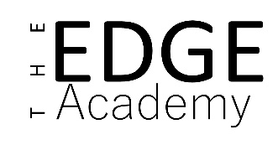

Relationships and Sex Education Policy

Policy Details
Policy prepared by: | Charlotte Poynton, Senior Assistant Principal
Date reviewed: | December 2023
Approved by Governors | December 2023
Date of next review: | December 2024

RATIONALE AND ETHOS:
Relationships and sex education focuses on exploring the emotional, social and physical aspects of growing up, having relationships, engaging in sex, and learning about human sexuality and sexual health. As a school we aim to provide a curriculum focused on our key principles of being safe, ready and respectful. This involves nurturing the physical, emotional, social, cultural, moral, intellectual and spiritual development of our pupils.
The importance of stable loving relationships based upon respect, trust, love and care is emphasised within the context of a modern changing society. RSE at The Edge encourages the personal development of pupils as well as integrating SMSC, the school’s Safeguarding Policy and Safer Recruitment in Education Guidance.
The DFE states, ‘To embrace the challenges of creating a happy and successful adult life, pupils need knowledge that will enable them to make informed decisions about their wellbeing, health and relationships and to build their self-efficacy. Pupils can also put this knowledge into practice as they develop the capacity to make sound decisions when facing risks, challenges and complex contexts. Everyone faces difficult situations in their lives. These subjects can support young people to develop resilience, to know how and when to ask for help, and to know where to access support.
High quality, evidence-based and age-appropriate teaching of these subjects can help prepare pupils for the opportunities, responsibilities and experiences of adult life. They can also enable schools to promote the spiritual, moral, social, cultural, mental and physical development of pupils, at school and in society. The duties on schools in this area are set out in legislation.
The Relationships Education, Relationships and Sex Education and Health Education (England) Regulations 2019, made under sections 34 and 35 of the Children and Social Work Act 2017, make Relationships and Sex Education (RSE) compulsory for all pupils receiving secondary education.’ (Relationships Education, Relationships and Sex Education (RSE) and Health Education, DFE, 2019)

AIMS:
- to promote a knowledge and understanding of physical and emotional development.
- to develop respect for self and others and a sense of personal responsibility.
- to encourage personal development and develop positive self-esteem and confidence into and throughout adolescence.
- to encourage skills, attitudes and values that will allow students to manage their personal development from birth to adulthood, making positive, healthy choices.
- to help students with the physical, moral and emotional challenges of growing up.
- to provide students with skills to keep safe.
- to develop an understanding of positive, loving relationships and the importance of a stable family life.
- to inform students about the processes of human reproduction.
- to enable students to be assertive, informed and in a position to make responsible choices, thus protecting themselves from potential exploitation and abuse.
- to promote a positive attitude towards a range of sexual orientation within relationships whilst understanding the similarities and differences between people.

OBJECTIVES:
- To inform pupils about the processes of puberty, sexual intercourse and human reproduction and to present them with factual information about sexual health
- To develop positive values and a moral framework that will guide pupil decisions, judgements and behaviours.
- To enable pupils to be assertive, to make well informed, reasonable and responsible choices.
- To understand the arguments for delaying sexual activity.
- To provide knowledge about loving relationships and the importance of a stable family life.
- To discuss the nature and range of sexuality in society whilst respecting the diversity of others.
- To develop pupils’ research skills to locate and interpret information from a range of sources.
- To ensure that pupils know how and where to access additional support if needed. To identify high risk behaviours that could lead to unwanted pregnancies, sexually transmitted infections or risks to personal safety of self and others.
- To understand that in some relationships domestic violence and other types of abuse will put individuals at risk and there are support mechanisms to help victims.
- To ensure pupils understand the legal position regarding the age of consent, safe sex, acceptable behaviour and confidentiality.
- To understand what is meant by sexual exploitation whether at home, in the community or on the internet.
- To understand the expectations that different cultures may place on youngsters and how they might impact on the lives of youngsters.

We ensure RSE is inclusive and meets the needs of all our pupils, including those with special educational needs and disabilities (SEND) by offering highly differentiated teaching and additional one to one support as required.

PROCESSES:
The RSE curriculum and this policy will be audited and reviewed annually to ensure it reflects the needs of the pupils and the ethos of the school. The curriculum will be open to a consultation period with input from students, staff, governors and parents. The policy and curriculum will both be available to find on the school website.
Pupils will be taught RSE though Life Skills and Science lessons, although it is recognised that all subjects will have embedded SMSC and the safeguarding of pupils.

Recognising the transient nature of our pupils, we will provide regular opportunities for the teaching of SRE and also targeted work based on need. Our curriculum will adapt to meet the needs of the cohort of students and will reflect priorities identified by student voice, parents and carers and the safeguarding team. The curriculum has a spiral approach, which gradually revisits and reintroduces topics at a deeper and more complex level for each key stage or year group, whilst rehearsing, emphasising and embedding the essential skills and attributes young people need to manage their lives — both now and in the future.

High quality resources will support our RSE provision and will be regularly reviewed and a range of teaching methods and strategies will be used that encourage open discussion within a supportive learning environment based upon a set of agreed ground rules. Outside speakers may contribute to the overall delivery of RSE, and we may also include interventions via specialist theatre groups.

Assessment in RSE will take the approach that students will be able to articulate what they have learnt lesson by lesson in an exit note. There will be no formal written assessments but student work scrutiny should show progress over time a deeper understanding of the issues discussed.

An overview of the learning in each year group can be found in the long-term plans attached in the appendix.

SAFE AND EFFECTIVE PRACTICE
We will ensure a safe learning environment by challenging any inappropriate (e.g. homophobic, personal or sexist) comments and dealing with in line with the antibullying policy where necessary. Inappropriate language will be challenged and the biological terminology taught.
Teachers and pupils will agree ground rules and sensitive issues will be handled by offering time to discuss, reflect and follow up. Distancing techniques such as case studies are used because students may feel uncomfortable discussing personal issues. Pupils’ questions will be answered as directly as possible but specialist support services will be signposted throughout each topic. Pupils will be able to raise questions anonymously using a question box placed discreetly in the main teaching room.

SAFEGUARDING
Teachers are aware that effective RSE, which brings an understanding of what is and what is not appropriate in a relationship, can lead to a disclosure of a child protection issue. Teachers cannot guarantee 100% confidentiality to pupils. This should be made clear to pupils at the start of the programme and on a regular basis. If a pupil discloses information which causes a member of staff to have concerns for the child’s safety, the member of staff will adhere strictly to the School and LA Safeguarding procedure and by law must pass the information onto the Designated Senior Leader (DSL).
ENGAGING STAKEHOLDERS
Parents will be informed about this RSE policy through a parent pack and letter shared on social media linking to the policy on our website. We will work closely with parents to ensure that they are fully aware of what is being taught and provide additional resources and support through our website. As part of our whole school approach to RSE opportunities for parents to view the materials and resources used will shared on our website.
Parents/carers will be informed about RSE teaching during induction. Parents/carers have a right to withdraw their children from some, or all, aspects of sex education. If withdrawal is requested in writing to the Principal a meeting will be arranged to discuss the issue further. This will be recorded and alternative provision made within existing resources where possible. DFE guidance states, ‘Pupils can be withdrawn up to and until three terms before the child turns 16. After that point, if the child wishes to receive sex education rather than be withdrawn, the school should make arrangements to provide the child with sex education during one of those terms.’ There is no right to withdrawal from Relationships and Health Education.
Governors will be informed of the RSE policy and curriculum and approve it annually.
Pupil voice will be used to review and tailor our RSE programme to match the different needs of pupils.

EQUAL OPPORTUNITIES:
The Edge’s policy and programmes reflect the ethos of the school. All members of staff are committed to providing a secure, non-judgmental environment in which to learn, irrespective of gender, ethnicity, family circumstances or social background. RSE programmes aim to engage all pupils. Teachers plan activities to provide a variety of teaching styles to meet the learning needs of all pupils.

ROLES AND RESPONSIBILITIES
The RSE programme will be led by Senior Assistant Principal, Charlotte Poynton. It will be taught by Charlotte and a range of staff. It will be supported by senior leadership and all staff as part of our Safe, Ready, Respectful ethos.
A working party will be made up of staff, parents/carers and governors to ensure the programme is comprehensive and inclusive.
Teaching staff will receive RSE training throughout the year to ensure they are aware of their responsibilities.

MONITORING, REPORTING AND EVALUATION
Teachers will critically reflect on their work in delivering RSE and amend the programme half termly. Pupils will have opportunities to review and reflect on their learning during lessons and regular pupil voice will be influential in adapting and amending planned learning activities.

Appendix A
PSHE Association Quality Assured Resources
PSHE ASSOCIATION: https://www.pshe-association.org.uk/curriculum-and-resources/resources/guidance-teaching-about-consent-pshe-education-key
Guidance for teaching about consent in PSHE education • Consent • Pornography • Coercion and abuse
MEDWAY PUBLIC HEALTH https://www.pshe-association.org.uk/curriculum-and-resources/resources/medway-secondary-relationship-and-sex-education
Secondary PSHE education - relationships and sex education. • Key stage 3 • Puberty • Healthy relationships and consent • Gender identity and sexual orientation • Sexual health and pregnancy
NSPCC: Making Sense of Relationships https://www.nspcc.org.uk/preventing-abuse/safeguarding/schools-protecting-children-abuse-neglect/making-sense-of-relationships
• Healthy and unhealthy relationships • Online relationships • Sharing explicit images (sexting) • Consent • Pornography
CEOP: https://www.pshe-association.org.uk/curriculum-and-resources/resources/ceop-exploited-film-and-resource-pack
Exploited • Relationship abuse • Child Sexual Exploitation
CHILDNET INTERNATIONAL: https://www.pshe-association.org.uk/curriculum-and-resources/resources/childnet-crossing-line-online-safety-pshe-toolkit
Crossing the Line • Online bullying • Sharing explicit images (sexting)
HOME OFFICE: https://www.pshe-association.org.uk/curriculum-and-resources/resources/disrespect-nobody-teaching-resources-preventing
Disrespect Nobody • Relationship abuse
PUBLIC HEALTH ENGLAND: https://www.pshe-association.org.uk/curriculum-and-resources/resources/rise-above-schools-teaching-resources
Rise Above for schools • Key stage 3 • Friendship and peer pressure • Fear of missing out (FOMO) • Online bullying
BETTY: https://www.pshe-association.org.uk/curriculum-and-resources/resources/betty-its-perfectly-natural-0
It’s Perfectly Natural • Growth and change • Menstruation and puberty
CORAM LIFE EDUCATION: https://www.pshe-association.org.uk/curriculum-and-resources/resources/adoptables-schools-toolkit-coram-life-education
Different types of families • Supporting adopted young people
ISLINGTON HEALTHY SCHOOLS: https://www.pshe-association.org.uk/curriculum-and-resources/resources/sre-covered-islington-healthy-schools-team
SRE Covered • Positive relationships • Contraception and sexual health • Pregnancy choices and parenting
WOMEN’S AID: https://www.pshe-association.org.uk/curriculum-and-resources/resources/expect-respect-education-toolkit-womens-aid
Expect Respect • Managing conflict • Healthy and unhealthy relationships • Bullying and harassment • Domestic abuse
CHRISTOPHER WINTER PROJECT: https://www.pshe-association.org.uk/curriculum-and-resources/resources/teaching-sre-confidence-secondary-schools-cwp
Social media • Sexual exploitation and bullying • Consent and pornography • Personal safety in relationships

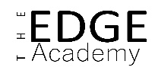
Appendix B- Parent info sheet devised in consultation with parents.

Key Stage 3 Relationships and Sex Education Parents and Carers Pack 2023-2024
We have worked hard to make sure that our new Life Skills curriculum reflects the values of our school community. We have assessed what pupils need to know to be safe, ready and respectful in school, in their personal relationships and in the wider world. We will ensure we take in to account every pupil’s learning needs when teaching Life Skills.
We now want to ensure that you are aware of what we are discussing in class and feel confident talking to staff if you have any concerns. These subjects will be approached openly and sensitively and some students may want to discuss some of the issues in further detail. It is vital that we work together and share a common approach to questions raised. I have outlined what we will be covering and why it is important for your child below.

What are we learning about? | Why is it important for students to have open and honest discussions about this?
POSITIVE RELATIONSHIPS | To know what positive relationships look and feel like, including how to get help if needed.
PORTRAYAL OF RELATIONSHIPS | To recognise that the media may not reflect real life and the possible impact of this on yours and others’ expectations.
FAMILY LIFE | To know how important supportive and stable relationships are for a family, whatever form they take
FORMING AND MAINTAINING RELATIONSHIPS | To know the different stages of relationships and assess what you need to be ready for each stage.
CONSENT | To understand the idea of consent and the social, emotional and legal importance of informed consent.
CONTRACEPTION AND SEXUAL HEALTH | To learn about the risks of unprotected sex and how to safely use different forms of contraception
PEER PRESSURE | To understand the feelings and pressure that the need for peer approval can generate
BULLYING AND ABUSE | To recognise and know how to manage bullying and abuse in all its forms.
ONLINE RELATIONSHIPS | To establish clear personal boundaries around those aspects of their lives they wish to be private.
This curriculum is LGBT+ Inclusive and while we try to explore all views sensitively, we will not tolerate prejudiced or discriminatory language.
The full programme can be found in our RSE policy on our website at www.theedgeacademy.co.uk/policies. Graphic overviews of what we cover can be found on the Life Skills home learning page at https://www.theedgeacademy.co.uk/learning-from-home-life-skills/ and example resources are listed below each overview.
We welcome any input from parents and carers, if you want to discuss any of this in further detail I can be contacted on 0121 533 5858 or charlotte.poynton@theedgeacademy.co.uk

Key Stage 4 Relationships and Sex Education Parents and Carers Pack 2023-2024
We have worked hard to make sure that our new Life Skills curriculum reflects the values of our school community. We have assessed what pupils need to know to be safe, ready and respectful in school, in their personal relationships and in the wider world. We will ensure we take in to account every pupil’s learning needs when teaching Life Skills.
We now want to ensure that you are aware of what we are discussing in class and feel confident talking to staff if you have any concerns. These subjects will be approached openly and sensitively and some students may want to discuss some of the issues in further detail. It is vital that we work together and share a common approach to questions raised. I have outlined what we will be covering and why it is important for your child below.

What are we learning about? | Why is it important for students to have open and honest discussions about this?
POSITIVE RELATIONSHIPS | To know what positive relationships look and feel like, including how to get help if needed.
PORTRAYAL OF RELATIONSHIPS | To recognise that the media, including pornography, may not reflect real life and the possible impact of this on yours and others’ expectations.
FAMILY LIFE | To know what makes a successful family, including your rights around adoption, fostering and fertility treatment.
FORMING AND MAINTAINING RELATIONSHIPS | To know the signs and the impact of relationship abuse and how to get support.
CONSENT | To understand the social, emotional and legal importance of informed consent and how capacity to consent can be impaired by drugs or alcohol.
CONTRACEPTION AND PREGNANCY | To learn about the risks of unprotected sex and how to safely use different forms of contraception. To explore the different pathways for dealing with unintended pregnancy.
PEER PRESSURE | To understand the feelings and pressure that the need for peer approval can generate
ONLINE RELATIONSHIPS | To establish clear personal boundaries around those aspects of their lives they wish to be private.
This curriculum is LGBT+ Inclusive and while we try to explore all views sensitively, we will not tolerate prejudiced or discriminatory language.
The full programme can be found in our RSE policy on our website at www.theedgeacademy.co.uk/policies. Graphic overviews of what we cover can be found on the Life Skills home learning page at https://www.theedgeacademy.co.uk/learning-from-home-life-skills/ and example resources are listed below each overview.
We welcome any input from parents and carers, if you want to discuss any of this in further detail I can be contacted on 0121 533 5858 or charlotte.poynton@theedgeacademy.co.uk

Appendix C Letter To Parents

Relationships and Sex Education Relationship and Sex Education Update

Dear Parents/Carers,

In light of recent changes to requirements for relationships and sex education (RSE), we have worked hard to make sure that our new curriculum reflects:
- Our pupils’ age and maturity levels, as well as their cultural and religious backgrounds.
- The values of our school community.
- Every pupil’s learning needs.
- What pupils need to know to be safe, ready and respectful in school, in their personal relationships and in the wider world.
Life Skills is the curriculum subject that gives young people the knowledge, understanding, attitudes and practical skills to live safe, healthy, productive lives and meet their full potential. I am writing to let you know that over the next term, your child’s class will be taking part in lessons which will focus on the relationships and sex education (RSE) aspect of this programme. RSE lessons will include teaching about: healthy relationships, including friendships and intimate relationships; families; growing and changing, including puberty; personal hygiene; changing feelings; becoming more independent; keeping safe and consent; developing self-esteem and confidence. Pupils will also have opportunities to ask questions that help prepare them for relationships of all kinds in the modern world.
Life Skills is taught throughout the school in every year group and is monitored and reviewed regularly by the staff and governing body. Please visit the RSE policy on the school’s website as well as the curriculum section of the website for more detail. All Life Skills teaching takes place in a safe learning environment and is underpinned by our school ethos and values.
As a school community, we are committed to working in partnership with parents. If you would like to find out more or discuss any concerns, I can be contacted on 0121 533 5858 or at charlotte.poynton@theedgeacacdemy.co.uk

Yours sincerely,

Charlotte Poynton
Senior Assistant Principal

Example KS4 Graphic Organiser
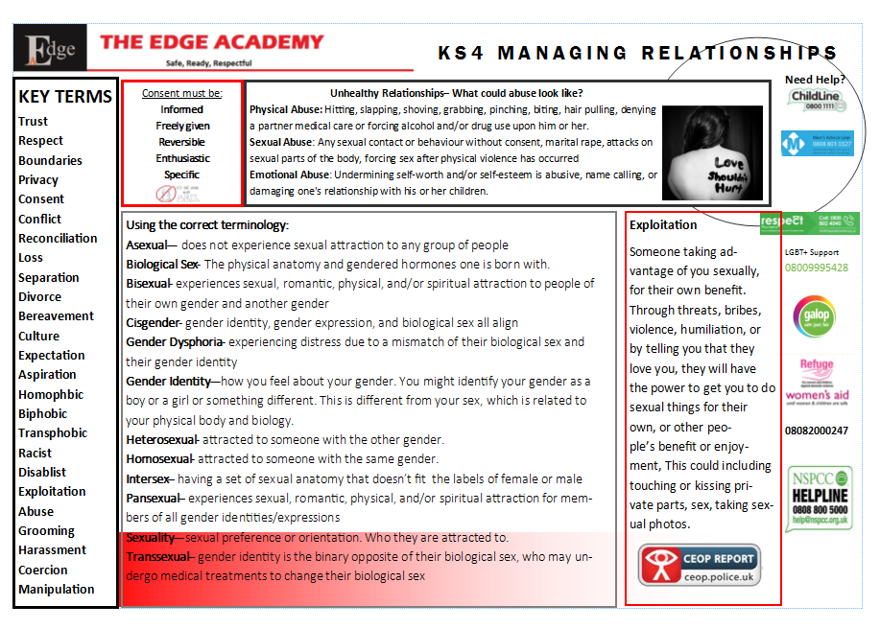
Example KS3 Graphic Organiser
