West Midlands Police Museum at the Lock-Up.

Dear parents/carers,

We are delighted to have the opportunity to visit the West Midlands Police Museum at the Lock-Up. This is a particularly exciting trip in that it was requested by students and they will be planning the transport and the finer details of the visit.
On Wednesday 15th March Conect students will travel on public transport to the museum where we will take a guided tour and learn about Birmigham’s criminal past. Lunch will be provided but there will potentially be opportunities to buy snacks and drinks if students would like to bring a small amount of cash. We will then return to school for 2.30 dismissal as usual.

If you have any questions regarding this visit please do not hesitate to get in touch with me at 0121 533 5858 or charlotte.poynton@theedgeacademy.co.uk

Yours faithfully,
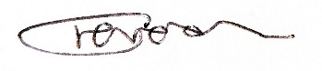
Charlotte Poynton
Assistant Principal

