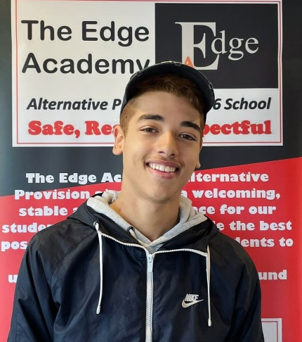
GCSE Result Update August 2021
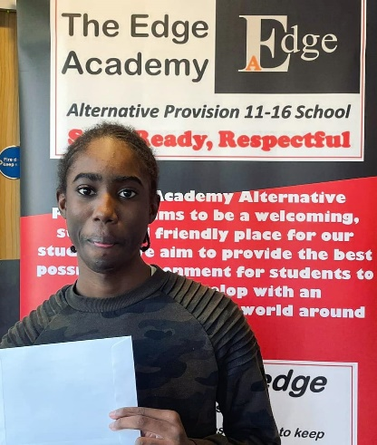
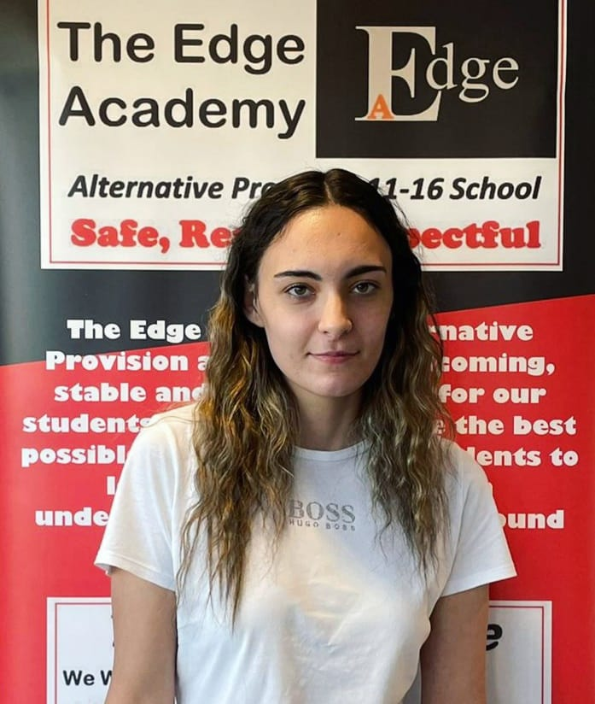

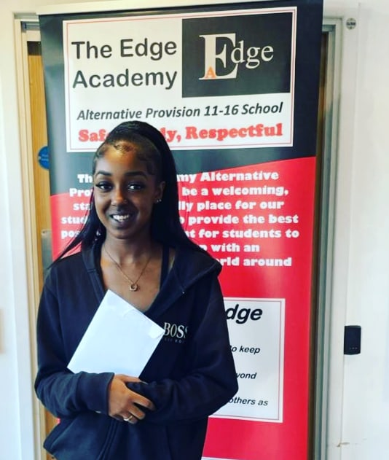
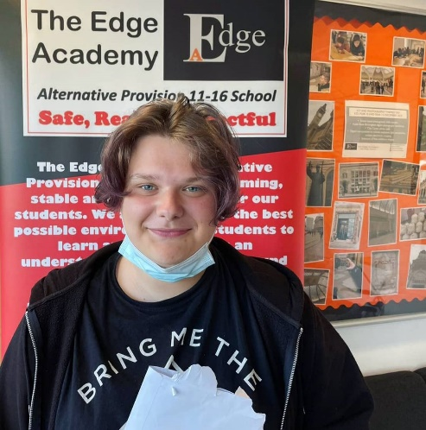
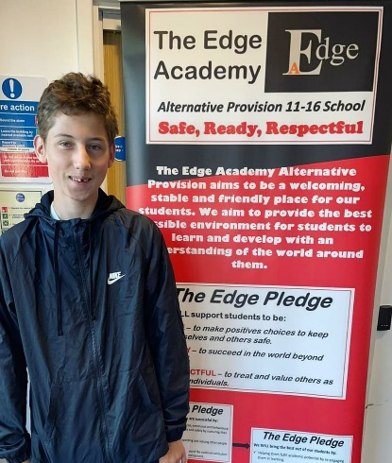

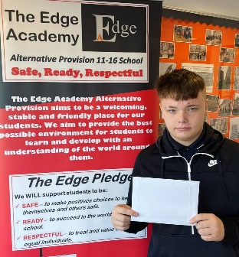
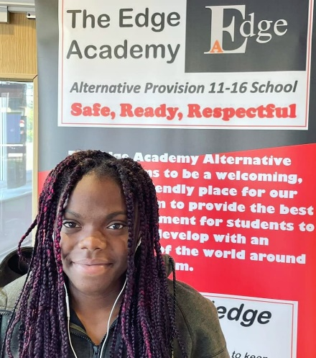

Dear Parent/ Carer,
Amongst all of the continuing difficulties caused by the Coronavirus pandemic since 2020, I am delighted to write to you with positive news of the GCSE Results achieved by our departing Year 11 students today.

As you would expect given our recent OFSTED “Good” judgement, our initial analysis of the results show that we have continued what is a now a four-year upward trend of sustained improvement and that:
- The results are once again the best the school has ever achieved since it opened in 2015, both in terms of attainment and progress.
- For the first time ever, the majority of all Year 11 students achieved 7 Level 2 qualifications, passed with the highest percentage of grades at Grades 4, 5 and 6 since the school opened.
- 100% of Year 11 students entered for the core subjects of English Language and Literature, Maths and Combined Science achieved Level 2 qualifications. An impressive 42% of Year 11 students leave us having achieved three Level 2 qualifications in Science having also passed Biology.
- The broadening of our “Safe, Ready, Respectful” curriculum in recent years now means that students pass a more diverse range of option subjects than ever before, with all Year 11 students entered for Art, Media Studies and Food achieving a Level 2 qualification.
- Our highest ever number of Year 10 students now have qualifications banked as they prepare to start Year 11, with the majority having already achieved a Level 2 qualification in Chemistry.
- One of our Year 11 students has achieved the best ever “across the board” individual performance since the school opened, passing 8 Level 2 qualifications, with half of these being passed at Grade 5.
I would like to particularly congratulate Year 11 students on their achievements and it is important that they congratulate themselves in the same way that any other year group would do outside of a global crisis. Grades were arrived at following a rigorous moderation process in line with government guidance as well as student work being externally checked by examination boards; students must never feel in the future that their grades were based on estimates or that they are worth less than those of students in previous years.
Those of you familiar with The Edge will be aware that our departing Year 11 students have once again been a pleasure to work with and it is no surprise to us that every single one of them has now also secured further education placements for September. In addition, I would like to pay tribute to our team of staff for the manner in which they have transformed The Edge’s provision and outcomes in recent years- this has only been made possible through their hard work and it is a joy to work with them all.
Finally, a heartfelt thank you to families and the wider community for all of the support we receive from you- we will continue to be a welcoming, friendly and stable place for our students and will continue to support you all through the next and hopefully final phases of the pandemic. Please contact me directly at andrew.wakefield@theedgeacademy.co.uk if there is anything else we can be doing at present to help and support.
Yours faithfully,
Andrew Wakefield
Principal

