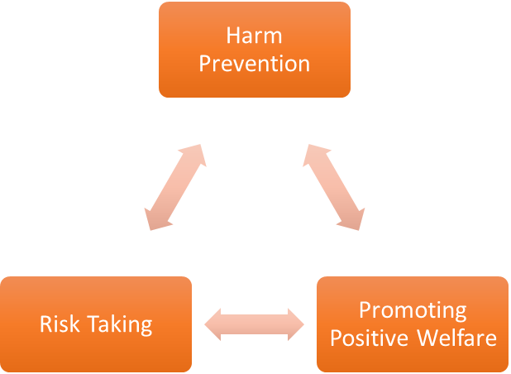
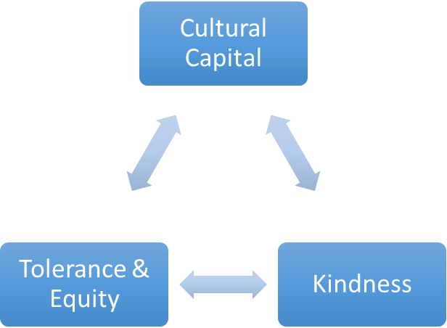
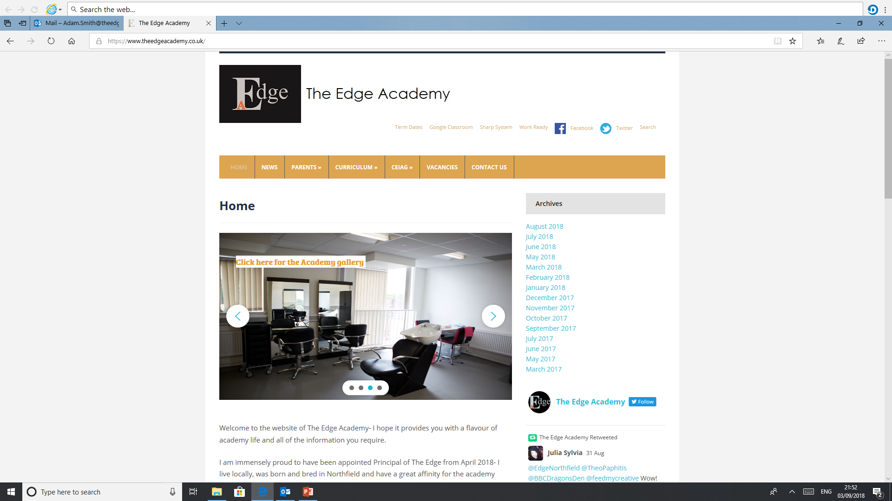
SAFE

RESPECTFUL
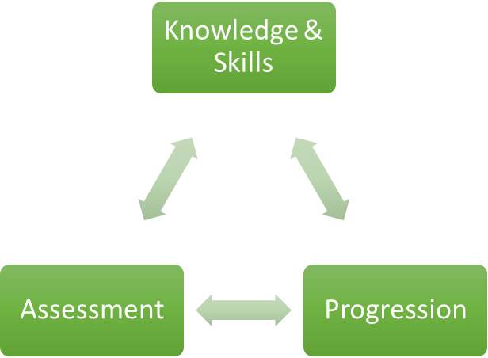

READY

Well Being
Why is WELL BEING important to our learners at The Edge Academy?
Sport and physical education are fundamental to the early development of children and youth and the skills learned during play, physical education and sport contribute to the holistic development of young people. Through participation in sport and physical education, young people learn about the importance of key values such as: honesty, teamwork, fair play, respect for themselves and others, adherence to rules and resilience.

How can WELL BEING support our learners to be SAFE?
One of the most obvious benefits of sport is increased physical health. At present it is estimated that more adults are obese (23%) in Northfield than across all other Birmingham city districts and with 24% of Birmingham city children in Year 6 classed as obese v 19% across England. Obesity is only one of many medical conditions that can be significantly helped by participation in sport – others include Heart Disease, Diabetes and Osteoporosis.
It is a great way for young people to meet each other in a safe environment where similar interests are shared. Friendship and the sense of a common focus encourage feeling of belonging in young people

How can WELL BEING support our learners to be READY?
The preparation of our young people to manage as adults with post-school stress and demands to support young people’s mental health are vital aspects of our very core purpose as a school. We recognise the relatively low-starting points of individual resilience from a wide range of frequently negative previous experiences. Sport and physical activity provide multiple opportunities to be successful as both an individual, a pair or as part of a team or group.

How can WELL BEING support our learners to be RESPECTFUL?
Physical education provides a forum for young people to learn how to deal with competition and how to cope with both winning and losing. These learning aspects highlight the impact of physical education and sport on a child’s social and moral development in addition to physical skills and abilities.

What barriers to WELL BEING are there to overcome for our learners at The Edge Academy?
Sport is an attractive activity for young people, and can often be used as a ‘hook’ to engage children and young people. While the physical benefits of participation in sport are well known and supported by large volumes of empirical evidence, sport and physical activity can also have positive benefits on educational attainment and aspiration. Learners at the Edge may have social and economic experiences that may have restricted the value and opportunities that sport can provide. In Birmingham, 260,000 people are inactive, representing 30% of the population and which is higher than across the UK.

Why do we follow the current WELL BEING course with our learners at The Edge Academy?
A 1-hour 40-minute physical education lesson is part of the core curriculum offer for ALL students in ALL years. This is a non-examined practical activity-based experience utilising venues, facilities or activities that our students would not necessarily have access to outside of the school offer.

What inspired your passion for WELL BEING as a teacher and curriculum leader?
“It is important to me to try and inspire younger people to get involved with sport, because they’re the next generation that will carry it on after us. It’s just about trying to get as many people involved with sport as we can, and helping them enjoy it, that’s the most important thing. If I can make one child smile then it’s all worthwhile, I desperately want them to experience the character defining challenges that have shaped my life. How sport has taken me to places I could only have dreamed of and been inspired to emulate people who have achieved remarkable feats of courage, determination and physical endeavour.”

Where can WELL BEING lead our learners to in their aspirations and lives ahead?
Physical education and sport also build health activity habits that encourage life-long participation in physical activity. This extends the impact of physical education beyond the schoolyard and highlights the potential impact of physical education on public health. Physical education is far more than what career or occupation it can take you to, but in fact more about the experiences and wellbeing habits that it can contribute towards in forming a healthy adult life.

How in light of COVID-19 school closures impact, have you modified or reprioritised your subject programmes of study?

Our Core Purpose |  | The Edge Curriculum INTENT
Safe | Harm Prevention  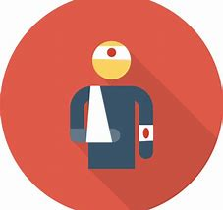 | - Careful analysis of our locality, its risks to young people and the response to patterns and emerging trends identified through careful monitoring of safeguarding concerns data.  - The role and continual review of the safeguarding curriculum at the Edge comprising of Lifeskills (PSHE), daily tutor time programme, weekly assembly schedule, programme of visiting external delivery, themed days/events, awareness days events to include specifically the teaching online safety in schools and Sex and Relationships education (compulsory from 2020).
Safe | Risk Taking   | - Positive mindset development and the nurturing of calculated positive risk taking is crucial to developing a high challenge, low threat environment where all young people feel secure learners.  - The importance of challenging aspirations and realistic CEIAG are crucial tools to engagement of the wider academic offer at the Edge. This is achieved through the central offer of work-related learning opportunities to all students and immersion in post-16 learning provision events and independent guidance.
Safe |   Positive Welfare | - The preparation of our young people to manage as adults with post-school stress and demands to support young people’s mental health. The acknowledgment of relatively low-starting points of individual resilience from education experiences and the planned provision for opportunities to be successful.  - The role and continual review of the safeguarding curriculum at the Edge comprising of Lifeskills (PSHE), daily tutor time programme, weekly assembly schedule, programme of visiting external delivery, themed days/events, awareness days and events to include specifically the teaching online safety in schools and Sex and Relationships education (compulsory from 2020).
Ready | 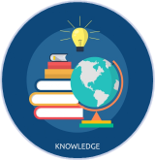  Knowledge and Skills | - Equipping our young people to have experienced threshold concepts, subject specific enrichment and key knowledge and skills in literacy and numeracy by the time they leave our school.  - An environment that cultivates the individual growth of identified knowledge and skills and through informed planning and the opportunities to apply the acquired knowledge and skills.  - Ensuring that there is depth and breadth in the Edge curriculum offer across key stages and subject sequencing to certify that we are ‘spiralling’ knowledge and skill across the years, in order to support progression.  - An effective and inspiring experience of CEIAG provision drawing on a broad diet of post-16 learner pathways, providers, effective bespoke guidance and a core offer of work related learning opportunities for all.
Ready | Assessment   | - Rigorous review and professional reflection to challenge why are we assessing young people and for what purpose to measure against realistic targets.  - Accountability at classroom and subject levels for how do you use the assessment, what methods do we use to assess, how assessments are linked to personal improvement feedback and then subsequently how do such assessments impact on future teaching and learning.
Ready |   Progression | - Harnessing and building real value in the significant underpinning factors of literacy and reading to all progression and sequencing this as a core value of our provision.  - Creating and sharing information to inform teachers and students themselves to know that progress is taking place for all learners in all subjects  - Recognition and acknowledgement that progress may not be the same for all abilities and groups but is supportive a truly individualised pathway to achievement built on the concept of equity. Where FAIR does not mean everyone gets the same thing, but FAIR at the Edge means everyone gets what they need to be successful in the classroom.
Respectful | Cultural Capital   | - The Edge Pledge – experience is not less, it is more. Education is bigger than schooling. The promise to deliver or provide that is focussed, definite and our guarantee.  - Strategically mapped and sequenced model of educational of visits in response to student council input and identified gaps in individuals’ life experiences. Central to this is the evolution to offer a high-quality two-hour enrichment session every Friday afternoon featuring a variety of “small group” on-site and off-site activities to support the holistic curriculum offer.  - Planning and provision in all our subject areas and from all adult roles to enhance the life experience and opportunities for our young people.  - The high-profile celebration for our young people of their local area, heritage and identity and to embrace and recognise what does it mean to be a ‘Brummie’.
Respectful | Tolerance & Equity  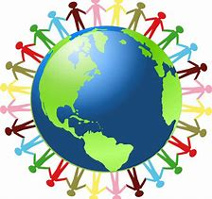 | - Teaching kindness and compassion at The Edge, not only fosters the positive behaviour that creates warm and inclusive school environments, but helps children feel that they belong, leading to reduced bullying.  - Collaborative mapped provision with other agencies and voluntary organisations to enhance community cohesion.  - Recognition of the value of family learning opportunities and embracing individual differences through culture and faith.  - Fostering empathy to build trust, with trust comes respect. There is genuine power in kindness, compassion and patience. For many learners, kindness may the one true trait that they look for in a teacher.
Respectful | 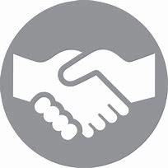  Kindness | - A fundamental kindness-based programme in school that embeds a discrete culture of kindness in an environment where kindness has not necessarily been seen, modelled or experienced. Our mantra of being ‘relentlessly reasonable’ attempts to harness that;  - Feelings of joyfulness are contagious, encouraging more kind behaviour by the giver and recipient.  - Research has determined that kindness increases our ability to form meaningful connections with others and even small acts of kindness are reported to heighten our sense of wellbeing, increase energy and give a wonderful feeling of optimism and self-worth.  - Our young people being part of projects that help others, provides them with a real sense of perspective and helps them appreciate the things in their own lives reinforcing that kindness is a key ingredient that helps children feel good.

