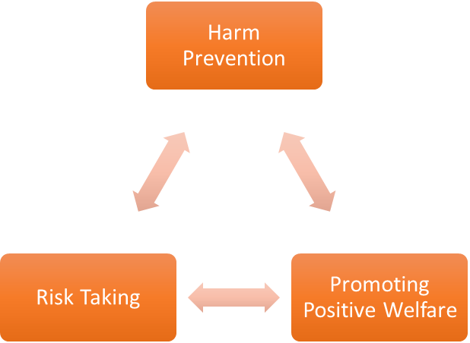
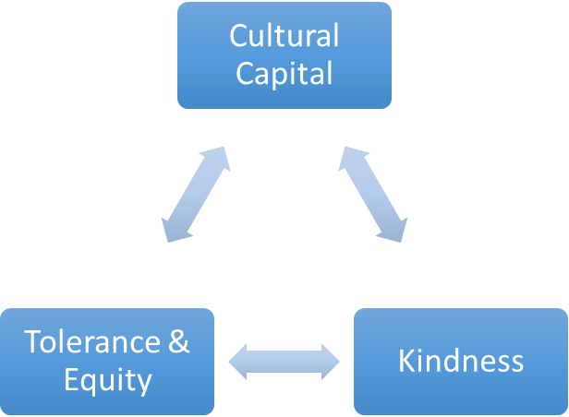
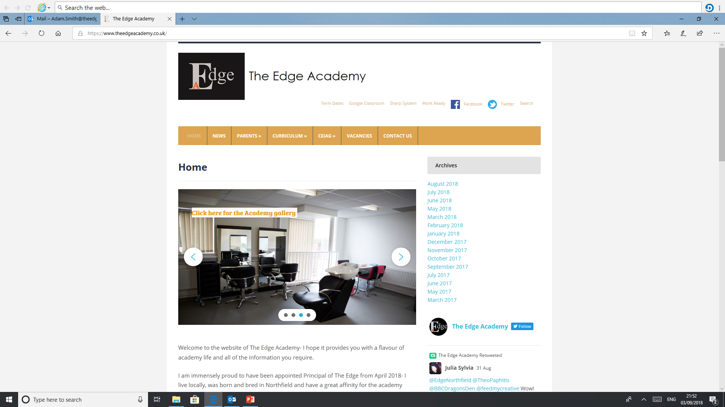
SAFE

RESPECTFUL
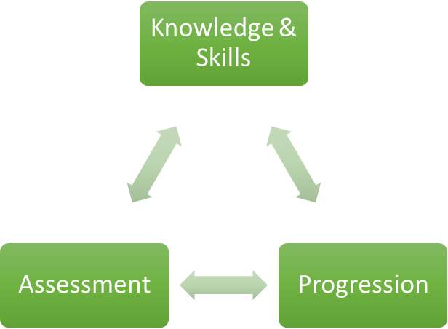

READY

Project

Why is Project important to our learners at The Edge Academy?
The Project lessons allow students and staff to broaden The Edge curriculum offer by encouraging and supporting learners to show what they can do, rather than what they can't. We can create thematic projects that reflect the learners’ interests and address any identified gaps in their learning. Project lessons allow us to spend time on the vital aspects of learning that the formal curriculum may miss, for example, social skills, learning through play, craft and experience based learning.

How can Project support our learners to be SAFE?
The project lessons allow students to explore many types experiential learning, they will have to adapt to different environments, different expectations and using different resources. They can gain accreditation by demonstrating safe working practices in a variety of situations.

How can Project support our learners to be READY?
Project lessons allow students to broaden their horizons in a safe and supported way. Students will be encouraged to try new things, evaluate their experiences and suggest new projects of their own. This self-directed learning will give them the essential skills needed for college and work.

How can Project support our learners to be RESPECTFUL?
Project lessons will open students up to a range of new experiences and new people. They will learn to appreciate that our diverse interests and skills are what make us unique and that this is a cause for celebration.

What barriers to Project are there to overcome for our learners at The Edge Academy?
Students arrive at The Edge lacking in essential skills, they may find a change in pace or expectations causes anxiety. These lessons pose unique challenges as students may find they excel in some areas and struggle in others.

Why do we follow the current Project course/examination board with our learners at The Edge Academy?
The AQA Unit Award Scheme is a unique recording of achievement scheme, rather than a qualification. It offers learners the opportunity to have their achievements formally recognised with a certificate each time a short unit of learning is successfully completed. It provides a wide range of units which are differentiated, making accreditation accessible to all pupils regardless of their ability.

What inspired your passion for Project as a teacher and curriculum leader?
The Project lessons allow us to celebrate small steps, we can see students’ regular achievements build towards a broad and varied record of achievement. I love learning about what my students do outside of school and matching the lessons to their interests.

Where can Project lead our learners to in their aspirations and lives ahead?
Project lessons are so diverse they can inspire students in unexpected ways. You may find you have a hidden talent or a passion for something you would never have tried yourself. That is the beauty of project lessons. Learn about yourself and learn from those around you.

How in light of COVID-19 school closures impact, have you modified or reprioritised your subject programmes of study?
Project lessons have been ongoing in school and resources have been delivered to students at home paper and online resources have been provided. Some of the more lengthy practical projects have not been possible with those learning remotely but they have been offered competitions and masterclasses to keep them engaged. We have also maintained a focus on practices to ensure good mental health and build resilience to prepare for the return to school.

Our Core Purpose |  | The Edge Curriculum INTENT
Safe | Harm Prevention  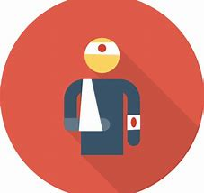 | - Careful analysis of our locality, its risks to young people and the response to patterns and emerging trends identified through careful monitoring of safeguarding concerns data.  - The role and continual review of the safeguarding curriculum at the Edge comprising of Lifeskills (PSHE), daily tutor time programme, weekly assembly schedule, programme of visiting external delivery, themed days/events, awareness days events to include specifically the teaching online safety in schools and Sex and Relationships education (compulsory from 2020).
Safe | Risk Taking   | - Positive mindset development and the nurturing of calculated positive risk taking is crucial to developing a high challenge, low threat environment where all young people feel secure learners.  - The importance of challenging aspirations and realistic CEIAG are crucial tools to engagement of the wider academic offer at the Edge. This is achieved through the central offer of work-related learning opportunities to all students and immersion in post-16 learning provision events and independent guidance.
Safe |   Positive Welfare | - The preparation of our young people to manage as adults with post-school stress and demands to support young people’s mental health. The acknowledgment of relatively low-starting points of individual resilience from education experiences and the planned provision for opportunities to be successful.  - The role and continual review of the safeguarding curriculum at the Edge comprising of Lifeskills (PSHE), daily tutor time programme, weekly assembly schedule, programme of visiting external delivery, themed days/events, awareness days and events to include specifically the teaching online safety in schools and Sex and Relationships education (compulsory from 2020).
Ready | 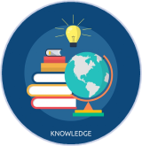  Knowledge and Skills | - Equipping our young people to have experienced threshold concepts, subject specific enrichment and key knowledge and skills in literacy and numeracy by the time they leave our school.  - An environment that cultivates the individual growth of identified knowledge and skills and through informed planning and the opportunities to apply the acquired knowledge and skills.  - Ensuring that there is depth and breadth in the Edge curriculum offer across key stages and subject sequencing to certify that we are ‘spiralling’ knowledge and skill across the years, in order to support progression.  - An effective and inspiring experience of CEIAG provision drawing on a broad diet of post-16 learner pathways, providers, effective bespoke guidance and a core offer of work related learning opportunities for all.
Ready | Assessment   | - Rigorous review and professional reflection to challenge why are we assessing young people and for what purpose to measure against realistic targets.  - Accountability at classroom and subject levels for how do you use the assessment, what methods do we use to assess, how assessments are linked to personal improvement feedback and then subsequently how do such assessments impact on future teaching and learning.
Ready |   Progression | - Harnessing and building real value in the significant underpinning factors of literacy and reading to all progression and sequencing this as a core value of our provision.  - Creating and sharing information to inform teachers and students themselves to know that progress is taking place for all learners in all subjects  - Recognition and acknowledgement that progress may not be the same for all abilities and groups but is supportive a truly individualised pathway to achievement built on the concept of equity. Where FAIR does not mean everyone gets the same thing, but FAIR at the Edge means everyone gets what they need to be successful in the classroom.
Respectful | Cultural Capital   | - The Edge Pledge – experience is not less, it is more. Education is bigger than schooling. The promise to deliver or provide that is focussed, definite and our guarantee.  - Strategically mapped and sequenced model of educational of visits in response to student council input and identified gaps in individuals’ life experiences. Central to this is the evolution to offer a high-quality two-hour enrichment session every Friday afternoon featuring a variety of “small group” on-site and off-site activities to support the holistic curriculum offer.  - Planning and provision in all our subject areas and from all adult roles to enhance the life experience and opportunities for our young people.  - The high-profile celebration for our young people of their local area, heritage and identity and to embrace and recognise what it means to be a ‘Brummie’.
Respectful | Tolerance & Equity   | - Teaching kindness and compassion at The Edge, not only fosters the positive behaviour that creates warm and inclusive school environments, but helps children feel that they belong, leading to reduced bullying.  - Collaborative mapped provision with other agencies and voluntary organisations to enhance community cohesion.  - Recognition of the value of family learning opportunities and embracing individual differences through culture and faith.  - Fostering empathy to build trust, with trust comes respect. There is genuine power in kindness, compassion and patience. For many learners, kindness may the one true trait that they look for in a teacher.
Respectful | 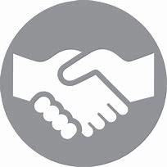  Kindness | - A fundamental kindness-based programme in school that embeds a discrete culture of kindness in an environment where kindness has not necessarily been seen, modelled or experienced. Our mantra of being ‘relentlessly reasonable’ attempts to harness that;  - Feelings of joyfulness are contagious, encouraging more kind behaviour by the giver and recipient.  - Research has determined that kindness increases our ability to form meaningful connections with others and even small acts of kindness are reported to heighten our sense of wellbeing, increase energy and give a wonderful feeling of optimism and self-worth.  - Our young people being part of projects that help others, provides them with a real sense of perspective and helps them appreciate the things in their own lives reinforcing that kindness is a key ingredient that helps children feel good.

