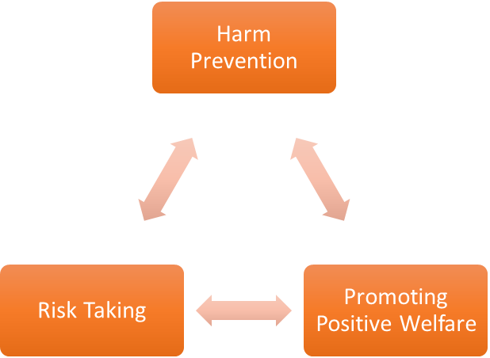
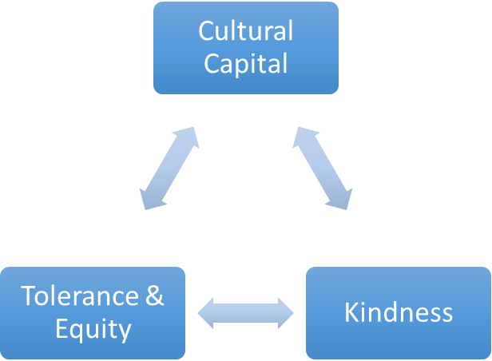
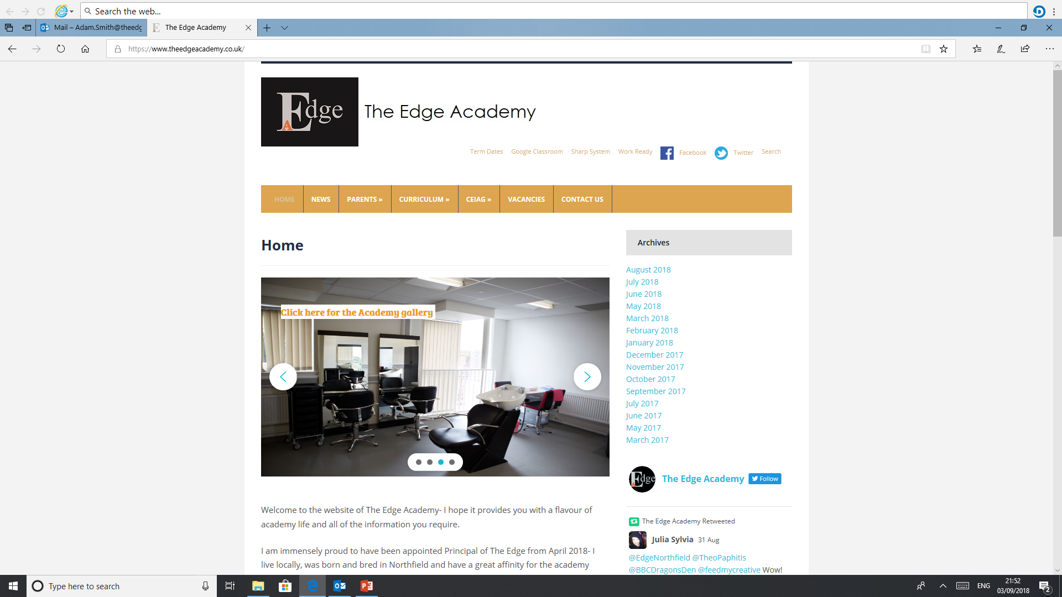
SAFE

RESPECTFUL
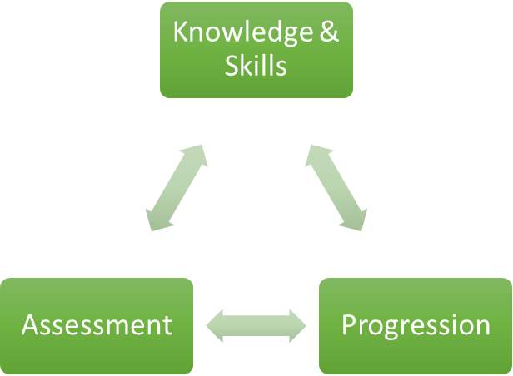

READY

Enrichment

Why is Enrichment important to our learners at The Edge Academy?
Students at the edge often arrive without having experienced the same life opportunities and skills as the average for their age, for example one year 10 student had never been on a train, through enrichment we hope to narrow this gap and provide pupils with the opportunity to experience a wide range of life skills.

How can Enrichment support our learners to be SAFE?
Through a carefully selected and engineered enrichment curriculum we provide opportunities for pupils to experience different cultural and local amenities in a safe and supported way. Pupils have learnt how to behave safely in and around public transport and while using pupil leisure facilities.

How can Enrichment support our learners to be READY?
Enrichment provides opportunities for pupils to learn knew knowledge and skills which will be needed to succeed throughout life, whether this is interacting with the pupil or taking part in sporting opportunities which are available to all.

How can Enrichment support our learners to be RESPECTFUL?
Cultural capital is offered to all pupils weekly, this gives pupils the opportunity to experience local communities and events from visiting the world famous Birmingham Rag markets to exploring the many miles of Birmingham’s Canal infrastructure.

What barriers to Enrichment are there to overcome for our learners at The Edge Academy?
Pupils sometimes arrive at the edge academy lacking vital life skills which are needed to succeed in every day life, when pupils are offered these chances and experience they can become apprehensive and anxious. At the edge we help, support and guide pupils through these challenges and help them engage with local cultural capital which is on offer in their city.

What inspired your passion for Enrichment as a teacher and curriculum leader?
As I have always lived and studied locally I understand the opportunities and experiences that are on offer in the pupil’s great city. I believe that it is important for pupils to realise what is available on their ‘door step’ and how they can engage with this for the rest of their adult lives.

Where can Enrichment lead our learners to in their aspirations and lives ahead?
It does not matter what career and education aspirations pupils have they will always need the skills and knowledge taught during enrichment to thrive, whether this is learning how to use public transport or learning to communicate appropriately with the local community, these skills will help develop interpersonal skills which can be applied throughout life.

How in light of COVID-19 school closures impact, have you modified or reprioritised your subject programmes of study?
Enrichment has potentially been the most effected subject due to the COVID-19 pandemic. Government advice means that public transport options for enrichment were not available along with almost all indoor sport facilities and enrichment opportunities which the pupils have had access to before. Only one 'bubble' has had access to offsite enrichment opportunities every week with the other 'bubble' staying on site to complete activities such as board games and catering. Although all pupils have had the opportunity to access enrichment opportunities COVID-19 has severally affected this.

Our Core Purpose |  | The Edge Curriculum INTENT
Safe | Harm Prevention   | - Careful analysis of our locality, its risks to young people and the response to patterns and emerging trends identified through careful monitoring of safeguarding concerns data.  - The role and continual review of the safeguarding curriculum at the Edge comprising of Lifeskills (PSHE), daily tutor time programme, weekly assembly schedule, programme of visiting external delivery, themed days/events, awareness days events to include specifically the teaching online safety in schools and Sex and Relationships education (compulsory from 2020).
Safe | Risk Taking   | - Positive mindset development and the nurturing of calculated positive risk taking is crucial to developing a high challenge, low threat environment where all young people feel secure learners.  - The importance of challenging aspirations and realistic CEIAG are crucial tools to engagement of the wider academic offer at the Edge. This is achieved through the central offer of work-related learning opportunities to all students and immersion in post-16 learning provision events and independent guidance.
Safe |   Positive Welfare | - The preparation of our young people to manage as adults with post-school stress and demands to support young people’s mental health. The acknowledgment of relatively low-starting points of individual resilience from education experiences and the planned provision for opportunities to be successful.  - The role and continual review of the safeguarding curriculum at the Edge comprising of Lifeskills (PSHE), daily tutor time programme, weekly assembly schedule, programme of visiting external delivery, themed days/events, awareness days and events to include specifically the teaching online safety in schools and Sex and Relationships education (compulsory from 2020).
Ready | 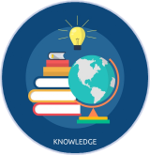  Knowledge and Skills | - Equipping our young people to have experienced threshold concepts, subject specific enrichment and key knowledge and skills in literacy and numeracy by the time they leave our school.  - An environment that cultivates the individual growth of identified knowledge and skills and through informed planning and the opportunities to apply the acquired knowledge and skills.  - Ensuring that there is depth and breadth in the Edge curriculum offer across key stages and subject sequencing to certify that we are ‘spiralling’ knowledge and skill across the years, in order to support progression.  - An effective and inspiring experience of CEIAG provision drawing on a broad diet of post-16 learner pathways, providers, effective bespoke guidance and a core offer of work related learning opportunities for all.
Ready | Assessment   | - Rigorous review and professional reflection to challenge why are we assessing young people and for what purpose to measure against realistic targets.  - Accountability at classroom and subject levels for how do you use the assessment, what methods do we use to assess, how assessments are linked to personal improvement feedback and then subsequently how do such assessments impact on future teaching and learning.
Ready |   Progression | - Harnessing and building real value in the significant underpinning factors of literacy and reading to all progression and sequencing this as a core value of our provision.  - Creating and sharing information to inform teachers and students themselves to know that progress is taking place for all learners in all subjects  - Recognition and acknowledgement that progress may not be the same for all abilities and groups but is supportive a truly individualised pathway to achievement built on the concept of equity. Where FAIR does not mean everyone gets the same thing, but FAIR at the Edge means everyone gets what they need to be successful in the classroom.
Respectful | Cultural Capital   | - The Edge Pledge – experience is not less, it is more. Education is bigger than schooling. The promise to deliver or provide that is focussed, definite and our guarantee.  - Strategically mapped and sequenced model of educational of visits in response to student council input and identified gaps in individuals’ life experiences. Central to this is the evolution to offer a high-quality two-hour enrichment session every Friday afternoon featuring a variety of “small group” on-site and off-site activities to support the holistic curriculum offer.  - Planning and provision in all our subject areas and from all adult roles to enhance the life experience and opportunities for our young people.  - The high-profile celebration for our young people of their local area, heritage and identity and to embrace and recognise what does it mean to be a ‘Brummie’.
Respectful | Tolerance & Equity   | - Teaching kindness and compassion at The Edge, not only fosters the positive behaviour that creates warm and inclusive school environments, but helps children feel that they belong, leading to reduced bullying.  - Collaborative mapped provision with other agencies and voluntary organisations to enhance community cohesion.  - Recognition of the value of family learning opportunities and embracing individual differences through culture and faith.  - Fostering empathy to build trust, with trust comes respect. There is genuine power in kindness, compassion and patience. For many learners, kindness may the one true trait that they look for in a teacher.
Respectful |   Kindness | - A fundamental kindness-based programme in school that embeds a discrete culture of kindness in an environment where kindness has not necessarily been seen, modelled or experienced. Our mantra of being ‘relentlessly reasonable’ attempts to harness that;  - Feelings of joyfulness are contagious, encouraging more kind behaviour by the giver and recipient.  - Research has determined that kindness increases our ability to form meaningful connections with others and even small acts of kindness are reported to heighten our sense of wellbeing, increase energy and give a wonderful feeling of optimism and self-worth.  - Our young people being part of projects that help others, provides them with a real sense of perspective and helps them appreciate the things in their own lives reinforcing that kindness is a key ingredient that helps children feel good.

