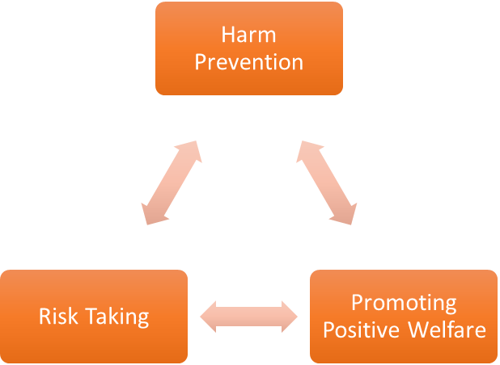
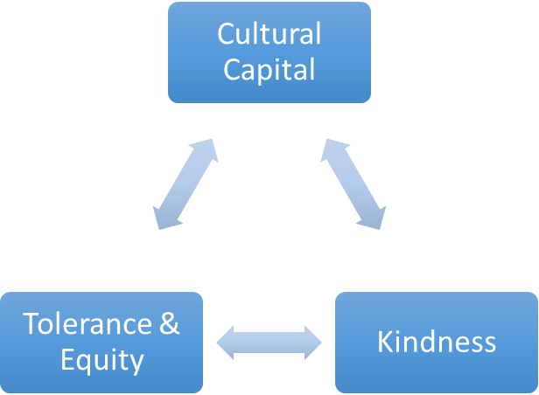
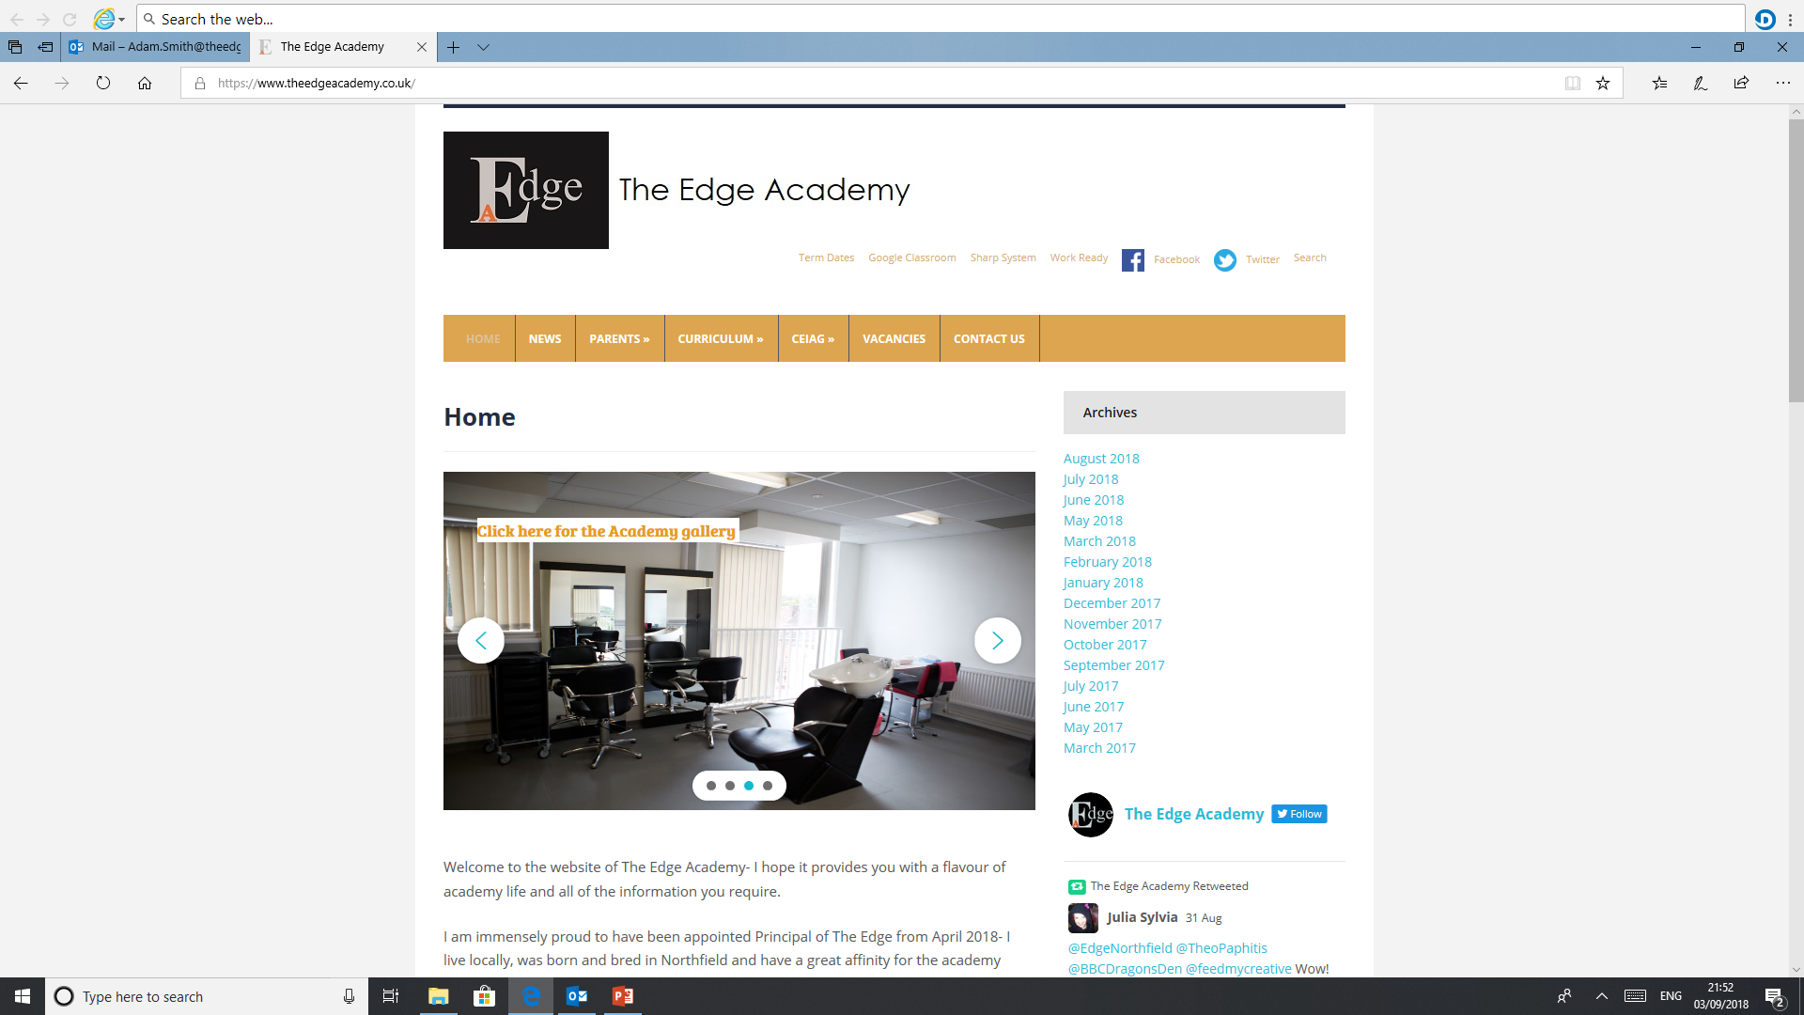
SAFE

RESPECTFUL
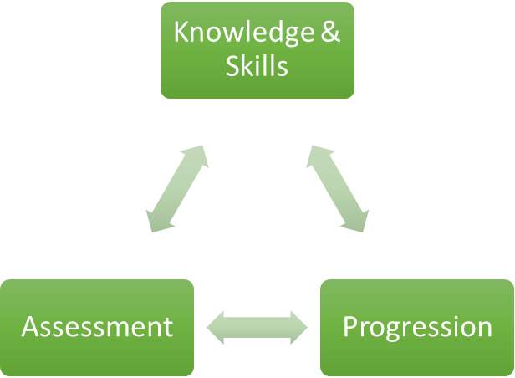

READY

Catering

Why is Catering important to our learners at The Edge Academy?
- To help individuals recognise that food is a basic requirement of life and should be enjoyed.
- To help individuals develop an understanding of the underlying scientific principles upon which current issues in nutrition are based.
- To inform about methods of food production and processing in domestic and commercial situations.
- To encourage an awareness of social, economic and cultural aspects of food choice.
- To gain various certificates and qualification.
- To inspire students about careers within food.

How can Catering support our learners to be SAFE?
There are a number of hazards for students in the kitchen that can be avoided when good practices are instilled in them. From understanding the dangers of sharp knives to the importance of thoroughly cleaning surfaces, teaching students culinary skills can help keep them safe when they are in the kitchen.

How can Catering support our learners to be READY?
Healthy eating and nutrition: based on The Eatwell Guide; in line with current government healthy eating guidelines.
Food provenance: reflect current UK farming and food production processes; recognise different views; if global food production/processing is highlighted, state location; acknowledge UK quality assurance standards/marks; give range of views when defining and discussing sustainability;
Food preparation: promote acquisition of food skills; encourage high food safety and hygiene standards; apply healthy eating knowledge; use a range of food commodities; reflect cultural and ethnic diversity, being mindful of different dietary needs; use current legislation and guidance in relation to food labelling
Food choice: acknowledge that there are a range of factors; include behavioural aspects; consider portion/serving size and pupil age;
Healthy lifestyles: promote healthy lifestyles more generally; reflect UK guidelines on physical activity recommendations; show that being active every day should be the norm.

How can Catering support our learners to be RESPECTFUL?
Catering lessons teach our students not only how to be respectful to their bodies, through healthy eating and exercise but also how to learn about various diets, as some people may have a medical condition or have different cultural or religious beliefs and they may follow specific dietary customs, and may exclude or prepare food in a particular way.

What barriers to Catering are there to overcome for our learners at The Edge Academy?
Many of our students have gaps in their learning and developmental delay, therefore they have not had the opportunities to develop their skills through role-play. Students can often become over stimulated and are unaware of the dangers or hazards within the kitchen. Some students require extra support to develop skills before they can participate as independent learners.
Another barrier to overcome would be to help improve the confidence and self-esteem in our students to overcome any anxiety or fears they may have in relation to working as a team or with other students in general. Some students may understand the theory side of food preparation and nutrition but might not grasp the skill to present it in their practical work so encouraging them can help improve practical ability.

Why do we follow the current course/examination board with our learners at The Edge Academy?
WJEC offer a Food and Nutrition qualification at GCSE level, this qualification is best suited to the current Edge students as it offers a range of assessments. These assessments offer a varied approach which enable all students to be successful.

What inspired your passion for Catering as a teacher and curriculum leader?
My passion first started watching my mother cook in the kitchen as a child and I realised that some students don’t get the same privilege that I did. So if I could provide that support and teach them things that I was taught it could help them lead good nutritional lifestyles and make the correct food choices which improves mental, physical and financial ability to A. know the importance of a home cooked meal and how much it can save you financially compared to a fast food restaurant and by giving them the correct diet improve their mental ability to succeed in life.

Where can Catering lead our learners to in their aspirations and lives ahead?
It stipulates a gateway to a potentially fulfilling career in food and preparation and provides knowledge they can pass on to their own children later in life.

How in light of COVID-19 school closures impact, have you modified or reprioritised your subject programmes of study?

The logistics of class numbers within the practical cooking area has required groups to be split within each of the single groups to create a carousel format to support a split group model or theory and practical offer within the same lesson. There has been a intentional curriculum rearrangement leading to an increase in the theory element of the course to offset the impact of COVID-19 restrictions upon the practical activities due to social distancing, handling of equipment and ingredients and sanitisation routines.
The remote learning offer has had a key focus upon health and safety and hygiene theory.
Students who have not been able to access practical lessons from home due to not being in school have been able to request ingredients and instructions to be delivered to their home address to enable them to still be part of learning.
Online cookery masterclass events have encouraged students to participate in ‘cook-a-long’ session with live or pre-recorded recipes.

Our Core Purpose |  | The Edge Curriculum INTENT
Safe | Harm Prevention   | - Careful analysis of our locality, its risks to young people and the response to patterns and emerging trends identified through careful monitoring of safeguarding concerns data.  - The role and continual review of the safeguarding curriculum at the Edge comprising of Lifeskills (PSHE), daily tutor time programme, weekly assembly schedule, programme of visiting external delivery, themed days/events, awareness days events to include specifically the teaching online safety in schools and Sex and Relationships education (compulsory from 2020).
Safe | Risk Taking   | - Positive mindset development and the nurturing of calculated positive risk taking is crucial to developing a high challenge, low threat environment where all young people feel secure learners.  - The importance of challenging aspirations and realistic CEIAG are crucial tools to engagement of the wider academic offer at the Edge. This is achieved through the central offer of work-related learning opportunities to all students and immersion in post-16 learning provision events and independent guidance.
Safe |   Positive Welfare | - The preparation of our young people to manage as adults with post-school stress and demands to support young people’s mental health. The acknowledgment of relatively low-starting points of individual resilience from education experiences and the planned provision for opportunities to be successful.  - The role and continual review of the safeguarding curriculum at the Edge comprising of Lifeskills (PSHE), daily tutor time programme, weekly assembly schedule, programme of visiting external delivery, themed days/events, awareness days and events to include specifically the teaching online safety in schools and Sex and Relationships education (compulsory from 2020).
Ready |   Knowledge and Skills | - Equipping our young people to have experienced threshold concepts, subject specific enrichment and key knowledge and skills in literacy and numeracy by the time they leave our school.  - An environment that cultivates the individual growth of identified knowledge and skills and through informed planning and the opportunities to apply the acquired knowledge and skills.  - Ensuring that there is depth and breadth in the Edge curriculum offer across key stages and subject sequencing to certify that we are ‘spiralling’ knowledge and skill across the years, in order to support progression.  - An effective and inspiring experience of CEIAG provision drawing on a broad diet of post-16 learner pathways, providers, effective bespoke guidance and a core offer of work related learning opportunities for all.
Ready | Assessment   | - Rigorous review and professional reflection to challenge why are we assessing young people and for what purpose to measure against realistic targets.  - Accountability at classroom and subject levels for how do you use the assessment, what methods do we use to assess, how assessments are linked to personal improvement feedback and then subsequently how do such assessments impact on future teaching and learning.
Ready |   Progression | - Harnessing and building real value in the significant underpinning factors of literacy and reading to all progression and sequencing this as a core value of our provision.  - Creating and sharing information to inform teachers and students themselves to know that progress is taking place for all learners in all subjects  - Recognition and acknowledgement that progress may not be the same for all abilities and groups but is supportive a truly individualised pathway to achievement built on the concept of equity. Where FAIR does not mean everyone gets the same thing, but FAIR at the Edge means everyone gets what they need to be successful in the classroom.
Respectful | Cultural Capital   | - The Edge Pledge – experience is not less, it is more. Education is bigger than schooling. The promise to deliver or provide that is focussed, definite and our guarantee.  - Strategically mapped and sequenced model of educational of visits in response to student council input and identified gaps in individuals’ life experiences. Central to this is the evolution to offer a high-quality two-hour enrichment session every Friday afternoon featuring a variety of “small group” on-site and off-site activities to support the holistic curriculum offer.  - Planning and provision in all our subject areas and from all adult roles to enhance the life experience and opportunities for our young people.  - The high-profile celebration for our young people of their local area, heritage and identity and to embrace and recognise what does it mean to be a ‘Brummie’.
Respectful | Tolerance & Equity   | - Teaching kindness and compassion at The Edge, not only fosters the positive behaviour that creates warm and inclusive school environments, but helps children feel that they belong, leading to reduced bullying.  - Collaborative mapped provision with other agencies and voluntary organisations to enhance community cohesion.  - Recognition of the value of family learning opportunities and embracing individual differences through culture and faith.  - Fostering empathy to build trust, with trust comes respect. There is genuine power in kindness, compassion and patience. For many learners, kindness may the one true trait that they look for in a teacher.
Respectful |   Kindness | - A fundamental kindness-based programme in school that embeds a discrete culture of kindness in an environment where kindness has not necessarily been seen, modelled or experienced. Our mantra of being ‘relentlessly reasonable’ attempts to harness that;  - Feelings of joyfulness are contagious, encouraging more kind behaviour by the giver and recipient.  - Research has determined that kindness increases our ability to form meaningful connections with others and even small acts of kindness are reported to heighten our sense of wellbeing, increase energy and give a wonderful feeling of optimism and self-worth.  - Our young people being part of projects that help others, provides them with a real sense of perspective and helps them appreciate the things in their own lives reinforcing that kindness is a key ingredient that helps children feel good.

