Introduction to Virtual Tutor Time Sessions
Dear Parent/Carer,
As part of the next phase of expanding our remote learning programme, next week (week beginning Monday 1st February) we are starting our Microsoft Teams journey with a virtual meeting for each class. It will be a chance for students choosing to work from home to catch up with their form tutor and other students who are at home. In the meeting they will begin to learn how Microsoft Teams works and have a chance to talk to their peers and form tutor about their home learning.
We are going to start by trialling this with group 10A and Helen McClane on Wednesday 3rd February at 12pm.
The meetings after that will take place on the following days:
Year group | Date and time | Form Tutor
Edge A | Monday at 12pm | Charlotte Poynton
Edge B | Tuesday at 12pm | Calum Hill
10A | Wednesday at 12pm | Helen McClane
10B | Thursday at 12pm | Ryan Taylor
11A | Friday at 12pm | Claire Fairburn

The following instructions will enable your child to access their email and to then in turn receive an email invite to a Teams meeting with a member of staff (a webcam is required for the pupil to be seen, and a microphone for them to be heard however neither of these functions are necessary - they can still join the meeting)

- To access OUTLOOK email, please search GOOGLE.CO.UK with the following words OUTLOOK MAIL LOGIN

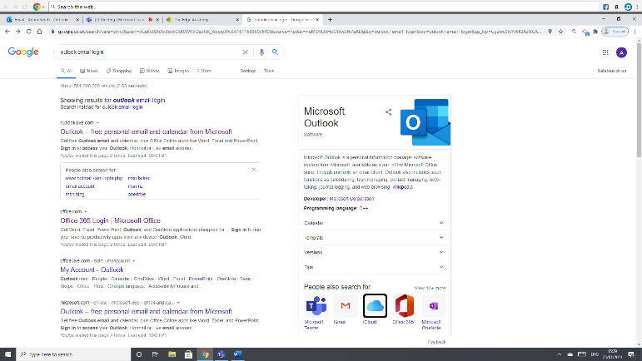

- Then select the first link ‘Outlook – free personal email and calendar with Microsoft’
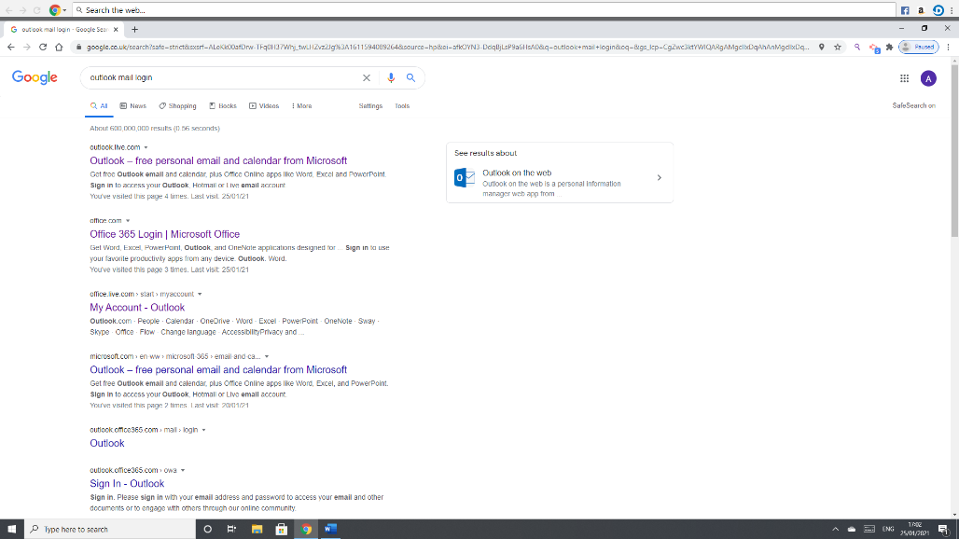

- Then click on SIGN IN at the top right-hand side of the screen
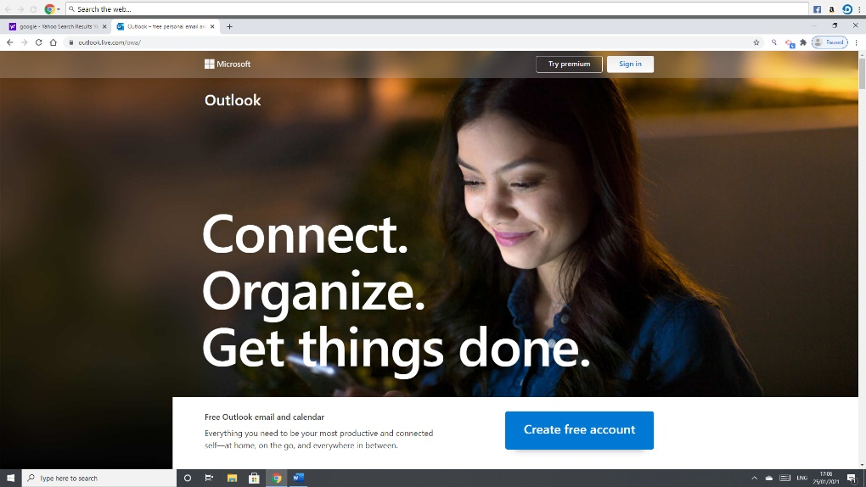

- Your child will then need to log in with their username and password.
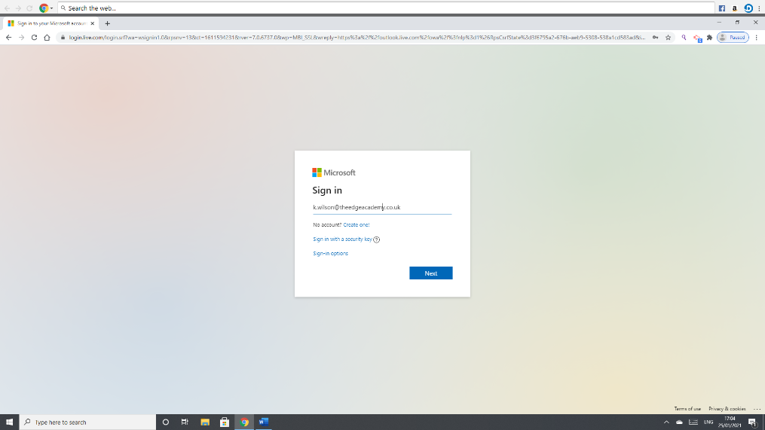
- Their USERNAME is included in this letter pack.

- Their PASSWORD is included in this letter pack.

- If there is any problem with your child logging in, please contact the school reception who can support and advise you.

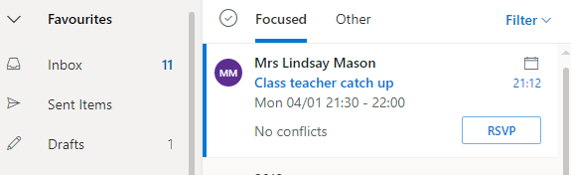
- Once logged in, your child will then need to check for an email from staff inviting them to a meeting.

- To join the meeting, open the email, and look for the ‘Click here to join meeting’ link to click on when the meeting is due to start. Your child will then be entered into a meeting with a member of staff and any other invited children.

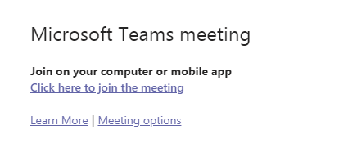

- The meeting can then be opened in the app if you have it on your device, but you don’t need it – the meeting can be opened in the browser instead.

- On the day, once you are into Microsoft Teams you will be waiting in the lobby until a teacher lets you into the meeting.

- You can complete the steps above ahead of the meeting and check your child can access their emails, has received the email and can open Teams. However, you will not be admitted into the meeting until the date and time at the start of this document.

The Edge Academy Microsoft Teams agreement
Before you join the meeting, please ensure you have read and agree to follow these guidelines:

- Be respectful at all times
- During the meeting, please act in the same way you would if you were in a classroom – it is an extension of school.
- If you can be seen, but someone else is talking, please do not distract from what they are saying.
- Make sure that everything you type or say is true, helpful and kind.
- Be patient, you may have to wait until it is your turn

If the above is not adhered to, a teacher will remove a student from the meeting.

If you are planning on using a camera, please ensure there is nothing in view that may cause offence to others, or that you do not wish to be seen.

We request that pupils are supervised at home during the meeting. They will most probably need assistance if they haven’t used Teams before.

During the meeting

Students will only be able to unmute with permission from the teacher. At points in the meeting, the students will be asked if they wish to contribute. There are two ways they can do this – by speaking or using the meeting chat. At the bottom of your child’s screen there will be a menu that looks like this:

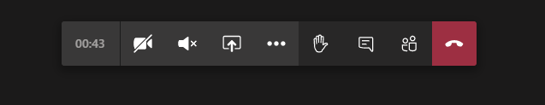
By clicking this icon, you can turn your camera on and off.
By clicking this icon, you can unmute and mute (turn your ability to talk on and off). You have to be given permission by the teacher to unmute.
At points in the meeting, students can indicate they wish to be given permission to unmute by raising their virtual hand.
By clicking this icon, students can raise their virtual hand and show the teacher they wish to say something.
The teacher will announce when they have given permission for a student to unmute.
Many children may do this at the same time so students will need to be patient and listen to other pupils first.
Click this icon to open the Meeting chat. Students can type in messages that the teacher and other pupil can see.

We understand that many people may not have used Microsoft Teams before, so I just want to thank you in advance for having a go at accessing a meeting for your child at home. If you have any questions at all regarding anything in this letter or around IT generally, please contact me at adam.smith@theedgeacademy.co.uk
Yours faithfully,
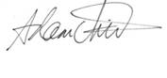

Adam Smith
Vice Principal

