
GCSE Result Update August 2020

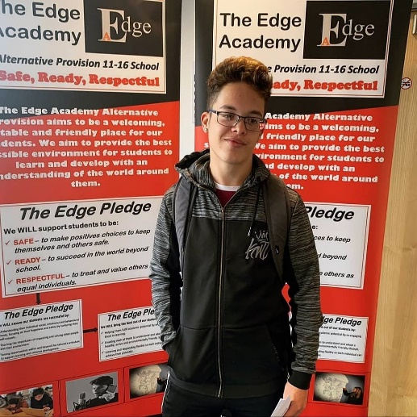

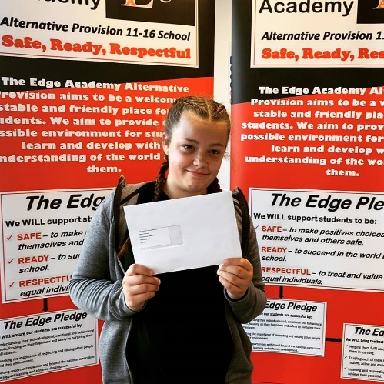
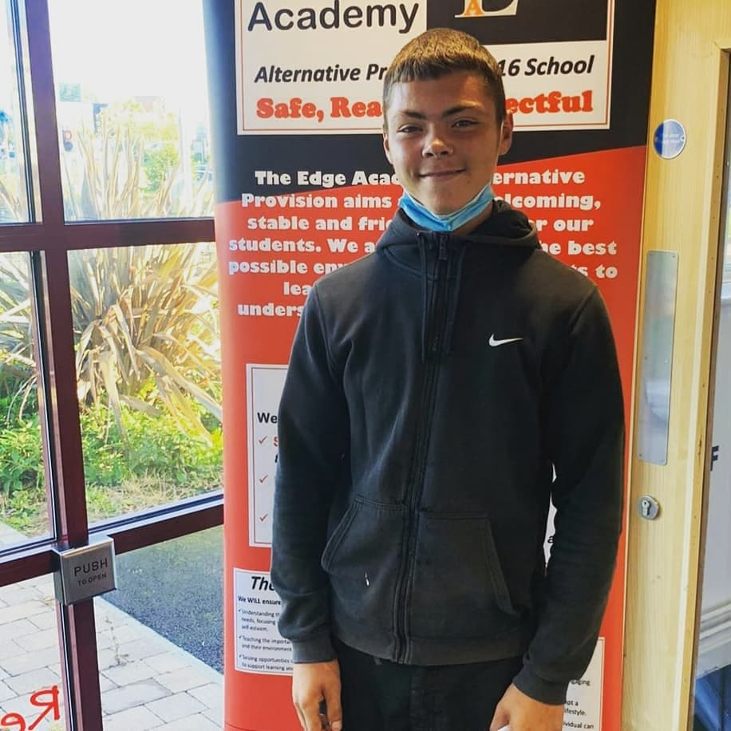
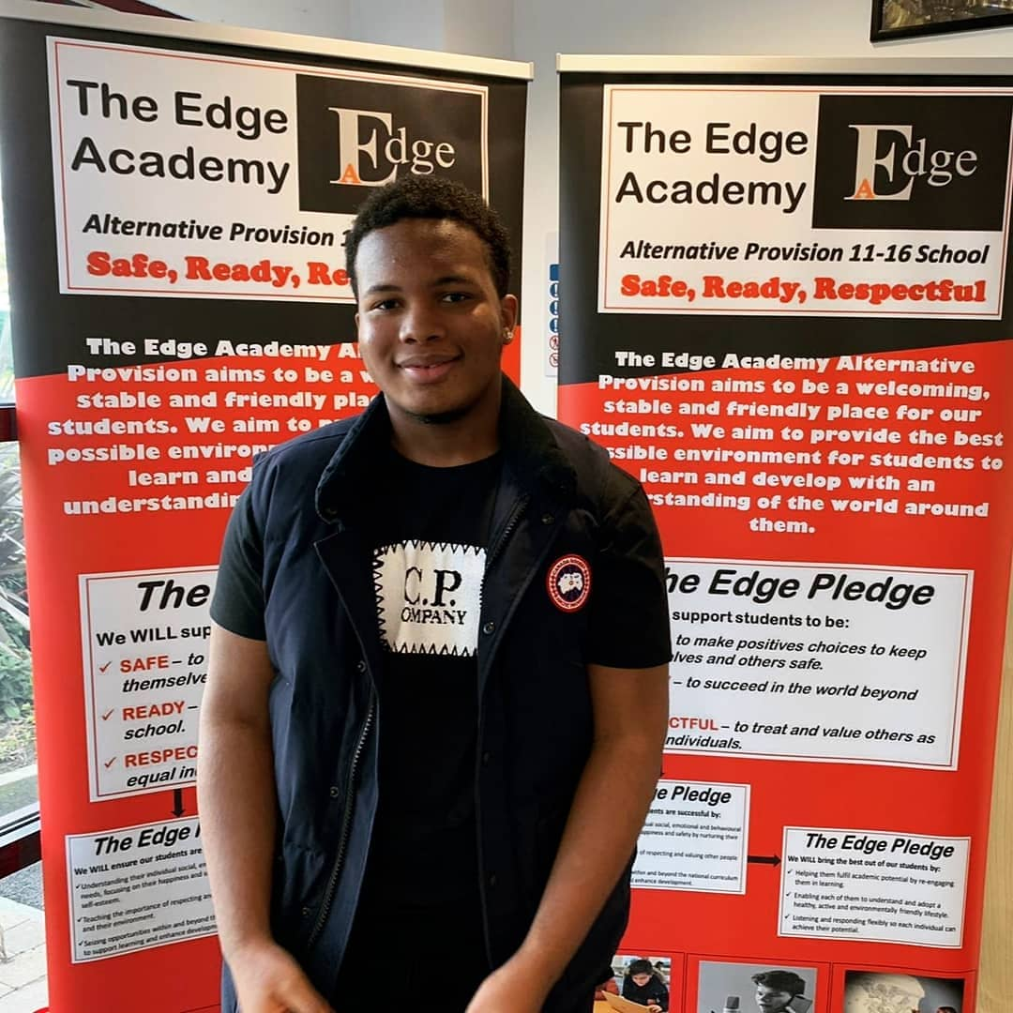


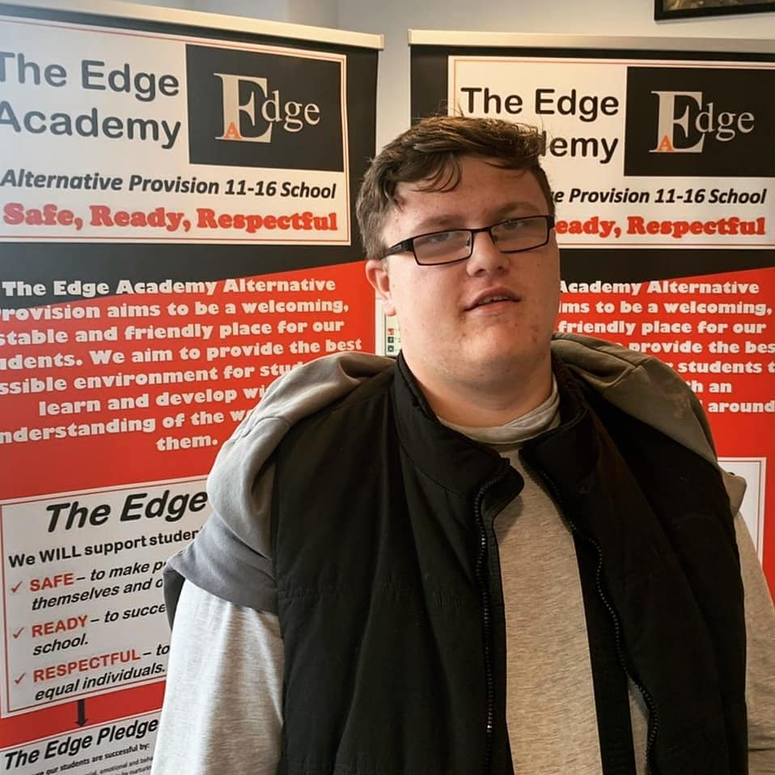
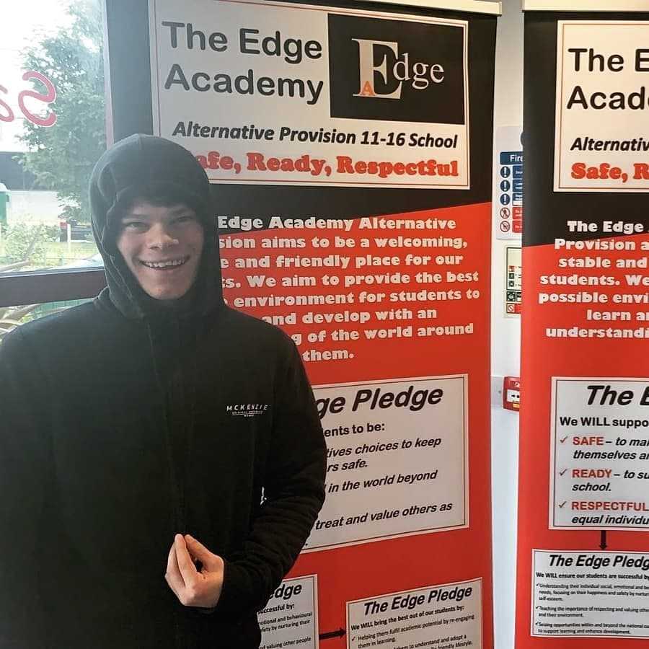

Dear Parent/ Carer,
Amongst all of the difficulties caused by the Coronavirus outbreak, I am delighted to write to you with positive news of the GCSE Results achieved by our departing Year 11 students today. This will no doubt be a huge relief to students and families given the level of media coverage this set of results has received in recent days.
Our initial analysis of the results show that we have continued what is a now a three-year upward trend of sustained improvement and that:
- The results are once again the best the school has ever achieved since it opened in 2015, both in terms of attainment and progress.
- For the first time ever, the majority of all Year 11 students achieved 5 Level 2 qualifications, passed with the highest percentage of grades at Grades 4 and 5 and above since the school opened.
- 100% of all Year 11 students achieved a Level 2 qualification in English and Maths.
- All Year 11 students who were entered for option subjects of Art and Food achieved a Level 2 qualification.
- The broadening of our “Safe, Ready, Respectful” curriculum in 2019/20 led to 81% of all Year 11 students achieving a Level 2 qualification in Science, and to Level 2 qualifications also being achieved in a more diverse range of subjects, including Religious Education, History, I Media, Health and Social Care and Graphics.
- Our highest ever number of Year 10 students now have qualifications banked as they prepare to start Year 11, with all students who were entered having already achieved a Level 2 qualification in Biology.
- One of our students has achieved the best ever individual performance since the school opened, passing 9 Level 2 qualifications, all at Grade 4 or above.
I would like to particularly congratulate Year 11 students on their achievements and it is important that they congratulate themselves in the same way that any other year group would do outside of a global crisis. “Centre assessed grades” were arrived at following a rigorous moderation and rank ordering process and students must never feel in the future that their grades were based on estimates or that they are worth less than those of students in previous years.
Those of you familiar with The Edge will be aware that our departing Year 11 students have been without a doubt the most committed set of Year 11 students we have ever had the pleasure to teach. As the academy has changed in recent years, they have been leaders in setting a positive example to other students in all aspects of school life, and it is no surprise to us that every single one of them has now also secured further education or employment placements for September.
In addition, I would like to pay tribute to our team of staff for the continued manner in which they have transformed the Edge in recent years- the “phenomenal change” highlighted in our OFSTED visit of 2019/20 has only been made possible through their hard work and it is a joy to work with them all.
Finally, a heartfelt thank you to families and the wider community for all of the support we receive from you- we will continue to be a welcoming, friendly and stable place for our students and will continue to support you all through the next phases of the pandemic. Please contact me directly at andrew.wakefield@theedgeacademy.co.uk if there is anything else we can be doing at present to help and support.
Yours faithfully,

Andrew Wakefield
Principal

