
Multiplication Rules (Learn these!)
+ve x +ve = +ve
+ve x -ve = -ve
-ve x -ve = +ve
(Show full working out for the following questions)

Multiplication:
-4 x 5 =
-7 x -7 =
-8 x -3 =
-9 x 9 =
0 x -4 =
12 x 11 =
11 x -11 =
(-3)² =
(-5)³ =
8 x 7 =
Long Multiplication:
56 x 103 =

14 x 7026 =

9 x 12 =

2 x 817924 =

15. 17 x 29 =

Division:
-12 ÷ 3 =
48 ÷ 6 =
121 ÷ -11 =
-132 ÷ -12 =
100 ÷ 25 =
Long Division:
323 ÷ 19 =

1064 ÷ 14 =

8829 ÷ 9 =

224 ÷ 14 =

156 ÷ 13 =

1
2

3
4
Factors and Multiples:
List all the prime factors of 42.

By either factor tree or division methods, find the prime factorisation of these numbers:

63 b. 70

Find the highest common factor (HCF) of 8 and 12.

Find the first five multiples of 6.

Find the lowest common multiple (LCM) of 15 and 20.

Trains leave one of the platforms at a railway station every 15 minutes.
On a different platform trains leave every 2 minutes.
Given that a train leaves both of these platforms at 8:10am, what is the next time when these trains will depart both platforms at the same moment?

Rearranging Equations
Rearrange the equations to make the variable in the brackets the subject and simplify where possible (Show your working on a separate sheet and write yours answers below):
3x + y = 4 (y)

7a - 2b = 3c (a)

3/2k = 9p (k)

21x = 7y (y)

1/5g + 4/5h = 2/5i (i)

x² + y² = 4 (x)

√r = 7s (r)

√a = 4b + 5 (a)

y³ = x³ (y)

j(k + 2) = m (k)

x^{1/2} = 3y² (x)

Solving Equations (Linear)
Solve the following equations to find x:
2x -5 = 3

3x + 1 = x + 7

2(2x - 3) = x - 3

3x + 5 = 5
4

3(x + 1) = 2 + 4(2- x)

A solution of x³ - x = 50 lies between 3 and 4. Use the method of trial and improvement to solve the equation and give your answer to 1 decimal place.

A rectangle and triangle have the same perimeter. Form an equation and solve it to find the value of x.

5
Factorising Quadratics
Factorise the following quadratic equations:
x² +5x + 4

x² + 10x + 21

x² + x - 2

x² - 9

x² - 144

x² + x - 12

Straight Line Graphs (Show your working on a separate sheet and write yours answers below)

A linear graph crosses the y axis at + 7 and has a gradient of 3. Write down the equation of the line.

Write down the equation of the line that is parallel to the line y = 4x + 7 and passes through the point (0, 5).

Find the equation of the line that passes through the points (3, 6) and (10, 20).

Find the equation of the line that passes through the points (8, 12) and (14, 15).

Find the equation of the line that passes through the points (-31, 23) and (-11, -7).

Line A is perpendicular to Line B.
Line B has the equation y = 2x + 1.
The points (-1, 6) lies on Line A.
Find the equation of Line A.

6
5
2x
6
3x
3x
7
Simultaneous Equations
Solve the following equations to find the coordinates of where the lines intersect:
x + y = 7
x - y = 3

3x + y = 16
4x + 10y = 4

3. 2x + 6y = 12
10y - 3x = 15

4. y = 8x + 1
y = 2x - 5

8
Sketch the two straight lines and label them (show x and y intercepts and where they intersect).
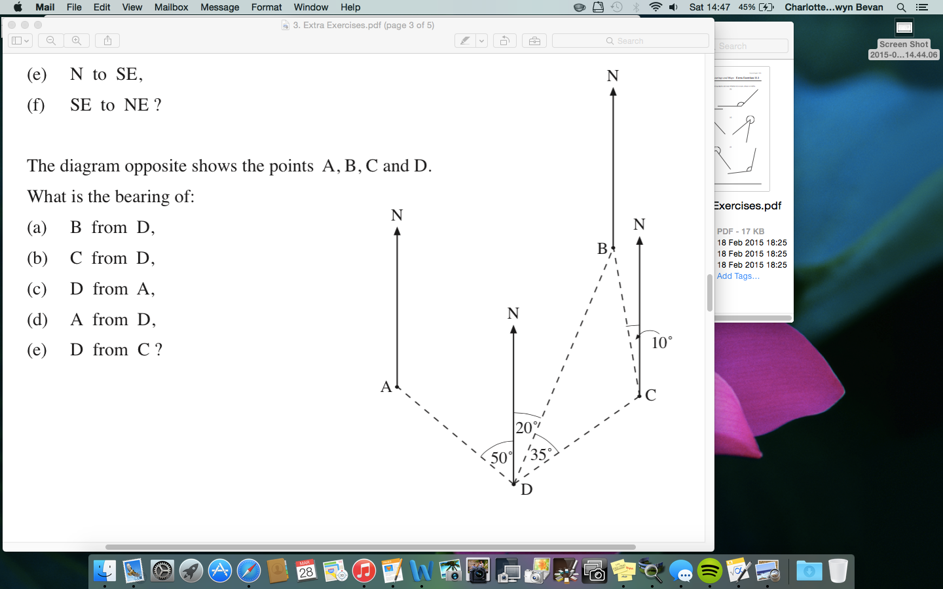
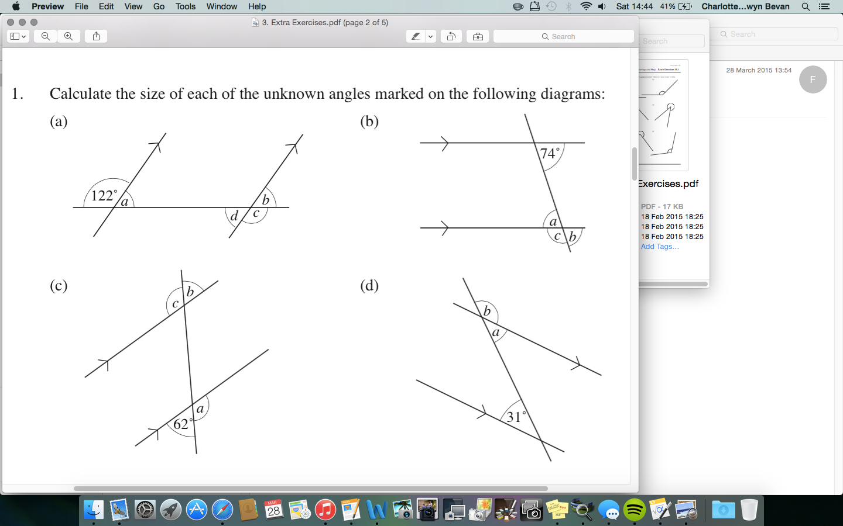
9
10
Bearings

1.

2. Eleanor flies her plane from Jersey to Plymouth on a bearing of 314 °. On what bearing should she fly back to Jersey?

Angles

a.
b.
c.
d.
Pythagoras’ Theorem

1. Calculate the lengths of the sides labelled x to 3 significant figures.

a.

b.

c.

d. Calculate the area of the following isosceles triangle

5
9
x
4
5
x
5
x
13
9 cm
9 cm
8 cm
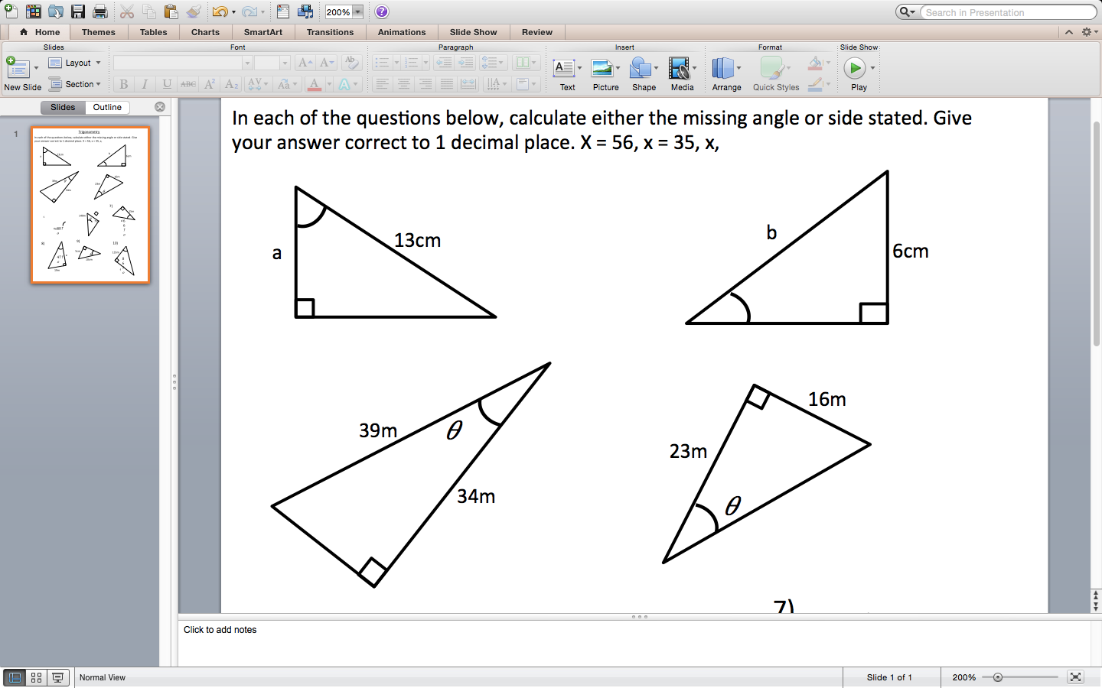
Trigonometry
Find x to 3 significant figures:

a.

b.

c.

d.

Rounding (Decimal Places and Significant Figures)
Round to the number of decimal places indicated in the brackets:
1.732 (1 dp)

10.059 (2 dp)

3.99 ( 1 dp)

21.45486 (3 dp)

7.099 ( 2 dp)

Round to the number of significant figures indicated in the brackets:

6. 1009 (3 sf)

7. 45.728 (3 sf)

8. 95 (1 sf)

9. 0.000335 (2 sf)

10. 0.074188 (3 sf)

11. 9.992 (3 sf)

12. 3784221 (4sf)

Dealing With Negative Numbers
Work out the following:

(2) x (-1) x (-3) x (-4)

(3) x (-1) x (-4) x (-2)
-6

(-2)³ x (-1)²
(-4)

a.
b.
c.
d.
x
x
11
12
56°
35°
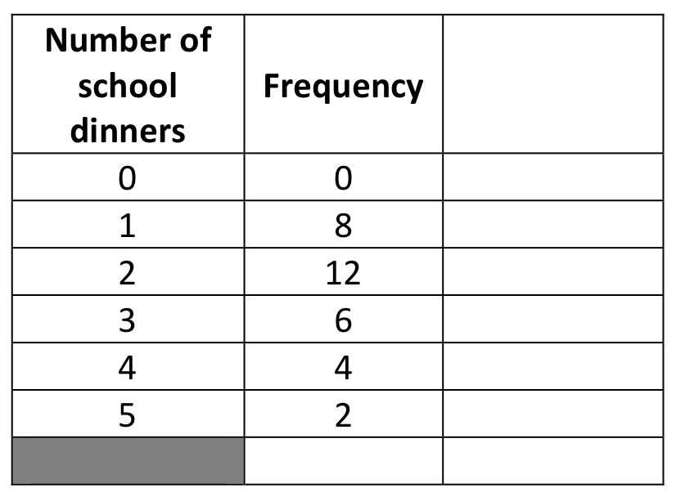
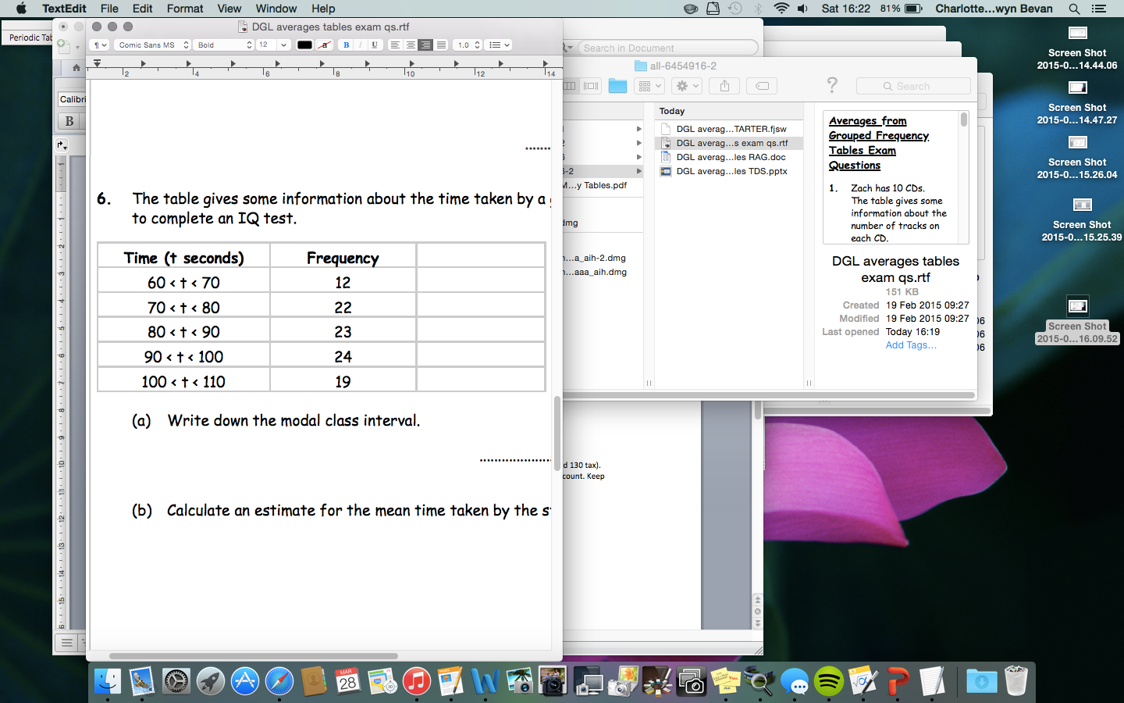
Standard Form
Put the following into standard form:
38.562

94663

0.000275

4.5

100

586.01

0.0571

Averages
1. a. Put these numbers in a stem and leaf diagram and include a key.
35, 67, 43, 59, 53, 31, 60, 45, 55, 39, 48, 53, 40, 49

b. Calculate the mean median, mode and range.

13
14
2. Beth carried out a survey of the number of school dinners students had in one week. The table shows this information. Copy and complete the table.
a. Write down the mode.
b. How many students were there altogether?
c. How many school dinners were served during the week?

d. Calculate the mean number of school dinners .

e. Calculate the median number of school dinners.

3. The table gives some information about the time taken by a group of 100 students to complete an IQ test.

a. Write down the modal class interval.
.....................................................
b. Calculate an estimate for the mean time taken by the students.

................... seconds

(x)
(f)
xf

