Algebra
- Factorising and multiplying out brackets – page 2
- Graphs – page 3
- Indices – page 5
- Simplifying and rearranging equations – page 6
- Solving equations – page 7
- Exam questions – page 8

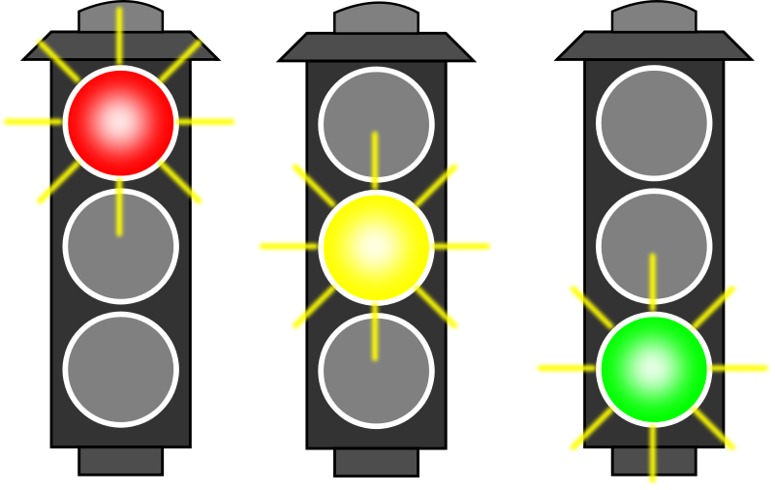
Factorising and multiplying out brackets

Expand and simplify the following brackets
- 3(x + y)
- 6(3x + 4)
- –(2x - 3)
- –(3x + 2)
- (x+2)(x+3)
- (2x+1)(x+2)
Factorise the following
- 4x + 8
- 6y – 9
- 7b – 14a
- xy - x
Expand and simplify
- -4(2x + 5)
- -7(3x – 4)
- 4(-3x – 3)
- – 5( -2x + 3)
- (3x + 2)(x + 4)
- (5x + 2)(6x + 7)
Factorise the following
- 6x² + 2
- 5x² – x
- 9x² – 3x
- a²b + ab²
- x² + 4x + 3
- x² + 4x + 4
Expand and simplify
- 12x – 3y – 2(4x + y)
- 14x + 8y – 6(6x – 2y)
- 7x – 3y –(5x + 2y)
- 12x + 3y – (4x – 2y)
- (5x + 3) ²
- (6x -2) ²
Factorise the following
- x² + 2x – 3
- x² + 2x –8
- x² - 10x + 24
- m² – n²
- 2x² + 9x + 4

Graphs
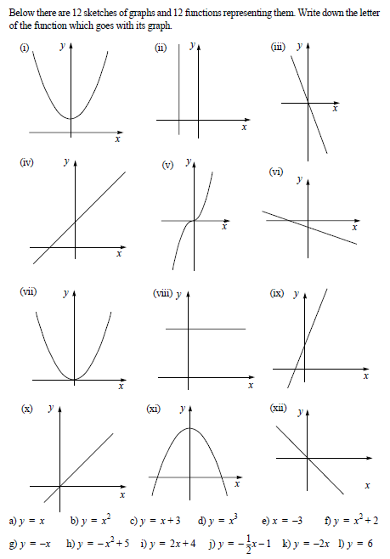

Draw a table with x values from -3 to 3 for these curves and then plot the values on a graph.
- Y = x
- Y = 2x + 3
- Y = x² + 2x – 3
- Y = x³ -2x + 2
- Y = 2x² – 4x - 3

- What is the equation of the line parallel to y = x which goes through the point (3,0)?
- What is the equation of the line parallel to y = 2x which goes through the point (5,0)?
- What is the equation of the line parallel to y = 3x + 2 which goes through the point (0,0)?
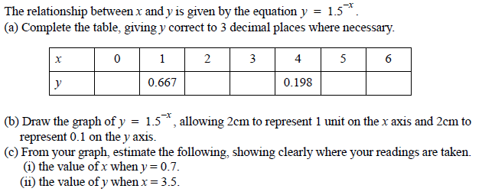
- What is the equation of the line parallel to y = -x -6 which goes through the point (0,2)?

Indices

Write down the value of the following
- 3²
- 3³
- 3⁴
- 3⁵
- 10²
- 10⁰
Simplify the following
- y² x y³
- y⁵ x y⁶
- a⁴ / a²
- a² / a²
Simplify
- (a⁶)⁴
- (x³)⁶
- a²y² x a²
- a³b³ x a²
- (3x)²
- (2x)³
- 3y² x 4
- 5a³ x a⁴
- 6y² x 4y³
- 24a⁴ / 6a²
- 18b⁷ / 3b
- 12a³b² / 3ab
Simplify
- x⁹ / x⁹
- a⁵ / a⁷
- 20y³ / 10y⁴
- 4b³ / 8b⁵
- y² x y⁻³
- 2y² x 3y⁻⁵
- b⁰ x b^{1/2}
- y^{1/2} x y^{-1/2}
- (x^{1/2})³
- (a^{1/4})²
- 25^{1/2}
- 8^{1/3}

Simplifying and Rearranging expressions
Simplify the following expressions
- x + 3x + 4 + 3
- 5a + 2a + 8 + 6
- 2x – 6x
- -4y + 3y
- 6x – x + 5 + 2
- 9a – 7a + 7 – 4
- x – 2y – 3x + 4y
- 5a – 2b – 8b + 6a
- xy + 3xy
- 4cd + 7c – 2cd
- uv – v² + u² – uv – u
- 7ab² – 7a²b + a²b – 4ab²
Make the letter in brackets the subject
- v = u + at (u)
- v = u + at (a)
- d = 3b – c (b)
- c = pd + w (w)
- x = 7y – z (z)
- a = 3b + c (b)
- w = (4v + u)/3 (v)
- x = (5y + b)/4 (b)
- 2x = x + b (b)
- 6y = 3a – 2y (a)
- P = (1/2)a + 3b (a)
- w= 2v + (1/4)u (v)
Make the letter in brackets the subject

- a = b²/c (b)
- x = y/z² (z)
- c = 4a²/b (a)
- 3v = 9/u² (u)
- 1/2x = (2/3)x + y (y)
- 3/4y – 2x = y (y)
- 7/2x = ½(x + y) (x)
- 4/9b = (1/3)(b – 3c) (b)
- 1/x = 1/a + 1/b (x)
- 2/(3x) = 2/y + 3/z (x)
- 1/√x = (1/2)a + (1/3)b (x)
- 2/√x = 3/(2y) + b/2 (x)

Solving equations
Solve the following equations
- x + 4 = 6
- x + 7 = 17
- x – 2 = 4
- y – 7 = 11
- 12a = 36
- 6x = 42
- 7b = - 35
- 4y = - 24
- 4a + 2 = 10
- 9a + 6 = 33
- 7x – 3 = 18
- 12x – 7 = 17

Solve the following equations
- x + 3 = 2x
- 6x – 5 = 5x
- 3x + 6 = 5x
- 8x + 5 = 10x
- 4x + 2 = 2x
- 4x + 4 = - 12
- x + 7 = 2x – 2
- 6x – 12 = 3x + 12
- 5x – 2 = 2x + 4
- 2(x + 1) = 8
- 3(x – 1) = 9
- 5(x + 2) = 15

Solve the following equations
- x/4 = 30
- (2/3)x = 8
- 3/(x + 2) = 1
- 2x + 3 = 3x + 2
- 5(x + 3) = 7x + 5
- 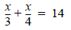
- 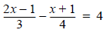
- 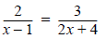
- x² - 25 = 0
- x² – 3x – 10 = 0

Algebra Exam Questions
Jun 12 paper 1
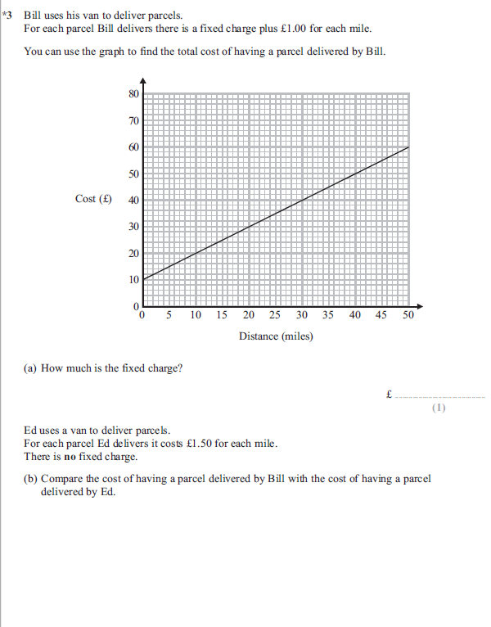

Jun 12 Paper 1
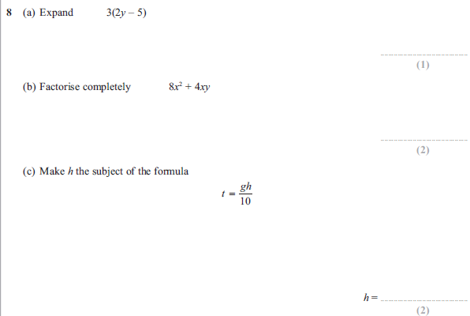
Jun 12 paper 1
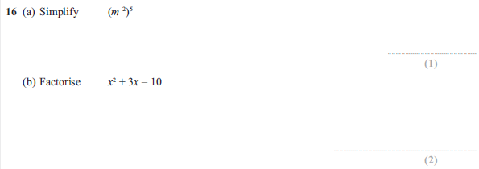

Jun 12 paper 1
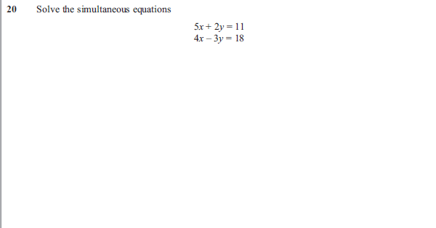
Jun 12 paper 1
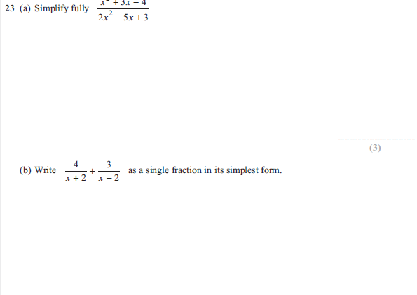

Jun 12 paper 1
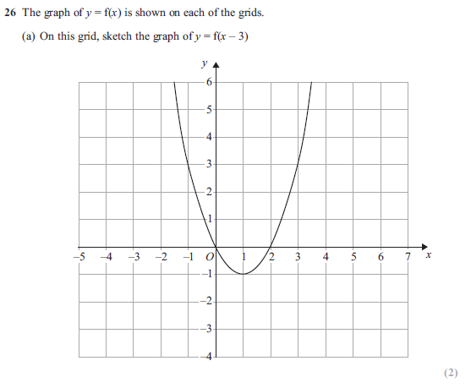
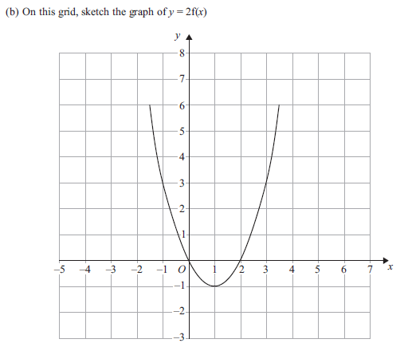

Jun 12 paper 2
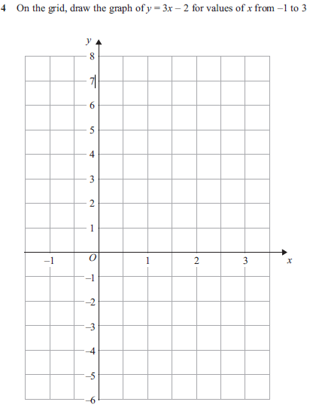

Jun 12 paper 2
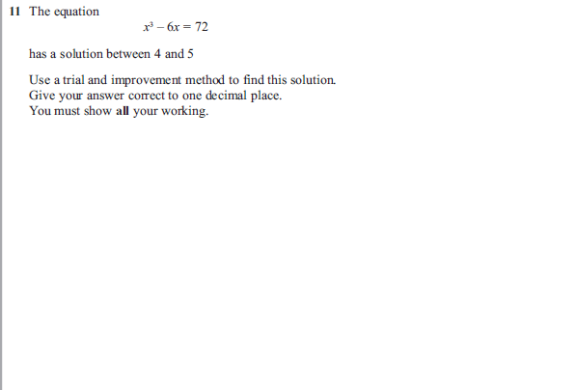

Jun 12 paper 2
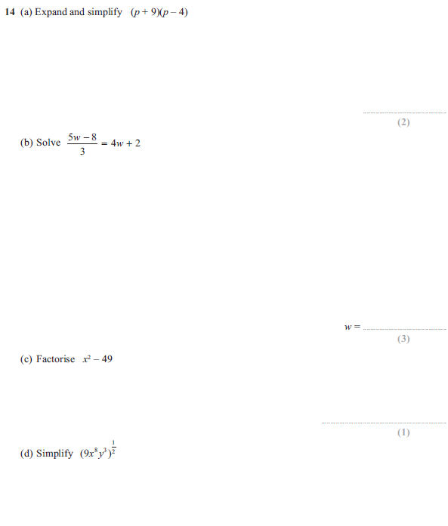

Jun 12 paper 2
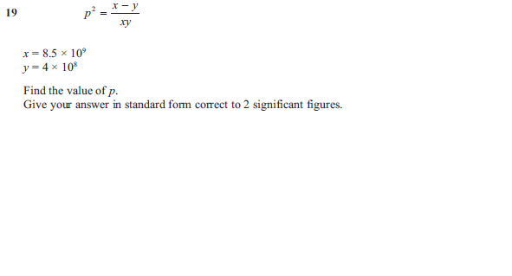
Jun 12 paper 2
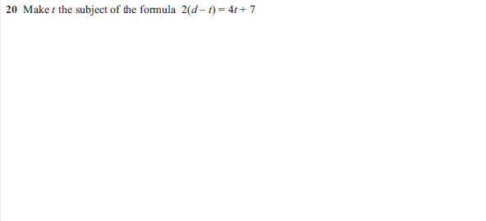

Jun 12 paper 2
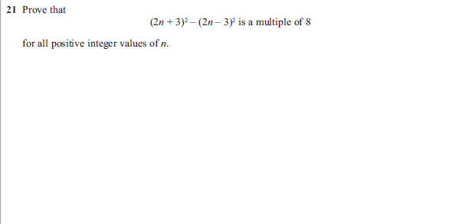
Jun 12 paper 2
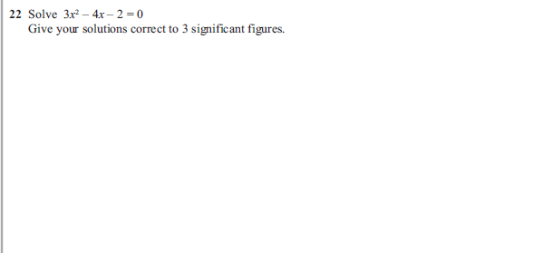

Nov 12 paper 1
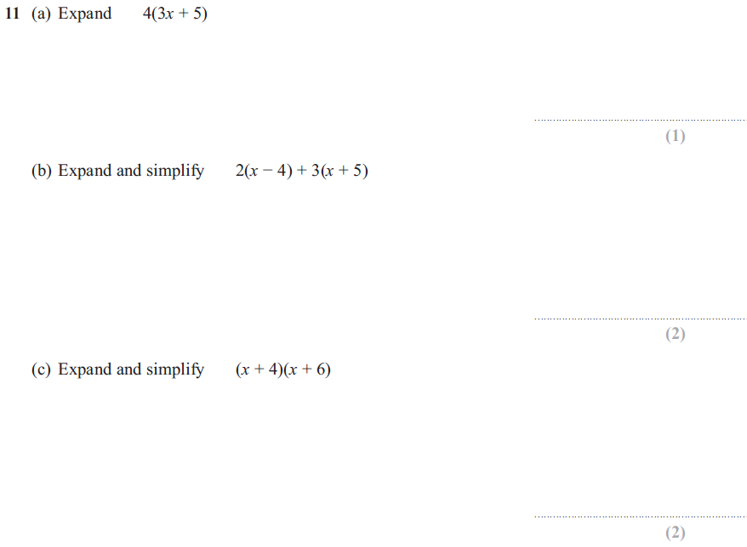
Nov 12 paper 1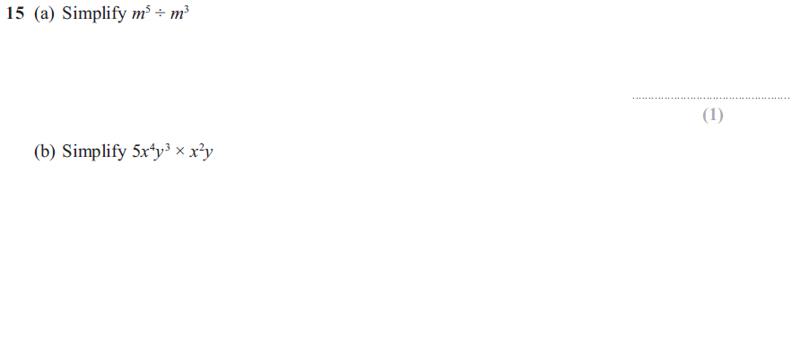
Nov 12 paper 1


