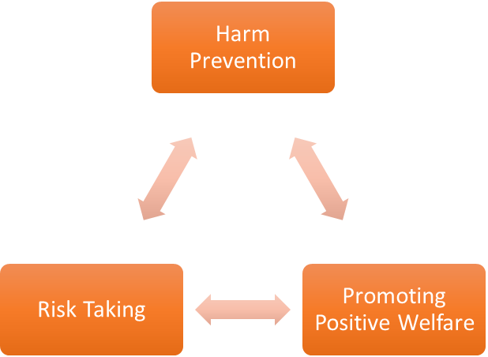
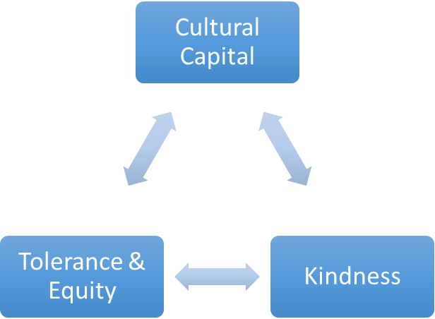
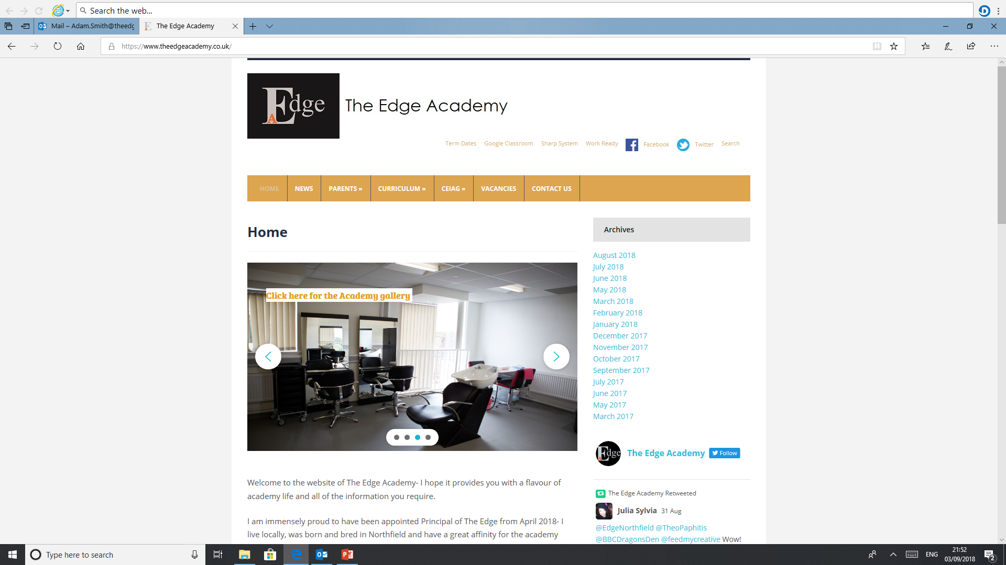
SAFE

RESPECTFUL
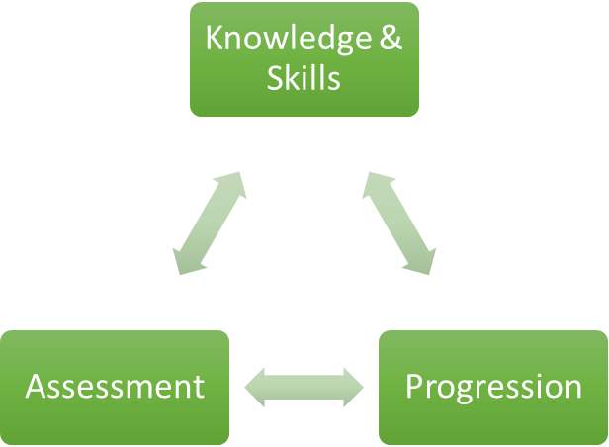

READY

Maths

Why is Maths important to our learners at The Edge Academy?
Learners usually arrive to The Edge Academy with gaps in knowledge, this is important to function in society and complete everyday tasks others may take for granted, for example, telling the time, budgeting for when they live independently, calculating change from a shop, calculating area to decorate and many more. These basic skills are needed for young adults to function in society and live successful and meaningful lives.

How can Maths support our learners to be SAFE?
Pupils are encouraged to try something new maths they have never done before, this may be something simple for example, a curriculum enrichment trip or it may be demonstrating a new skill they have learnt in front of other learners on the white board. Pupils will learn mathematical theories and principles and relate these to every day live pushing pupils outside their ‘comfort zone’ and achieving something new.

How can Maths support our learners to be READY?
Maths uses a spiral curriculum to revisit and reinforce the learning of topics throughout all years, this is tracked using a subject specific tracking sheet which not only highlights what pupils have achieved but also provides a visual key to show what they need to learn. Assessment during maths happens periodically and uses both online and written test papers, this is not the only way pupils are assessed the evidence they produce in their books can also be used to keep track of pupil’s progress.

How can Maths support our learners to be RESPECTFUL?
During maths lessons pupils will have the opportunity to put maths into ‘real life’, this will include curriculum enrichment opportunities to go into the local community and practise maths skills. For example, going to a park and using swings to learn about loci and visiting DIY stores to prepare students for real life whilst learning about area and volume.

What barriers to Maths are there to overcome for our learners at The Edge Academy?
Usually learners arriving at The Edge Academy have had negative experiences at mainstream school, as maths is a core lesson there is a focus/pressure in mainstream school for pupils to attend and achieve, this often leads learners to have negative views of core subjects. Due to the usual negative views learners often arrive with ‘gaps in their knowledge they need to learn or relearn.

Why do we follow the current Maths course/examination board with our learners at The Edge Academy?
AQA have worded questions in a more ‘user friendly’ way and offer multiple choice questions for AO1 in order for pupils to settle into the exam. EDEXCEL assess their GCSE using more worded questions which can confuse pupils; therefore, learners find the AQA exam more accessible and suited towards their needs.

What inspired your passion for Maths as a teacher and curriculum leader?
Whilst studying at university I found I was using Maths more than I thought I would for my course, I found this enjoyable and realised that maths could be interesting and fun if it was delivered in the right way. While I was completing my dissertation, I was assigned a tutor that would explain the mathematical processes to me and a easy to understand way I enjoyed, it was at this point I would pick maths to be my second subject when I continued my education onto my PGCE.

Where can Maths lead our learners to in their aspirations and lives ahead?
Maths is used everywhere, and is needed to function in society, pupils will be able to; tell the time with both a digital and analogue clock, be able to calculate prices of items in shops and change they will be given, be able to calculate the area and perimeter of shapes and use this to aid them in future life. Most job opportunities require basic maths, this is something all pupils should have by the time they leave full time education in order for them to achieve any of their aspirations.

Our Core Purpose |  | The Edge Curriculum INTENT
Safe | Harm Prevention   | - Careful analysis of our locality, its risks to young people and the response to patterns and emerging trends identified through careful monitoring of safeguarding concerns data.  - The role and continual review of the safeguarding curriculum at the Edge comprising of Lifeskills (PSHE), daily tutor time programme, weekly assembly schedule, programme of visiting external delivery, themed days/events, awareness days events to include specifically the teaching online safety in schools and Sex and Relationships education (compulsory from 2020).
Safe | Risk Taking   | - Positive mindset development and the nurturing of calculated positive risk taking is crucial to developing a high challenge, low threat environment where all young people feel secure learners.  - The importance of challenging aspirations and realistic CEIAG are crucial tools to engagement of the wider academic offer at the Edge. This is achieved through the central offer of work-related learning opportunities to all students and immersion in post-16 learning provision events and independent guidance.
Safe |   Positive Welfare | - The preparation of our young people to manage as adults with post-school stress and demands to support young people’s mental health. The acknowledgment of relatively low-starting points of individual resilience from education experiences and the planned provision for opportunities to be successful.  - The role and continual review of the safeguarding curriculum at the Edge comprising of Lifeskills (PSHE), daily tutor time programme, weekly assembly schedule, programme of visiting external delivery, themed days/events, awareness days and events to include specifically the teaching online safety in schools and Sex and Relationships education (compulsory from 2020).
Ready | 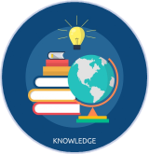  Knowledge and Skills | - Equipping our young people to have experienced threshold concepts, subject specific enrichment and key knowledge and skills in literacy and numeracy by the time they leave our school.  - An environment that cultivates the individual growth of identified knowledge and skills and through informed planning and the opportunities to apply the acquired knowledge and skills.  - Ensuring that there is depth and breadth in the Edge curriculum offer across key stages and subject sequencing to certify that we are ‘spiralling’ knowledge and skill across the years, in order to support progression.  - An effective and inspiring experience of CEIAG provision drawing on a broad diet of post-16 learner pathways, providers, effective bespoke guidance and a core offer of work related learning opportunities for all.
Ready | Assessment   | - Rigorous review and professional reflection to challenge why are we assessing young people and for what purpose to measure against realistic targets.  - Accountability at classroom and subject levels for how do you use the assessment, what methods do we use to assess, how assessments are linked to personal improvement feedback and then subsequently how do such assessments impact on future teaching and learning.
Ready |   Progression | - Harnessing and building real value in the significant underpinning factors of literacy and reading to all progression and sequencing this as a core value of our provision.  - Creating and sharing information to inform teachers and students themselves to know that progress is taking place for all learners in all subjects  - Recognition and acknowledgement that progress may not be the same for all abilities and groups but is supportive a truly individualised pathway to achievement built on the concept of equity. Where FAIR does not mean everyone gets the same thing, but FAIR at the Edge means everyone gets what they need to be successful in the classroom.
Respectful | Cultural Capital   | - The Edge Pledge – experience is not less, it is more. Education is bigger than schooling. The promise to deliver or provide that is focussed, definite and our guarantee.  - Strategically mapped and sequenced model of educational of visits in response to student council input and identified gaps in individuals’ life experiences. Central to this is the evolution to offer a high-quality two-hour enrichment session every Friday afternoon featuring a variety of “small group” on-site and off-site activities to support the holistic curriculum offer.  - Planning and provision in all our subject areas and from all adult roles to enhance the life experience and opportunities for our young people.  - The high-profile celebration for our young people of their local area, heritage and identity and to embrace and recognise what does it mean to be a ‘Brummie’.
Respectful | Tolerance & Equity   | - Teaching kindness and compassion at The Edge, not only fosters the positive behaviour that creates warm and inclusive school environments, but helps children feel that they belong, leading to reduced bullying.  - Collaborative mapped provision with other agencies and voluntary organisations to enhance community cohesion.  - Recognition of the value of family learning opportunities and embracing individual differences through culture and faith.  - Fostering empathy to build trust, with trust comes respect. There is genuine power in kindness, compassion and patience. For many learners, kindness may the one true trait that they look for in a teacher.
Respectful |   Kindness | - A fundamental kindness-based programme in school that embeds a discrete culture of kindness in an environment where kindness has not necessarily been seen, modelled or experienced. Our mantra of being ‘relentlessly reasonable’ attempts to harness that;  - Feelings of joyfulness are contagious, encouraging more kind behaviour by the giver and recipient.  - Research has determined that kindness increases our ability to form meaningful connections with others and even small acts of kindness are reported to heighten our sense of wellbeing, increase energy and give a wonderful feeling of optimism and self-worth.  - Our young people being part of projects that help others, provides them with a real sense of perspective and helps them appreciate the things in their own lives reinforcing that kindness is a key ingredient that helps children feel good.

