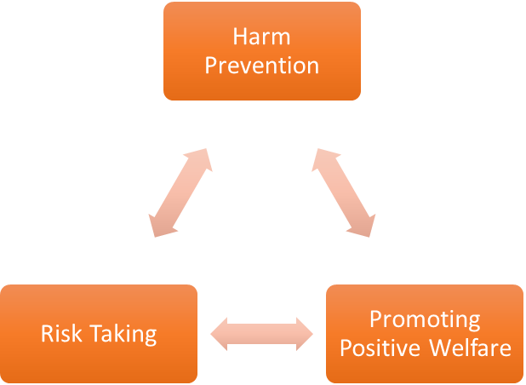
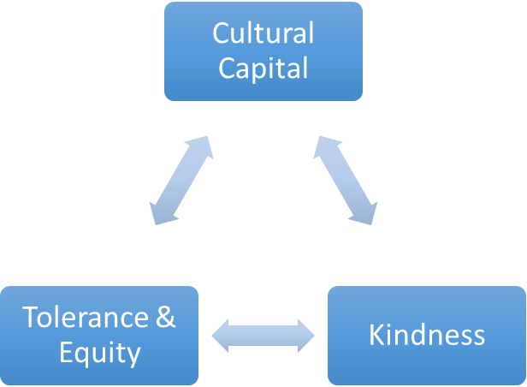
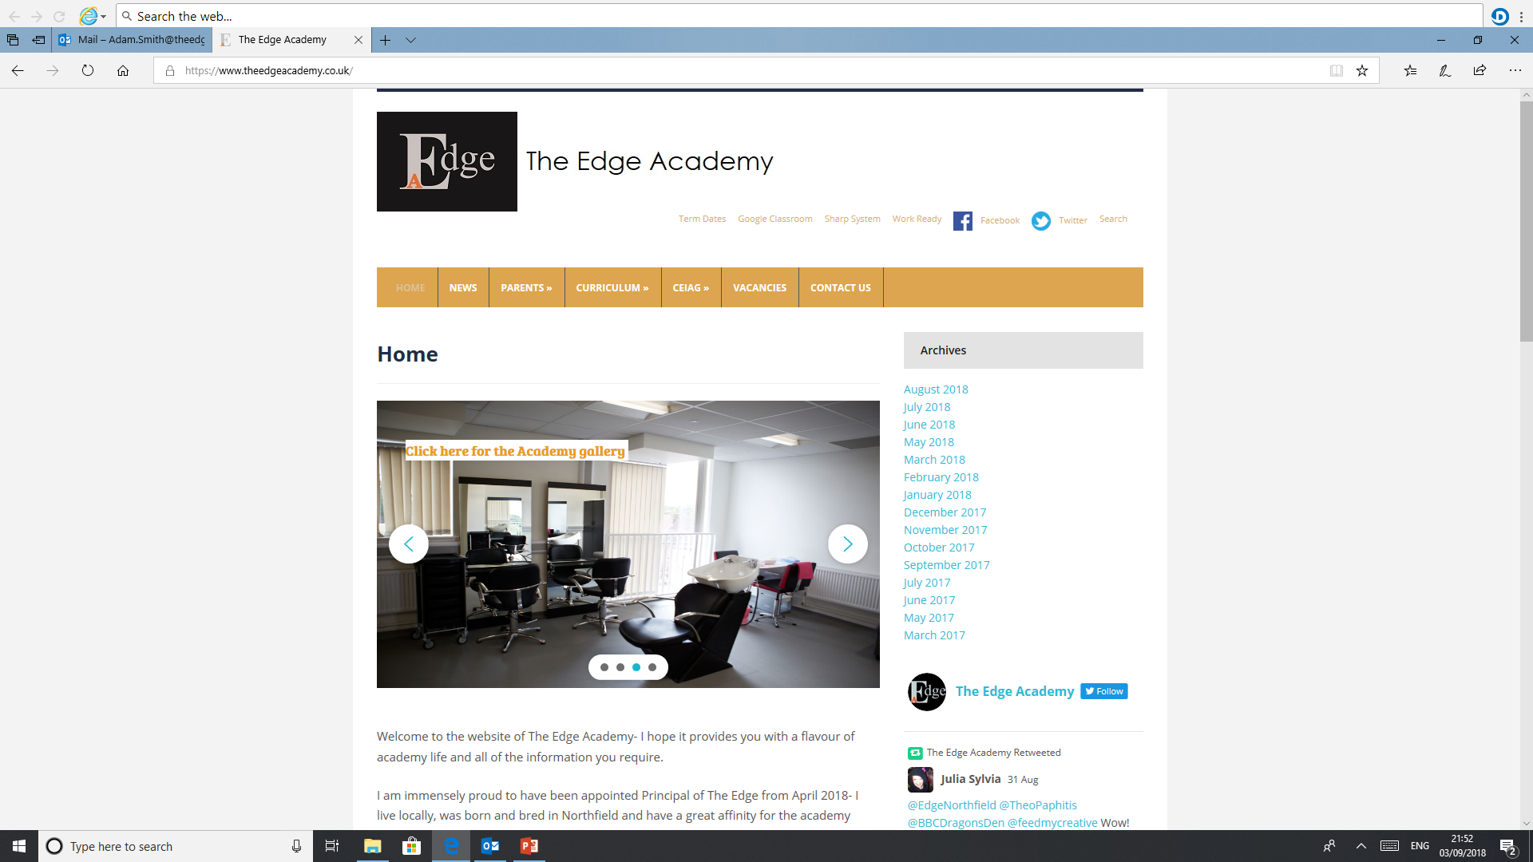
SAFE

RESPECTFUL
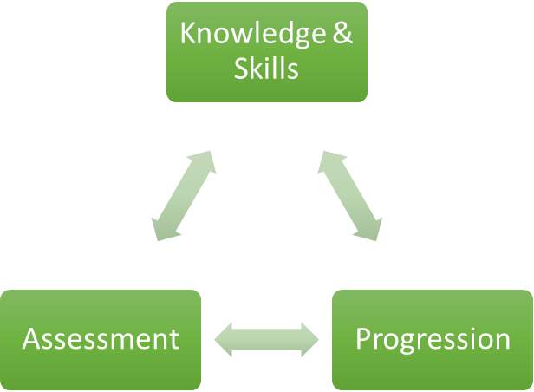

READY

English

Why is English important to our learners at The Edge Academy?
English is important to every learner because it relates to every aspect of your daily life: communicating with members of the public, family, friends or colleagues; reading recipes, instructions and bills! Writing notes, recording important information and remembering to write a card of thanks. Your basic literacy skills underpin every part of your life and it is imperative that you learn your basic spelling, punctuation and grammar!

How can English support our learners to be SAFE?
Through the Literature texts students read, they learn about risk taking and harm prevention through the scenarios discussed and by analysing characters from all genres and centuries of history. From the lives of youths on the streets in the 21st century in our capital city to Dickensian London, we evaluate the dangers, the issues and deprivation presented.

How can English support our learners to be READY?
Basic literacy skills underpin everything a student does to prepare them for the world of work or study beyond. Students must achieve a Level 4 or above to meet the standard requirements expected by the government. This in turn allows individuals to progress and flourish in their future careers, whatever that may entail!
Utilising our library on a regular basis and reading a wide range of novels will allow you to develop a passion for reading.

How can English support our learners to be RESPECTFUL?
Being kind, considerate and thoughtful are some of the adjectives to describe the qualities discussed through analysing the Literature texts studied. Students gain an awareness of the different lives of people from all walks of life. They learn to empathise and recognise that not all are treated equally and why there is a need to look after one another. British values underpin the discussions we have and the knowledge we learn.

What barriers to English are there to overcome for our learners at The Edge Academy?
Many of our students, on entry to the academy, have low levels of literacy: reading ages and poor levels of basic grammar. Therefore, barriers are immediate and many students cannot access the curriculum due to their lack of skills and feelings towards learning. This is why in every lesson students are expected to read in any form they can: learning objectives, lesson resources, textbooks or novels. Students are read to and read aloud. Furthermore, bespoke interventions are put in place for these learners to make rapid progress.

Why do we follow the current English course/examination board with our learners at The Edge Academy?
Students follow AQA English Literature and Language. The Subject Leader for English has taught this specification for over 20 years. She is an examiner for AQA and this allows her to have an excellent insight into the assessment objectives, which need to be covered. Furthermore, AQA Literature allows students the opportunity to study a range of texts from Shakespeare, pre 20th and post 20th century Literature and a range of poetry.

What inspired your passion for English as a teacher and curriculum leader?
When I went to secondary school, my favourite lesson was English. I adored reading from a young age – any book I could get my hands on! I also had an inspiring English teacher at school and English lecturer at college: they were the kindest and most caring people I had ever met. I read texts such as ’An Inspector Calls’, ‘Of Mice and Men’, ‘Animal Farm’, ‘1984’, ‘Macbeth’, ‘A Prayer for Owen Meany’,’ A Child in Time’, ‘Crime and Punishment’ and ‘The Handmaid’s Tale’ to name a few. Each one of these texts taught me a moral message and lesson for life.

Where can English lead our learners to in their aspirations and lives ahead?
English can lead you anywhere you choose. There are no limitations whatsoever.
However, if you are looking at specific professions you can become an author, a journalist, a teacher, a lexicographer, a digital copywriter, English as a foreign language teacher or a librarian. The list is actually endless – the world, as they say, is your oyster!

Our Core Purpose |  | The Edge Curriculum INTENT
Safe | Harm Prevention   | - Careful analysis of our locality, its risks to young people and the response to patterns and emerging trends identified through careful monitoring of safeguarding concerns data.  - The role and continual review of the safeguarding curriculum at the Edge comprising of Lifeskills (PSHE), daily tutor time programme, weekly assembly schedule, programme of visiting external delivery, themed days/events, awareness days events to include specifically the teaching online safety in schools and Sex and Relationships education (compulsory from 2020).
Safe | Risk Taking   | - Positive mindset development and the nurturing of calculated positive risk taking is crucial to developing a high challenge, low threat environment where all young people feel secure learners.  - The importance of challenging aspirations and realistic CEIAG are crucial tools to engagement of the wider academic offer at the Edge. This is achieved through the central offer of work-related learning opportunities to all students and immersion in post-16 learning provision events and independent guidance.
Safe |   Positive Welfare | - The preparation of our young people to manage as adults with post-school stress and demands to support young people’s mental health. The acknowledgment of relatively low-starting points of individual resilience from education experiences and the planned provision for opportunities to be successful.  - The role and continual review of the safeguarding curriculum at the Edge comprising of Lifeskills (PSHE), daily tutor time programme, weekly assembly schedule, programme of visiting external delivery, themed days/events, awareness days and events to include specifically the teaching online safety in schools and Sex and Relationships education (compulsory from 2020).
Ready | 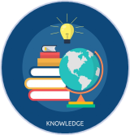  Knowledge and Skills | - Equipping our young people to have experienced threshold concepts, subject specific enrichment and key knowledge and skills in literacy and numeracy by the time they leave our school.  - An environment that cultivates the individual growth of identified knowledge and skills and through informed planning and the opportunities to apply the acquired knowledge and skills.  - Ensuring that there is depth and breadth in the Edge curriculum offer across key stages and subject sequencing to certify that we are ‘spiralling’ knowledge and skill across the years, in order to support progression.  - An effective and inspiring experience of CEIAG provision drawing on a broad diet of post-16 learner pathways, providers, effective bespoke guidance and a core offer of work related learning opportunities for all.
Ready | Assessment   | - Rigorous review and professional reflection to challenge why are we assessing young people and for what purpose to measure against realistic targets.  - Accountability at classroom and subject levels for how do you use the assessment, what methods do we use to assess, how assessments are linked to personal improvement feedback and then subsequently how do such assessments impact on future teaching and learning.
Ready |   Progression | - Harnessing and building real value in the significant underpinning factors of literacy and reading to all progression and sequencing this as a core value of our provision.  - Creating and sharing information to inform teachers and students themselves to know that progress is taking place for all learners in all subjects  - Recognition and acknowledgement that progress may not be the same for all abilities and groups but is supportive a truly individualised pathway to achievement built on the concept of equity. Where FAIR does not mean everyone gets the same thing, but FAIR at the Edge means everyone gets what they need to be successful in the classroom.
Respectful | Cultural Capital   | - The Edge Pledge – experience is not less, it is more. Education is bigger than schooling. The promise to deliver or provide that is focussed, definite and our guarantee.  - Strategically mapped and sequenced model of educational of visits in response to student council input and identified gaps in individuals’ life experiences. Central to this is the evolution to offer a high-quality two-hour enrichment session every Friday afternoon featuring a variety of “small group” on-site and off-site activities to support the holistic curriculum offer.  - Planning and provision in all our subject areas and from all adult roles to enhance the life experience and opportunities for our young people.  - The high-profile celebration for our young people of their local area, heritage and identity and to embrace and recognise what does it mean to be a ‘Brummie’.
Respectful | Tolerance & Equity   | - Teaching kindness and compassion at The Edge, not only fosters the positive behaviour that creates warm and inclusive school environments, but helps children feel that they belong, leading to reduced bullying.  - Collaborative mapped provision with other agencies and voluntary organisations to enhance community cohesion.  - Recognition of the value of family learning opportunities and embracing individual differences through culture and faith.  - Fostering empathy to build trust, with trust comes respect. There is genuine power in kindness, compassion and patience. For many learners, kindness may the one true trait that they look for in a teacher.
Respectful |   Kindness | - A fundamental kindness-based programme in school that embeds a discrete culture of kindness in an environment where kindness has not necessarily been seen, modelled or experienced. Our mantra of being ‘relentlessly reasonable’ attempts to harness that;  - Feelings of joyfulness are contagious, encouraging more kind behaviour by the giver and recipient.  - Research has determined that kindness increases our ability to form meaningful connections with others and even small acts of kindness are reported to heighten our sense of wellbeing, increase energy and give a wonderful feeling of optimism and self-worth.  - Our young people being part of projects that help others, provides them with a real sense of perspective and helps them appreciate the things in their own lives reinforcing that kindness is a key ingredient that helps children feel good.

