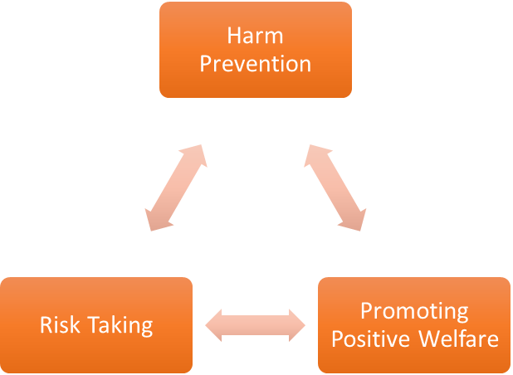
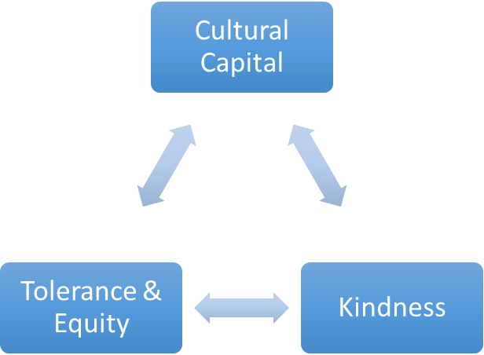
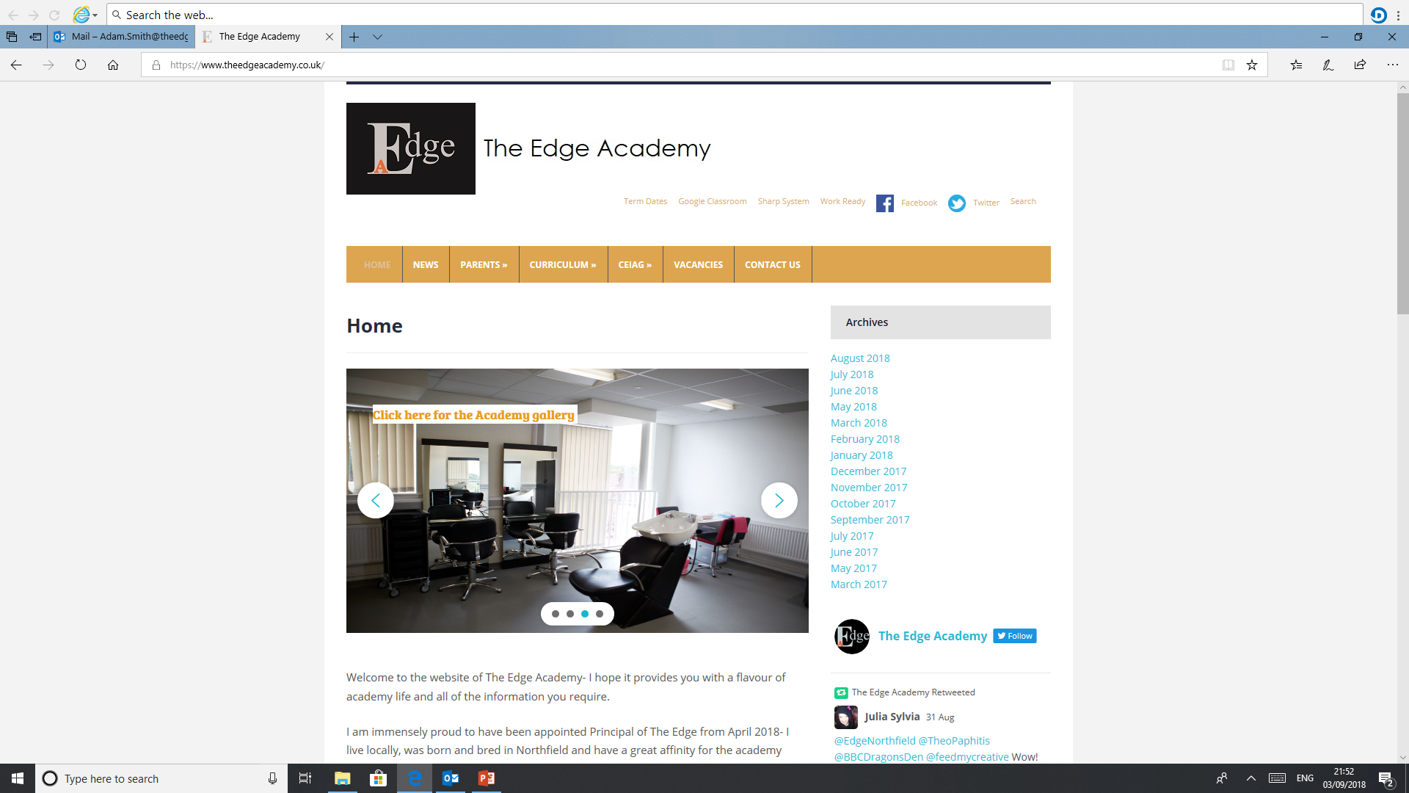
SAFE

RESPECTFUL
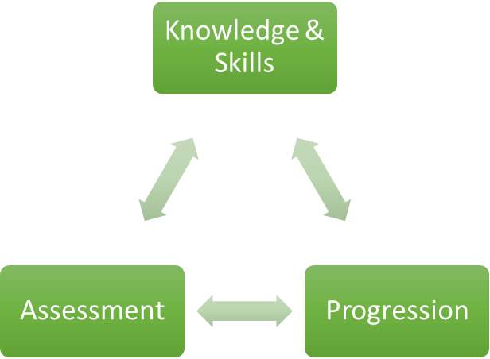

READY

Catering

Why is Catering important to our learners at The Edge Academy?
Catering provides our students with important life skills and makes them more self-aware of healthy living and budgeting. Catering offers those students who are not academically able a subject which they can excel in, as well as gaining a GCSE.

How can Catering support our learners to be SAFE?
Catering develops our student’s knowledge and awareness of safety within the kitchen, as well as how to be aware of basic food hygiene: cleaning, cross-contamination, chilling and cooking.

How can Catering support our learners to be READY?
Nutrition is one of the single most important factors when it comes to a child’s development. Proper nutrition is essential for children to succeed in school. By feeding children a proper diet and helping them to build the skills to prepare and cook, we are helping them to be able to function properly in school in addition to fostering their growing mind and bodies.

How can Catering support our learners to be RESPECTFUL?
Catering lessons help our students have more awareness of how to be respectful to their bodies, through healthy eating and exercise.

What barriers to Catering are there to overcome for our learners at The Edge Academy?
Many of our students have gaps in their learning and developmental delay, therefore they have not had the opportunities to develop their skills through role-play. Students can often become over stimulated and are unaware of the dangers or hazards within the kitchen. Some students require extra support to develop skills before they can participate as independent learners.

Why do we follow the current course/examination board with our learners at The Edge Academy?
WJEC offer a Food and Nutrition qualification at GCSE level, this qualification is best suited to the current Edge students as it offers a range of assessments. These assessments offer a varied approach which enable all students to be successful.

What inspired your passion for Catering as a teacher and curriculum leader?
Firstly, I love cooking and more importantly, I love eating food. Cooking healthy food should be enjoyable and make students aware that food that tastes good does not have to come from McDonalds or KFC. Students should be given the opportunities to learn about what food helps them function and promotes a positive and well-balanced lifestyle.

Where can Catering lead our learners to in their aspirations and lives ahead?
Catering offers vocational pathways post 16 – life skills, money budgeting, finance awareness and preparing young people for meal planning.

Our Core Purpose |  | The Edge Curriculum INTENT
Safe | Harm Prevention   | - Careful analysis of our locality, its risks to young people and the response to patterns and emerging trends identified through careful monitoring of safeguarding concerns data.  - The role and continual review of the safeguarding curriculum at the Edge comprising of Lifeskills (PSHE), daily tutor time programme, weekly assembly schedule, programme of visiting external delivery, themed days/events, awareness days events to include specifically the teaching online safety in schools and Sex and Relationships education (compulsory from 2020).
Safe | Risk Taking   | - Positive mindset development and the nurturing of calculated positive risk taking is crucial to developing a high challenge, low threat environment where all young people feel secure learners.  - The importance of challenging aspirations and realistic CEIAG are crucial tools to engagement of the wider academic offer at the Edge. This is achieved through the central offer of work-related learning opportunities to all students and immersion in post-16 learning provision events and independent guidance.
Safe |   Positive Welfare | - The preparation of our young people to manage as adults with post-school stress and demands to support young people’s mental health. The acknowledgment of relatively low-starting points of individual resilience from education experiences and the planned provision for opportunities to be successful.  - The role and continual review of the safeguarding curriculum at the Edge comprising of Lifeskills (PSHE), daily tutor time programme, weekly assembly schedule, programme of visiting external delivery, themed days/events, awareness days and events to include specifically the teaching online safety in schools and Sex and Relationships education (compulsory from 2020).
Ready |   Knowledge and Skills | - Equipping our young people to have experienced threshold concepts, subject specific enrichment and key knowledge and skills in literacy and numeracy by the time they leave our school.  - An environment that cultivates the individual growth of identified knowledge and skills and through informed planning and the opportunities to apply the acquired knowledge and skills.  - Ensuring that there is depth and breadth in the Edge curriculum offer across key stages and subject sequencing to certify that we are ‘spiralling’ knowledge and skill across the years, in order to support progression.  - An effective and inspiring experience of CEIAG provision drawing on a broad diet of post-16 learner pathways, providers, effective bespoke guidance and a core offer of work related learning opportunities for all.
Ready | Assessment   | - Rigorous review and professional reflection to challenge why are we assessing young people and for what purpose to measure against realistic targets.  - Accountability at classroom and subject levels for how do you use the assessment, what methods do we use to assess, how assessments are linked to personal improvement feedback and then subsequently how do such assessments impact on future teaching and learning.
Ready |   Progression | - Harnessing and building real value in the significant underpinning factors of literacy and reading to all progression and sequencing this as a core value of our provision.  - Creating and sharing information to inform teachers and students themselves to know that progress is taking place for all learners in all subjects  - Recognition and acknowledgement that progress may not be the same for all abilities and groups but is supportive a truly individualised pathway to achievement built on the concept of equity. Where FAIR does not mean everyone gets the same thing, but FAIR at the Edge means everyone gets what they need to be successful in the classroom.
Respectful | Cultural Capital   | - The Edge Pledge – experience is not less, it is more. Education is bigger than schooling. The promise to deliver or provide that is focussed, definite and our guarantee.  - Strategically mapped and sequenced model of educational of visits in response to student council input and identified gaps in individuals’ life experiences. Central to this is the evolution to offer a high-quality two-hour enrichment session every Friday afternoon featuring a variety of “small group” on-site and off-site activities to support the holistic curriculum offer.  - Planning and provision in all our subject areas and from all adult roles to enhance the life experience and opportunities for our young people.  - The high-profile celebration for our young people of their local area, heritage and identity and to embrace and recognise what does it mean to be a ‘Brummie’.
Respectful | Tolerance & Equity   | - Teaching kindness and compassion at The Edge, not only fosters the positive behaviour that creates warm and inclusive school environments, but helps children feel that they belong, leading to reduced bullying.  - Collaborative mapped provision with other agencies and voluntary organisations to enhance community cohesion.  - Recognition of the value of family learning opportunities and embracing individual differences through culture and faith.  - Fostering empathy to build trust, with trust comes respect. There is genuine power in kindness, compassion and patience. For many learners, kindness may the one true trait that they look for in a teacher.
Respectful |   Kindness | - A fundamental kindness-based programme in school that embeds a discrete culture of kindness in an environment where kindness has not necessarily been seen, modelled or experienced. Our mantra of being ‘relentlessly reasonable’ attempts to harness that;  - Feelings of joyfulness are contagious, encouraging more kind behaviour by the giver and recipient.  - Research has determined that kindness increases our ability to form meaningful connections with others and even small acts of kindness are reported to heighten our sense of wellbeing, increase energy and give a wonderful feeling of optimism and self-worth.  - Our young people being part of projects that help others, provides them with a real sense of perspective and helps them appreciate the things in their own lives reinforcing that kindness is a key ingredient that helps children feel good.

