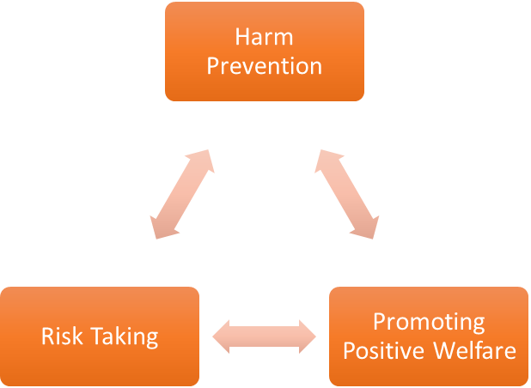
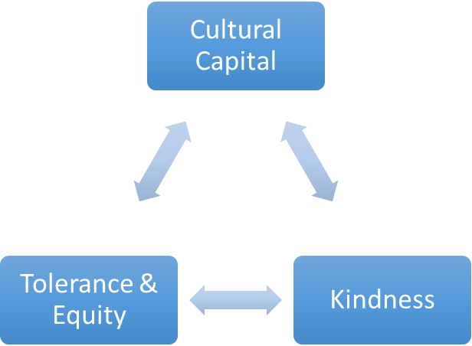
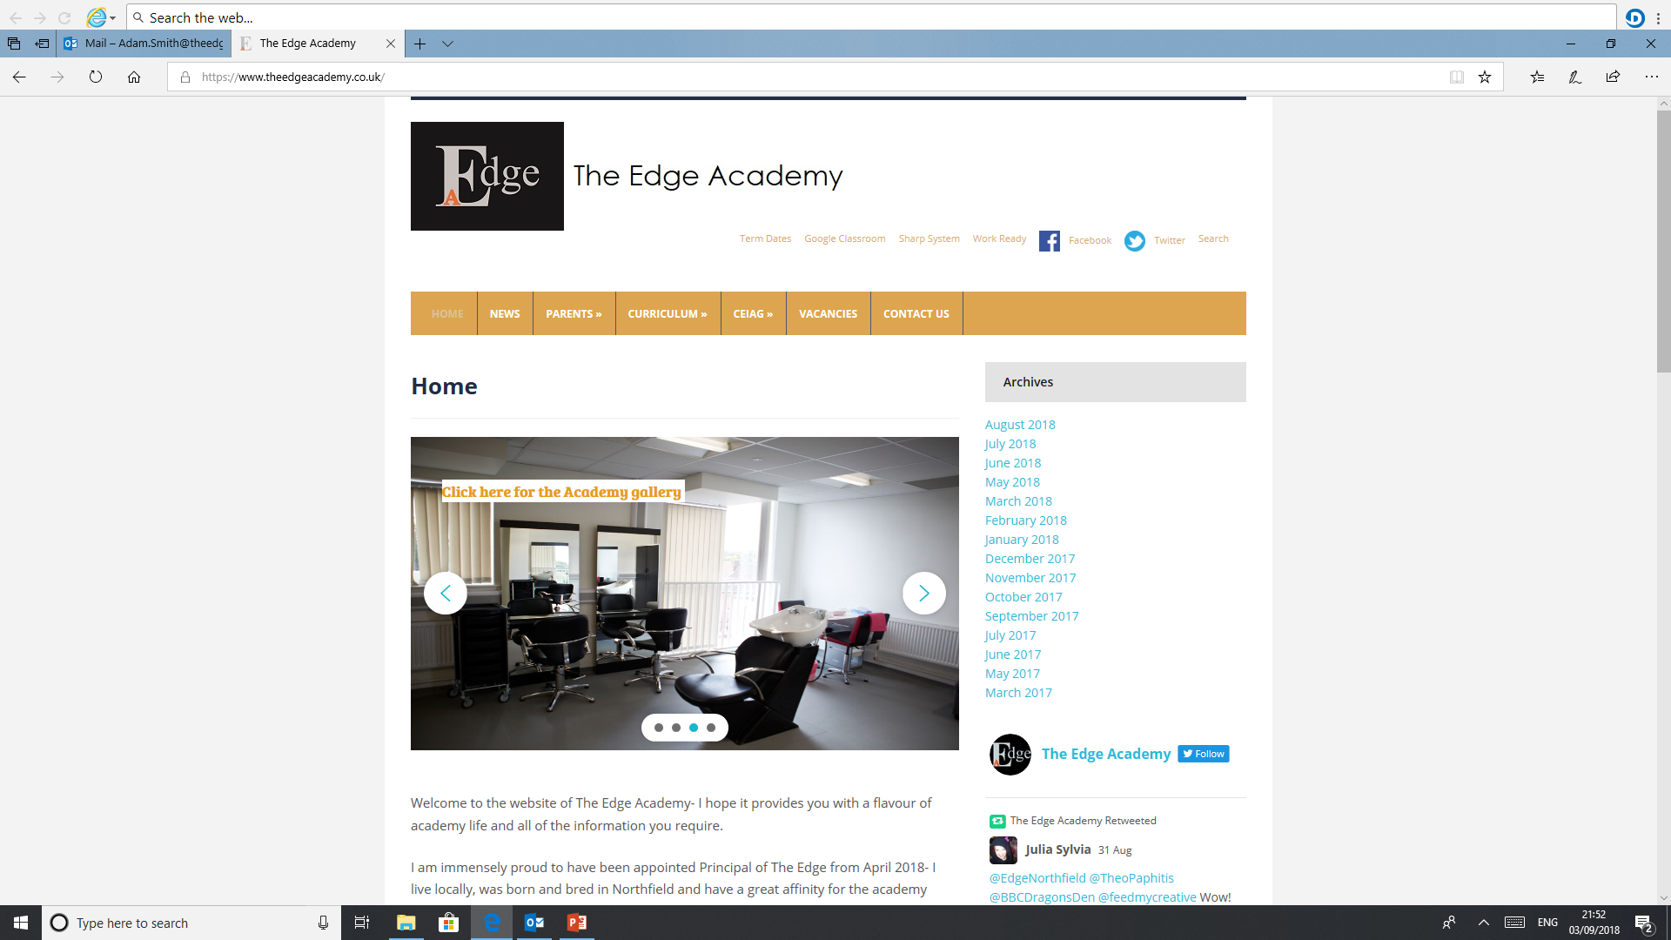
SAFE

RESPECTFUL
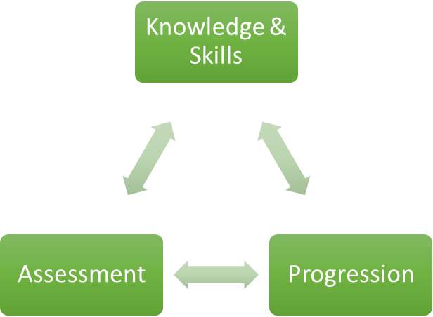

READY

ART

Why is Art important to our learners at The Edge Academy?
Many of our students at The Edge Academy have missed episodes of school or had minimal timetables, they have not had the opportunity to experiment with and play with different art materials as a form of therapy and self- reflection. I believe that students at The Edge Academy should have the opportunity to experiment with different materials as it supports their personal development as well social developments, art helps our students with the development of motor skills, language skills, social skills, decision-making, risk-taking, and creativity. Teaching through the arts can present difficult concepts visually, making them more easy to understand. Many of our students struggle within lessons that are more academic; art allows our students a break from the rigid academic lessons and allows them to work independently on their own interest. More importantly, art provides challenges for learners at all levels, promoting self-esteem.

How can Art support our learners to be SAFE?
Working in the arts helps learners to develop creative problem-solving skills, a transferable skill which students will be able to implement outside the academy. Art promotes positive mindset development and supports positive risk taking which is crucial to developing a high challenge, low threat environment where all young people feel secure learners. In providing positive discussions focused upon the arts, students can boost critical thinking, teaching students to take the time to be more careful and thorough in how they observe the world.

How can Art support our learners to be READY?
Art develops student’s problem-solving skills ready for life and creativity. Art nurtures inventiveness as it engages children in a process that aids in the development of self-esteem, self-discipline, cooperation, and self-motivation. Many students often become disengaged within the learning environment, Art allows these students to re-engage within education and be ready for the challenges presented by other subjects.

How can Art support our learners to be RESPECTFUL?
As part of our peer assessments, students learn about constructive criticism and learn not to take it personally. Collaborative workshops and art project opportunities are provided with other agencies and voluntary organisations, such as The Ikon Gallery and The Barber Institute to enhance local community cohesion. BEP Art education connects students with their own culture as well as with the wider world allowing students to develop their knowledge and discuss current issues, in a respectful and controlled environment.

What barriers to Art are there to overcome for our learners at The Edge Academy?
Many of the students have not had the opportunity to develop basic skills such as play and therapy in a controlled and structured environment. Many of our students can often become overstimulated during practical sessions and sometimes find this difficult to maintain focus. Some students require support and supervision to develop skills before they are able to work and explore their skills independently.

Why do we follow the current course/examination board with our learners at The Edge Academy?
Our students struggle with the restrictions of set work, which is not always tailored to their own hobbies and interests, Edexcel allows all learners to choose their own area of interest and base their coursework on this. This allows the students to develop their skills in their chosen area and allows students a wider breadth of choice and personal style allowing them to express their own thoughts and ideas.

What inspired your passion for Art as a teacher and curriculum leader?
My amazing and slightly bonkers Art Teacher at secondary school. Mr Killen managed to take every negative aspect of his life and turn it into a fun and sometimes crazy piece of art whilst sharing these life experiences with his students. During school, I struggled with academic subjects and was finally diagnosed with dyslexia when I began university. At school, I always found that I was more of a practical and visual learner and enjoyed subjects which had a fun and less academic aspect to it. Art allowed me to do well in a subject that did not require academic ability, whilst promoting and developing my self-esteem in other subject areas. As an Art Teacher I want to ensure that all students, no matter what their ability, are given the opportunity to thrive and do well whilst expressing themselves in a positive way.

Where can Art lead our learners to in their aspirations and lives ahead?
Art can lead to many opportunities within the creative industry such as designing, fashion, photography, gaming, interiors, illustration, animation, ceramics, tattoos, theatre set and costume design, advertising, community work, exhibitions and TEACHING! More importantly, Art creates transferable skills, which our students will need in their lives beyond the Edge Academy. More importantly, art allows students to; problem solve, make more decisions that are informed, share their feelings and emotions, have self-awareness and confidence to achieve their goals!

Our Core Purpose |  | The Edge Curriculum INTENT
Safe | Harm Prevention   | - Careful analysis of our locality, its risks to young people and the response to patterns and emerging trends identified through careful monitoring of safeguarding concerns data.  - The role and continual review of the safeguarding curriculum at the Edge comprising of Lifeskills (PSHE), daily tutor time programme, weekly assembly schedule, programme of visiting external delivery, themed days/events, awareness days events to include specifically the teaching online safety in schools and Sex and Relationships education (compulsory from 2020).
Safe | Risk Taking   | - Positive mindset development and the nurturing of calculated positive risk taking is crucial to developing a high challenge, low threat environment where all young people feel secure learners.  - The importance of challenging aspirations and realistic CEIAG are crucial tools to engagement of the wider academic offer at the Edge. This is achieved through the central offer of work-related learning opportunities to all students and immersion in post-16 learning provision events and independent guidance.
Safe |   Positive Welfare | - The preparation of our young people to manage as adults with post-school stress and demands to support young people’s mental health. The acknowledgment of relatively low-starting points of individual resilience from education experiences and the planned provision for opportunities to be successful.  - The role and continual review of the safeguarding curriculum at the Edge comprising of Lifeskills (PSHE), daily tutor time programme, weekly assembly schedule, programme of visiting external delivery, themed days/events, awareness days and events to include specifically the teaching online safety in schools and Sex and Relationships education (compulsory from 2020).
Ready | 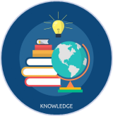  Knowledge and Skills | - Equipping our young people to have experienced threshold concepts, subject specific enrichment and key knowledge and skills in literacy and numeracy by the time they leave our school.  - An environment that cultivates the individual growth of identified knowledge and skills and through informed planning and the opportunities to apply the acquired knowledge and skills.  - Ensuring that there is depth and breadth in the Edge curriculum offer across key stages and subject sequencing to certify that we are ‘spiralling’ knowledge and skill across the years, in order to support progression.  - An effective and inspiring experience of CEIAG provision drawing on a broad diet of post-16 learner pathways, providers, effective bespoke guidance and a core offer of work related learning opportunities for all.
Ready | Assessment   | - Rigorous review and professional reflection to challenge why are we assessing young people and for what purpose to measure against realistic targets.  - Accountability at classroom and subject levels for how do you use the assessment, what methods do we use to assess, how assessments are linked to personal improvement feedback and then subsequently how do such assessments impact on future teaching and learning.
Ready |   Progression | - Harnessing and building real value in the significant underpinning factors of literacy and reading to all progression and sequencing this as a core value of our provision.  - Creating and sharing information to inform teachers and students themselves to know that progress is taking place for all learners in all subjects  - Recognition and acknowledgement that progress may not be the same for all abilities and groups but is supportive a truly individualised pathway to achievement built on the concept of equity. Where FAIR does not mean everyone gets the same thing, but FAIR at the Edge means everyone gets what they need to be successful in the classroom.
Respectful | Cultural Capital   | - The Edge Pledge – experience is not less, it is more. Education is bigger than schooling. The promise to deliver or provide that is focussed, definite and our guarantee.  - Strategically mapped and sequenced model of educational of visits in response to student council input and identified gaps in individuals’ life experiences. Central to this is the evolution to offer a high-quality two-hour enrichment session every Friday afternoon featuring a variety of “small group” on-site and off-site activities to support the holistic curriculum offer.  - Planning and provision in all our subject areas and from all adult roles to enhance the life experience and opportunities for our young people.  - The high-profile celebration for our young people of their local area, heritage and identity and to embrace and recognise what does it mean to be a ‘Brummie’.
Respectful | Tolerance & Equity   | - Teaching kindness and compassion at The Edge, not only fosters the positive behaviour that creates warm and inclusive school environments, but helps children feel that they belong, leading to reduced bullying.  - Collaborative mapped provision with other agencies and voluntary organisations to enhance community cohesion.  - Recognition of the value of family learning opportunities and embracing individual differences through culture and faith.  - Fostering empathy to build trust, with trust comes respect. There is genuine power in kindness, compassion and patience. For many learners, kindness may the one true trait that they look for in a teacher.
Respectful | 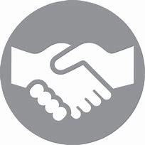  Kindness | - A fundamental kindness-based programme in school that embeds a discrete culture of kindness in an environment where kindness has not necessarily been seen, modelled or experienced. Our mantra of being ‘relentlessly reasonable’ attempts to harness that;  - Feelings of joyfulness are contagious, encouraging more kind behaviour by the giver and recipient.  - Research has determined that kindness increases our ability to form meaningful connections with others and even small acts of kindness are reported to heighten our sense of wellbeing, increase energy and give a wonderful feeling of optimism and self-worth.  - Our young people being part of projects that help others, provides them with a real sense of perspective and helps them appreciate the things in their own lives reinforcing that kindness is a key ingredient that helps children feel good.

