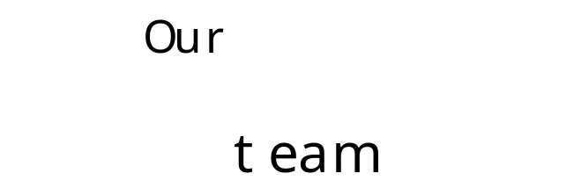
Safe, Ready, Respectful
Safe, Ready, Respectful
- Do act as an appropriate role model
- Do not jump to conclusions without checking facts
- Do not permit abusive activities e.g bullying, ridiculing. Report any such observations
- Do not make physical contact, make inappropriate comments or have inappropriate banter with children
- Do not make suggestive remarks, gestures or tell sexist, racist or homophobic jokes.
- Do not rely on your good name to protect you
- Do not believe it could not happen to you

If you have concerns about a child

Abuse (physical, sexual, emotional) or neglect can have a damaging effect on a child’s health, educational attainment and emotional wellbeing. Some changes in a child’s behaviour may not necessarily indicate that a child is suffering abuse or neglect. In some cases, those changes may be symptoms of a hidden disability, undiagnosed medical condition or changes in medication.
If whilst working with a child, you become concerned about:
- Comments made by a child
- Marks or bruising on a child
- Changes in a child’s behaviour
Please report these concerns to the class teacher or one of the academy designated safeguarding team as displayed around the school and on the back page of this leaflet.
Safeguarding Children and Young People

The Governing Body assures all visitors, parents/carers, workers and volunteers a warm welcome to the Edge Academy.
The academy has a legal duty of care for the health, safety, security and wellbeing of all students and adults. This duty of care incorporates the duty to ‘safeguard’ all students from subjection to any form of harm, abuse or nuisance.
You have a personal responsibility to comply with the academy code of behaviour in order to ensure your own safety and that of others.
Code of Behaviour
- Do treat everyone with respect
- Do provide an example you wish others to follow
- Do remember that someone might misinterpret your actions, not matter how well intentioned
- Do plan activities so that they may involve more than one person or at least are in sight or hearing of others
- Do respect a child’s right to personal privacy
- Do not photograph children (unless requested by school staff), exchange emails, text messages and phone numbers or give out your own personal details.
- Do not ‘friend’ or link with children or their parent/carers via Facebook or other similar social networking sites.



