1. Snow closure

We would like to thank all parents/carers and students for their understanding during our recent snow closure days. Closing the school is never an easy decision but student and staff safety will always be at the heart of our decision. We appreciate the difficulty it can cause in terms of childcare and thus aim to make decisions as early as possible although it is not always possible to do this due to weather and public transport being outside of our control.
6. Free breakfast!
Fingers crossed we will have no more extreme weather this winter!
2. Christmas holiday

We break up for Christmas on Friday 22nd December at 12:45. Students return to school at 9:15am on Tuesday 9th January. (Monday 8th January is a staff training day.)
3. Christmas jumper day – Friday 15th December


The academy is supporting the national ‘Christmas Jumper Day’ this Friday in aid of Save the Children. We appreciate the financial challenges Christmas can bring to families and are therefore not setting an amount that needs to be donated. All donations welcome however for this worthy cause.

4. Student of the week

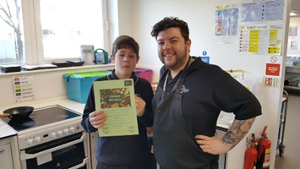
Well done to Tom for another ‘Student of the Week’ award. We were particularly impressed by his focus and commitment in his English mock exam. Awesome work!

5. Mince pie cookery masterclass – Thurs 7th Dec

Thank you to all who attended our cookery night. It was another huge success with some very positive feedback. Community links are important to us and we are keen to continue to run events like these. Please do not hesitate to contact nick.self@theedgeacademy.co.uk if you wish to receive updates.

All students are welcome to take advantage of a free breakfast between 9 – 9:15am each morning. There is also now free toast available each break time. Nutrition is an important part of academic success and we encourage students to feed their brains!
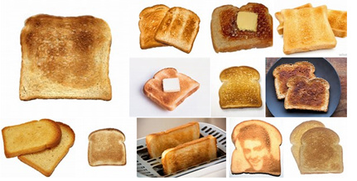
7. Anti-bullying poster competition

Congratulations to Jayme Baker in
Year 10 for winning the anti-bullying
poster competition. A talented artist
that inspired the work of other
students’ entries!

8. Communication with parents/carers

Please remember that as well as handing letters to students regarding academy news, we now put all letters on our website (www.theedgeacademy.co.uk) and text links to you each time this happens. We also post reminders on Twitter (address @edgenorthfield or go to website at www.twitter.com/edgenorthfield) and Facebook (address @edgeacademynorthfield or go to website at www.facebook.com/edgeacademynorthfield). Please follow/like our social media accounts as they provide exciting additional snapshots of academy life! Finally, we now also have a parent/carer electronic mailing list- if you have not already signed up for this, e-mail Vice Principal Andrew Wakefield at andrew.wakefield@theedgeacademy.co.uk and we will then e-mail all academy letters to you.

