17th November 2017

Dear Parent/Carer,

I am writing to inform you we are exploring the possibility of adopting a school pet. It is most likely to be a hamster or guinea pig and we are keen for students to have the chance to take on the responsibility of looking after the pet.
It is essential, therefore, that we have up to date medical and allergy information. Please return the slip below if you have any update on previously shared medical information or if you would like to speak to someone about this.
We will of course ensure all appropriate safety measures are taken to protect students and the pet with a detailed policy and risk assessment.

Yours sincerely,

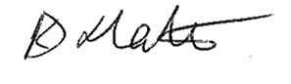
Karen Slater
Principal
---------------------------------------------------------------------------------------------------------
RE: ALLERGIES/MEDICAL INFORMATION
Student name_____________________________________
My child is allergic to animals YES / NO
If yes, please state which animals and the implications of the allergy___________________________
__________________________________________________________________________________
I would like a phone call to discuss the school pet YES / NO

RETURN SLIP TO RECEPTION

