Dear Parents/Carers,
As you will know from entries in all of our recent “Shaping Futures” newsletters, we are continuing to reinforce the importance of good attendance with all of our students in 2017/8. Put simply, students must “attend to achieve” as we know that students with the best attendance achieve the best grades when they leave The Edge.
To reward students with the best attendance, we will be continuing to award certificates at the Friday Brunch Reward Event every week for students who achieve 100% attendance in the previous week and for students with the best punctuality. As an additional reward, we will be holding two prize draws on Friday 10th November for £50 JD Sports Vouchers with all students achieving 100% attendance between half-term and Friday entered and all students who have been punctual also entered.
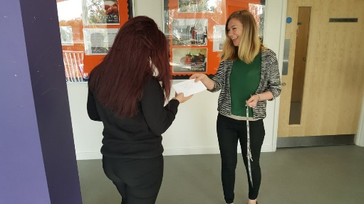
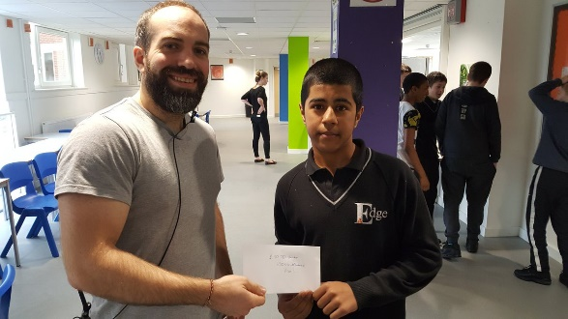

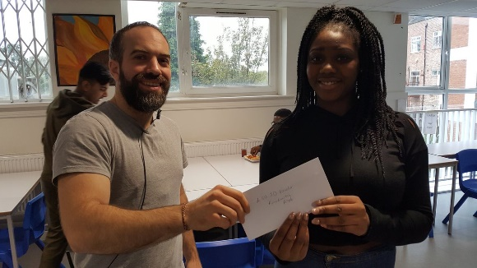
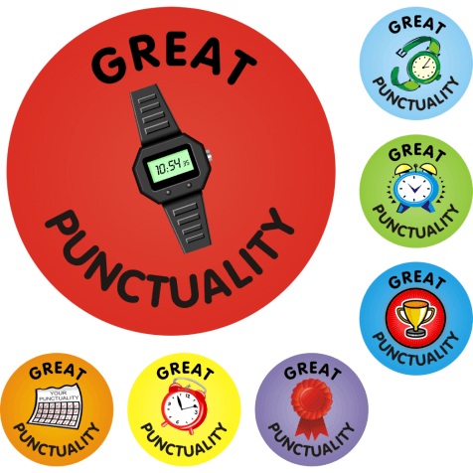
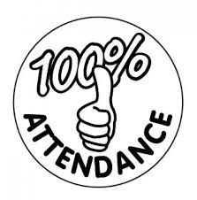

Pictured here are our previous JD Voucher winners from last half-term- this half-term, it could be your child who claims the prize!
Please contact me if there are any issues around attendance or punctuality that you would like to discuss.
Yours faithfully,

Andrew Wakefield
Vice Principal

