Teaching and Learning

It has been a week of innovative teaching and learning in our professional catering kitchen this week. High standards of work have been produced by students all week and they even got to experience lobster preparation and fish filleting!
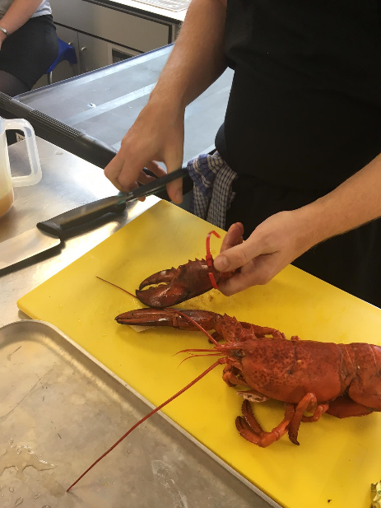
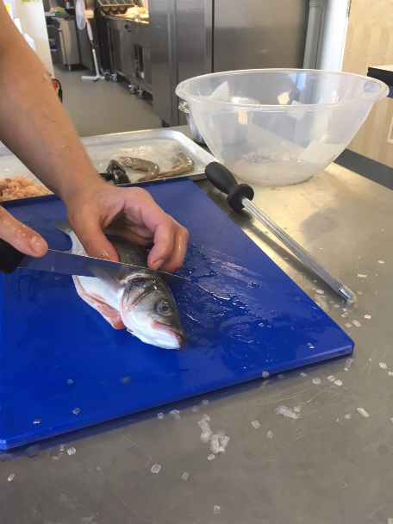


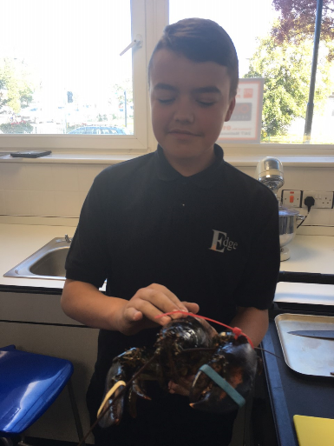

Other high-quality dishes produced this week included paella and a very sophisticated fruit salad!

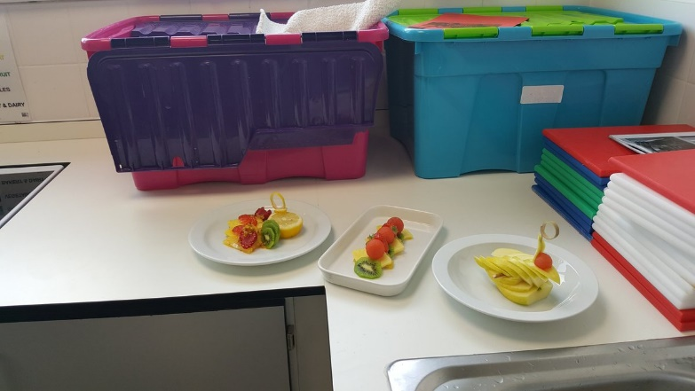
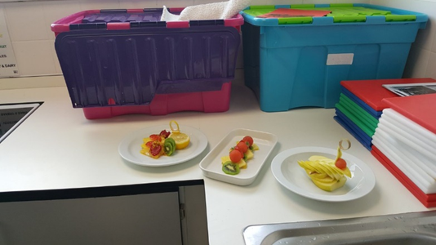

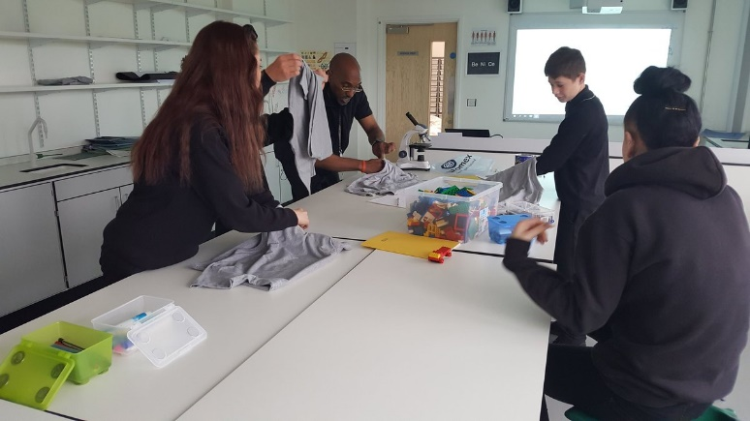
Star of the Week

Well done Essa from KS3 who not only won the “Star of the Week” award at this week’s Friday Brunch but shattered all records in the process! Essa won the most “Star of the Session” awards ever in a week since The Edge opened so he has now laid down a marker for all students to beat

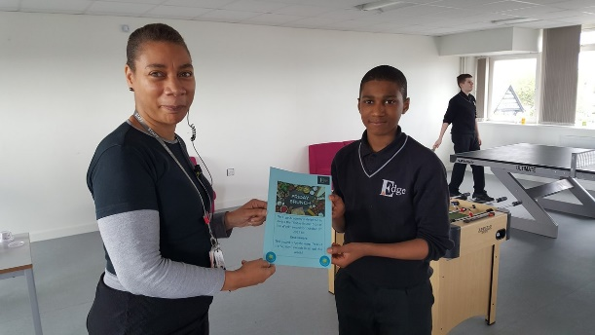

Friday Brunch Reward Event

“Student voice” is important to us, and we made further changes to the Friday Brunch Reward Event today based on suggestions we received. Students chose every aspect of the menu on offer today, and with several new categories of awards, it was great to see students enjoying themselves and receiving well-deserved certificates.
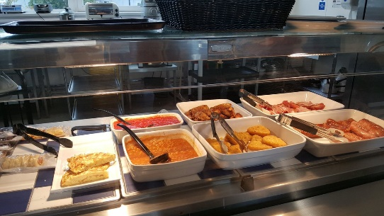
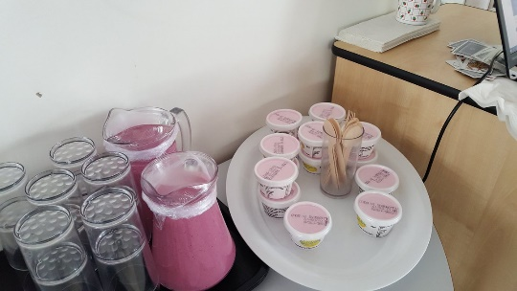

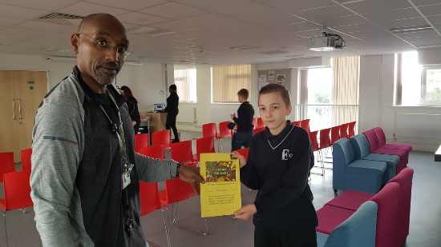
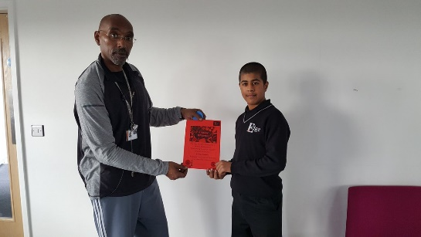

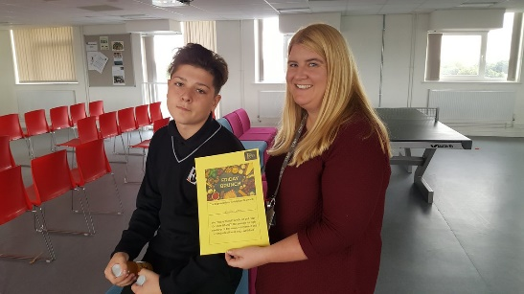

Partnership with Northfield/ WM Police

For a fixed period of time, we are delighted to announce that PC Richards of Northfield Police will be joining our staff at The Edge for a half day every week. As you know we always work in partnership with West Midlands Police, but PC Richards joins us as part of her community work and will be holding a series of supportive/ mentoring meetings with our students.
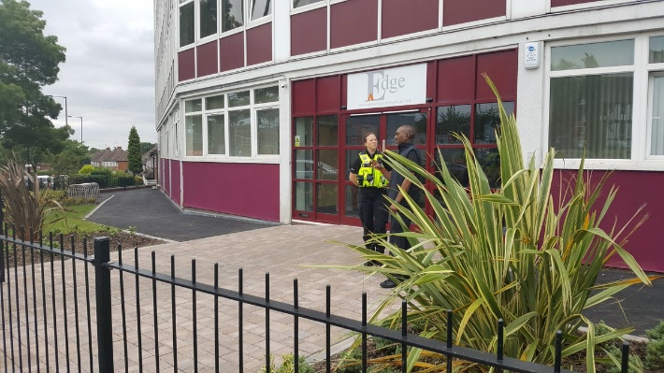

Attend to Achieve

All letters are on our website www.theedgeacademy.co.uk
We also post reminders on Twitter address @edgenorthfield or go to website at www.twitter.com/edgenorthfield
and Facebook address @edgeacademynorthfield or go to website at www.facebook.com/edgeacademynorthfield
Please follow/like our social media accounts as they provide exciting additional snapshots of academy life! We now also have a parent/carer electronic mailing list - if you have not already signed up for this, e-mail Vice Principal Andrew Wakefield at andrew.wakefield@theedgeacademy.co.uk and we will then e-mail all academy letters to you.

There were lots of exciting developments around attendance this week, including our first punctuality prize draw at this week’s Friday Brunch Reward Event. Well done to Caitlin in Y10 who was the winner of a £50 JD Sports voucher - we will be repeating a draw with the same prize before half-term! Pleasingly, there were significant improvements in punctuality from students this week- keep up the good work all!

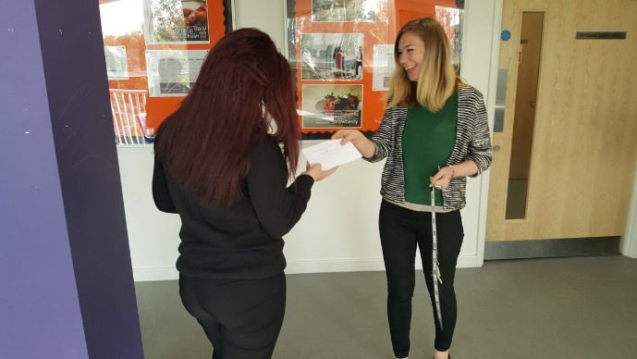

We are now committed to pushing all of our students to strive for 100% attendance- remember it is quite simply a case of “Attend to Achieve!” Each week from now on, we will be awarding certificates to all students who achieve 100% weekly attendance - Luke (see picture) was one of the first students to receive this new award today!

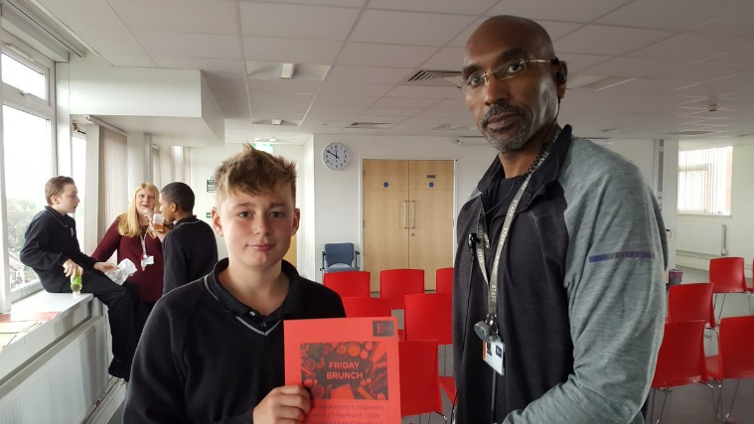

Finally, it was great to again welcome in senior staff from REACH AP School in Kings Heath to lead an “Attendance Review” for us. We are committed to working with partner schools to develop our attendance systems and we will be implementing a number of further improvements to our methods based on this review.

