1. Training days

Please note that the academy is closed to students on the following dates for staff training:

Monday 30th October
Monday 13th November
Monday 8th January
Monday 23rd July
Tuesday 24th July

The staff training we undertake at the academy focuses on our priorities and is largely based around the development of teaching and learning, and ensuring all safeguarding practices are of the highest quality.

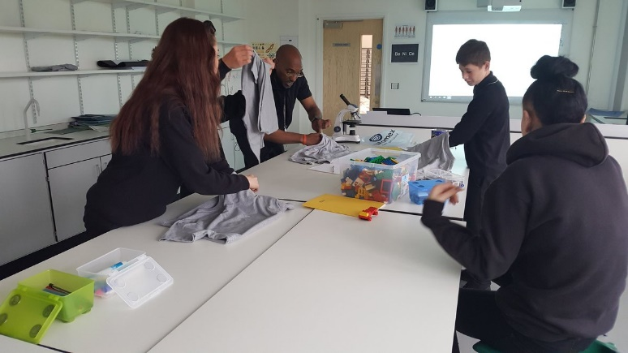
2. Detentions

Parents and students are commenting positively on the academy’s focus on the use of praise and rewards. Positive behaviour management strategies are very important to us and we will continue to ensure these are a focus. There are times, however, when students are issued with detentions. We have a made a slight adjustment to the detention system:

Red card/Incident card/Truancy = 15 minutes on the same day (If more than one of these is received, the time is added up)
Parents are notified of detentions of 30 minutes or longer. If this is not possible, the additional time will be completed the following day.
The academy informs parents of detentions up to 30 minutes where parents have specifically requested.

3. Friday Brunch Reward Event

Once more, a great time was enjoyed by all at our unique Friday Brunch event. We are paying great attention to detail by letting the students choose every aspect of what happens- this week they planned the lot, right down from the home-made Victoria Sponge cake to the choice of video games. We are committed to creating a culture of praise and rewards so any feedback on how we could further improve this weekly event, let us know.

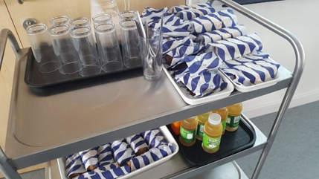
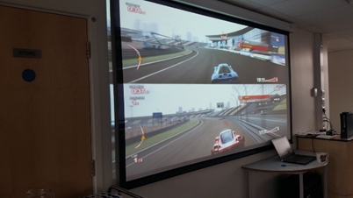

4. Star of the Week

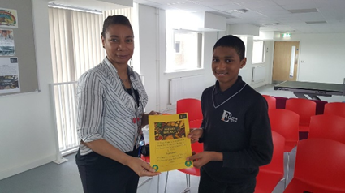
Essa from the KS3 group is a man on a mission at the moment! He won his second consecutive “Star of the Week” award at Friday Brunch this week (as always for receiving the highest number of “Star of the Session” awards) and can be seen here receiving his latest award from Ms Bartosek. Other Edge students beware- Essa has told senior staff he is hungry for the hat-trick next week!

5. Attend to achieve

It has been another busy week on attendance this week as all staff continue to push the “Attend to Achieve” initiative. Awards for high standards of punctuality and 100% weekly attendance are now a regular fixture of the Friday Brunch event- well done Luke and Minister who are pictured receiving their awards here.
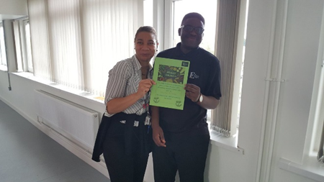
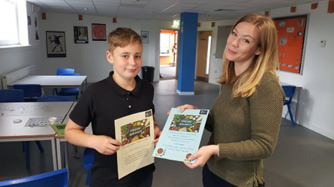

A full letter about attendance went home to all parents/ carers this week and can be accessed online at: http://www.theedgeacademy.co.uk/attendance-letter-october-9th-2017/ This gives comprehensive details of the two £50 JD Sports Voucher draws which will take place on Friday 20th October!

6. Chicken Tikka Masala Cookery Masterclass


Remember that our free Chicken Tikka Masala “Cookery Masterclass” on Thursday 19th October begins at 5pm and finishes at 7pm! The event was so popular that it was fully booked out on its second day of advertising- for those of you booked in, please remember to give your name on the door! If there are any late cancellations and places become available, we will let you know! Due to popular demand from the local community, we will also be live streaming the event on Facebook so for those of you who cannot make it, tune in!

7. Partnership with Northfield/ WM Police

It was great to see PC Richards in this week again running weekly surgeries for us and supporting our students. As you know, we always work in partnership with Northfield and West Midlands Police but PC Richards is proving to be a massive asset to our staff and we are really grateful for her work! She will continue to run the weekly surgeries at The Edge for the foreseeable future- if you have any questions regarding the work she is doing, let us know! Here she is pictured doing some early morning planning for her latest sessions with Mr Gayle assisting her!
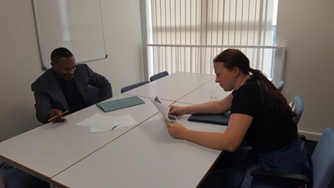
8. Online safety

The NSPCC website and Twitter feed is full of supportive advice for parents and children on a range of issues concerning their happiness and safety. In the digital world, it is imperative that parents and schools ensure children use the internet safely. This can be daunting, however, as many children are more skilled online than adults, but may not know or understand the potential dangers! The following tweet provides a useful link for parents/carers and students.

9. Parent/carer communication

A further reminder that as well as handing letters, newsletters etc to students regarding academy news, we now put all letters on our website (www.theedgeacademy.co.uk) and text links to you each time this happens. We also post reminders on Twitter (address @edgenorthfield or go to website at www.twitter.com/edgenorthfield) and Facebook (address @edgeacademynorthfield or go to website at www.facebook.com/edgeacademynorthfield). Please follow/like our social media accounts as they provide exciting additional snapshots of academy life! Finally, we now also have a parent/carer electronic mailing list- if you have not already signed up for this, e-mail Vice Principal Andrew Wakefield at andrew.wakefield@theedgeacademy.co.uk and we will then e-mail all academy letters to you.

