Dear Parents/Carers,
As you will know from entries in all of our recent “Shaping Futures” newsletters, we are continuing to reinforce the importance of good attendance with all of our students in 2017/8. Put simply, students must “attend to achieve” as we know that students with the best attendance achieve the best grades when they leave The Edge.
To reward students with the best attendance, we now award certificates at the Friday Brunch Reward Event every week for students who achieve 100% attendance in the previous week. As an additional reward, we will also be holding a prize draw on Friday 20th October for a £50 JD Sports Voucher with all students achieving 100% attendance between now and half-term entered.
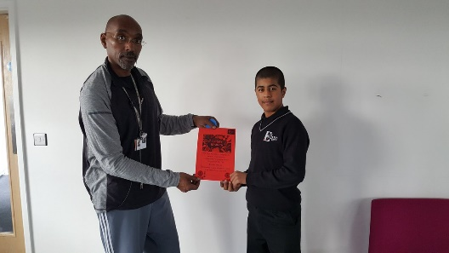

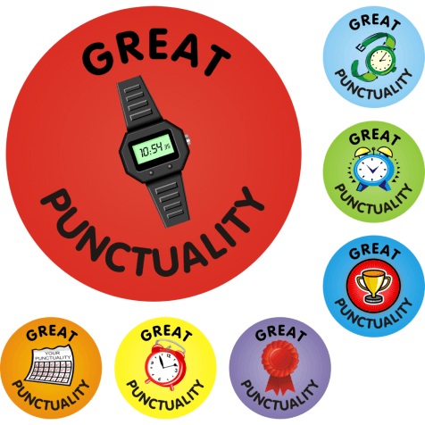
Finally, we would like to congratulate students for the improvements made in punctuality over the past fortnight. Punctuality has significantly improved and as we want to embed this improvement, we will be continuing to offer daily prizes for all students in form time by 9.15am until Half-Term. We will continue to award certificates to students with the best punctuality at Friday Brunch, and we will also hold a punctuality prize draw for a £50 JD Sports Voucher on Friday 20th October. Well done to Caitlin in Y10 who won the first draw last Friday!
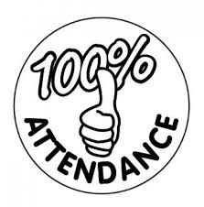
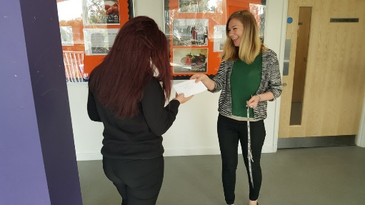

Please contact me if there are any issues around attendance or punctuality that you would like to discuss.
Yours faithfully,
Andrew Wakefield
Vice Principal

