5th March 2018

Dear Parent/Carer,

We continuously strive to improve the educational experiences for students at the Edge Academy. As part of our ongoing review systems, we are currently seeking both parent and student opinions on our uniform policy. I would be grateful if you could return the attached by Wednesday 7th March. Please feel free to either return this form, telephone the main reception, or email myself with your feedback (Karen.slater@theedgeacademy.co.uk).

Yours sincerely,

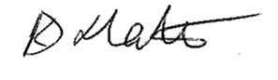
Karen Slater
Principal

-------------------------
Uniform policy - Parent voice
Please rank the following preferences (1 being your favourite, 3 being your least favourite):
- Uniform to remain as it is □
- Polo t-shirt and sweatshirt to remain, student can wear
any trousers/skirt and shoes/trainers □
- No uniform □

Other comments:

Name of student:

